

**SECONDARY SCHOOLS**

Start of Year arrangements for Glow

**Beginning of Year arrangements for Glow - Secondary Schools**

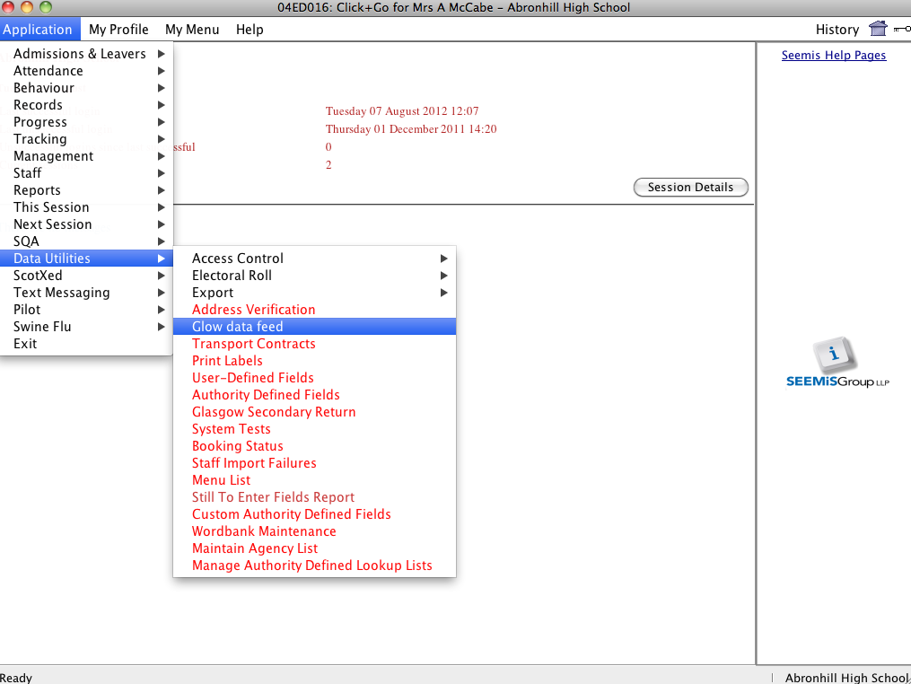In Click & Go from the **Applications** Menu choose **Data Utilities** and **Glow Data Feed**.

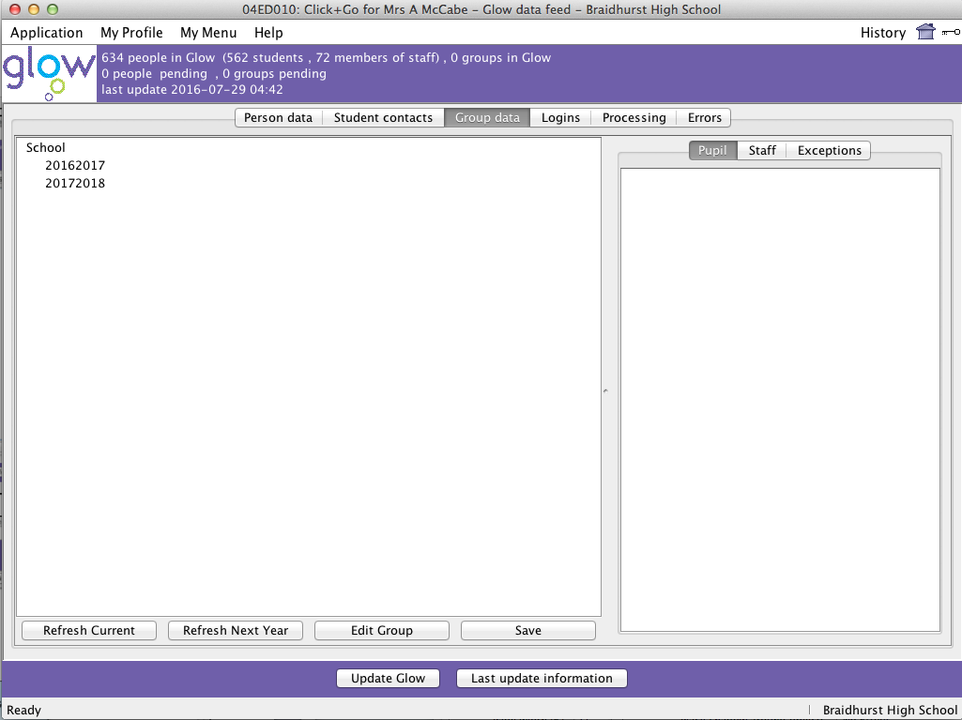Then click on the **Group data** tab.

You will notice that currently you have no groups in Glow.



Then click the **Refresh Current** button.

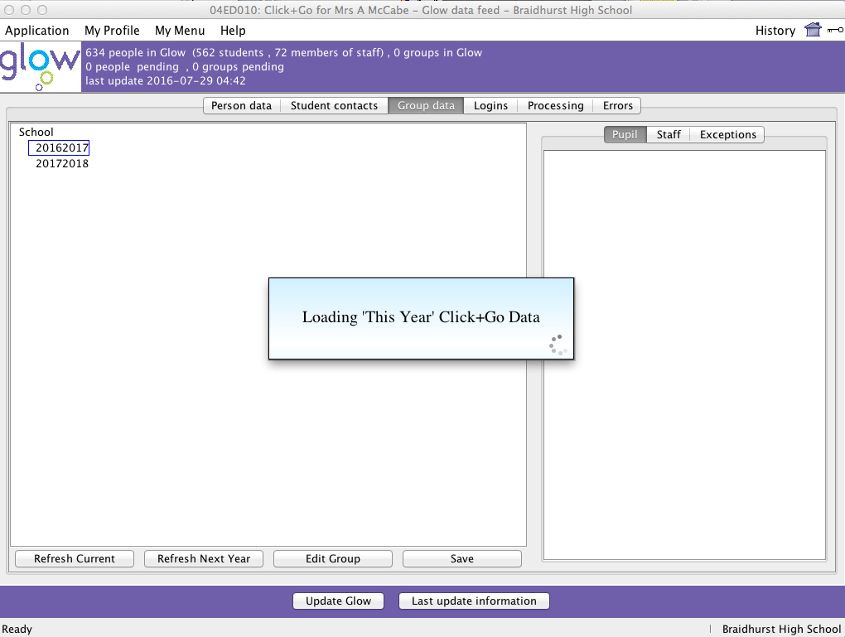You will see a message like this.

Depending on the size of your school it may take some time for the data to load.

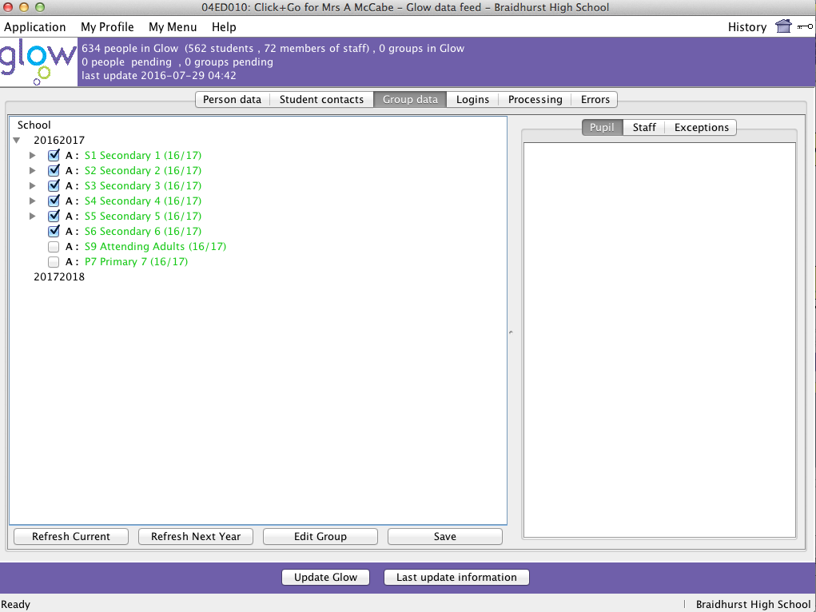Expand the year data by clicking the triangle next to 2016/2017

Put a tick in each box

as shown.

Data that is currently coloured in green is not in Glow.

Once all the boxes are ticked click the **‘Save’** button and then

‘**Update Glow’**.

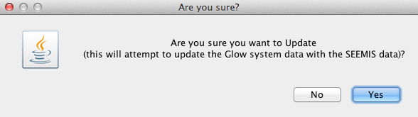

Click ‘Yes’ to confirm you wish to update Glow.

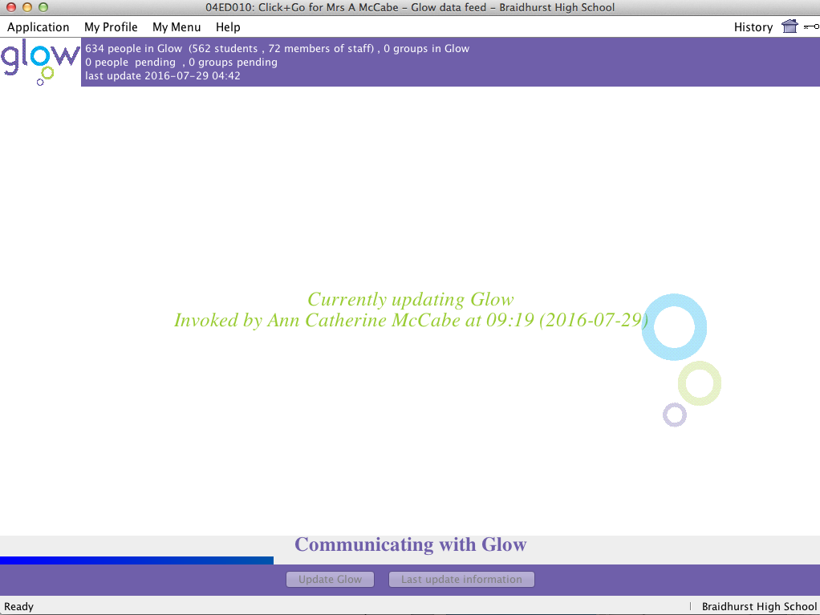

A window like the one above appears. This part of the transition is complete and your year groups will now be ready to move across to Glow.

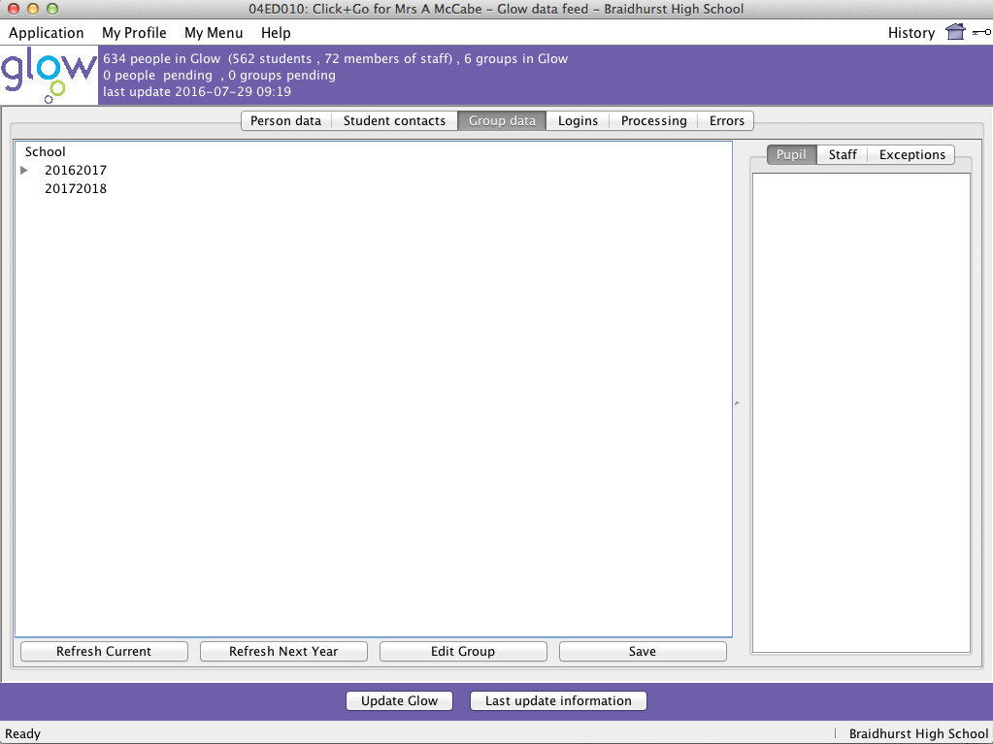After the process has completed in the top section you will see that you now have some groups in Glow.

Click **Refresh Current** again.

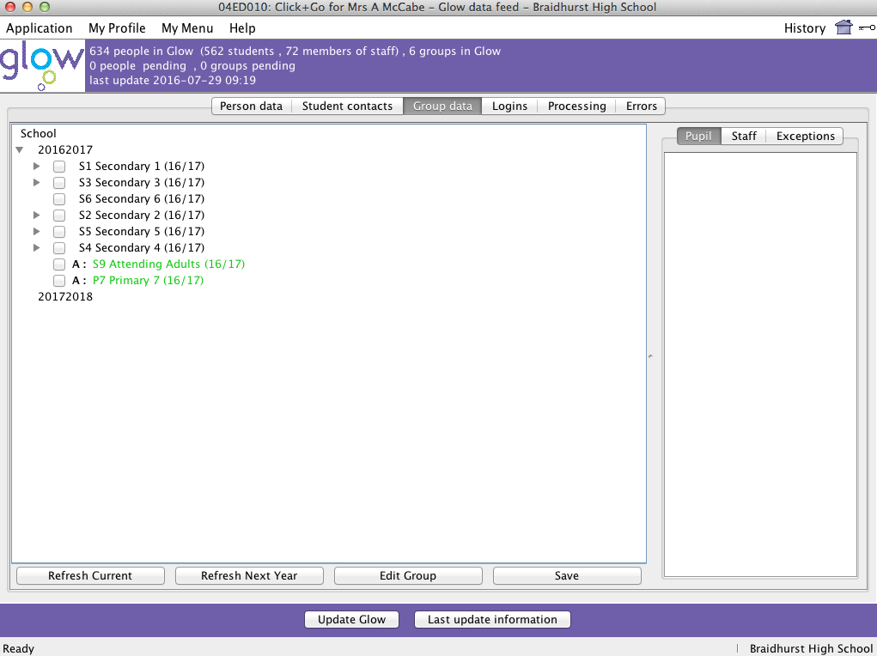

Once the data has loaded click on the triangle beside 2016/17 to expand the data.

Your year groups now appear as black text.

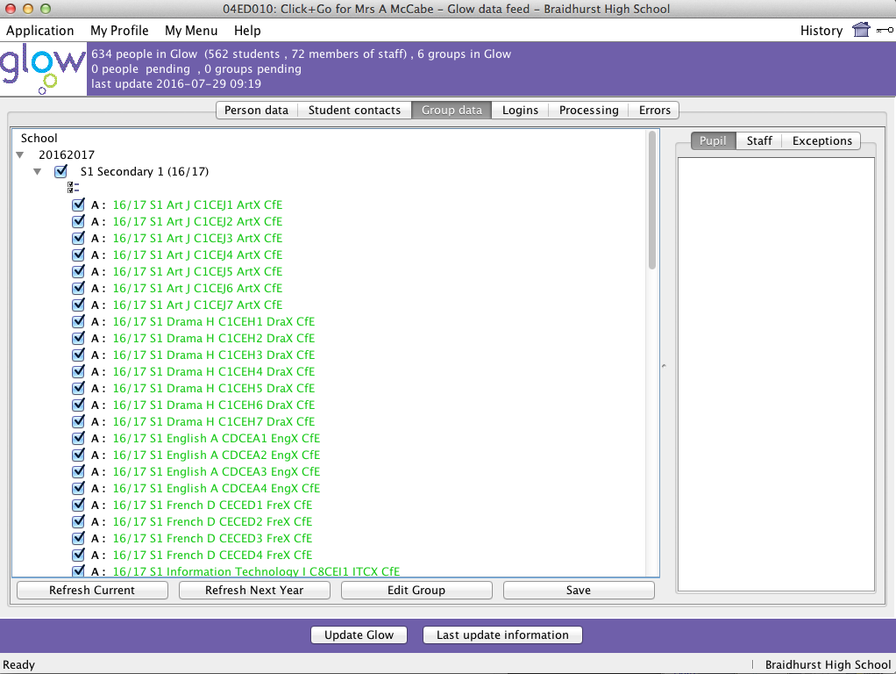

Click on the + or triangle beside each year group in turn.

You will see all the classes within that year group.

You want to ensure that all the boxes in each year group are ticked – the way to do this is to tick the box at the top with the double ticks.

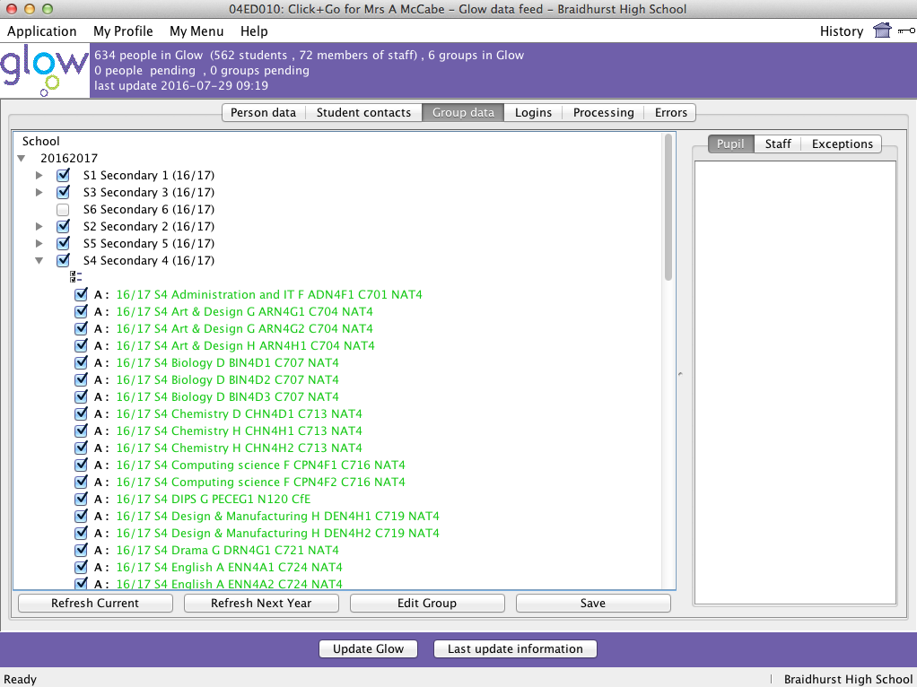Work your way down through the groups which have a triangle next to them as shown here.

When you have done this for all the year groups and classes click **Save** and then **Update Glow**.

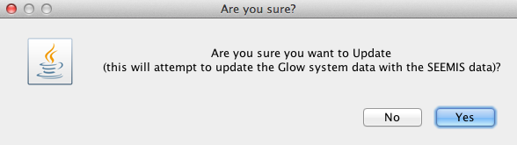

Click **Yes** to confirm

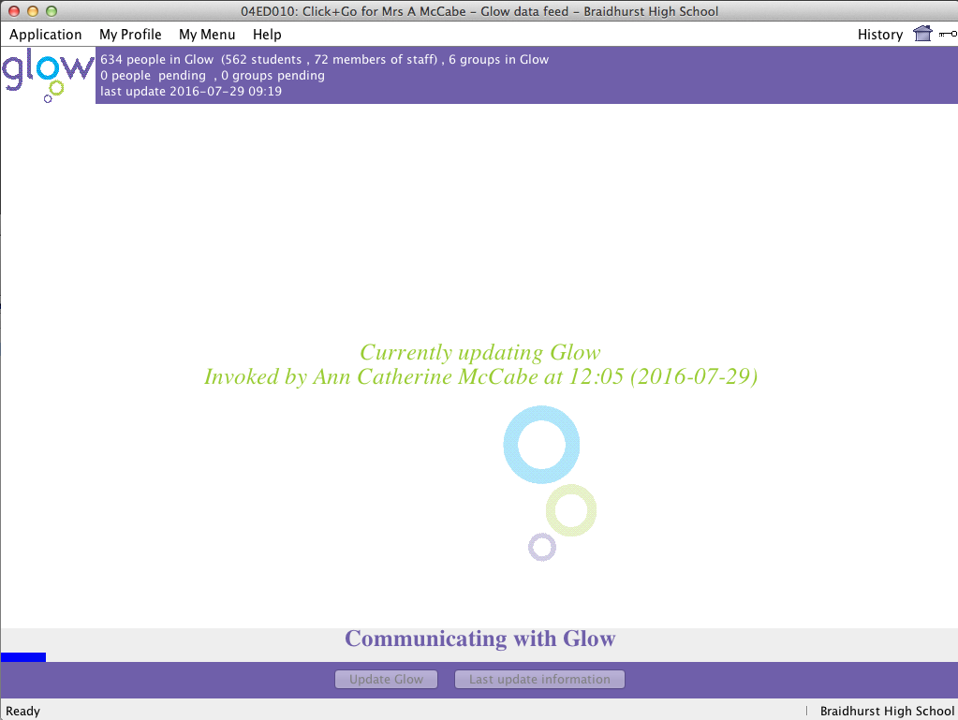

A screen like this will appear and your data will start to move across to Glow. It may take quite some time for this to happen.

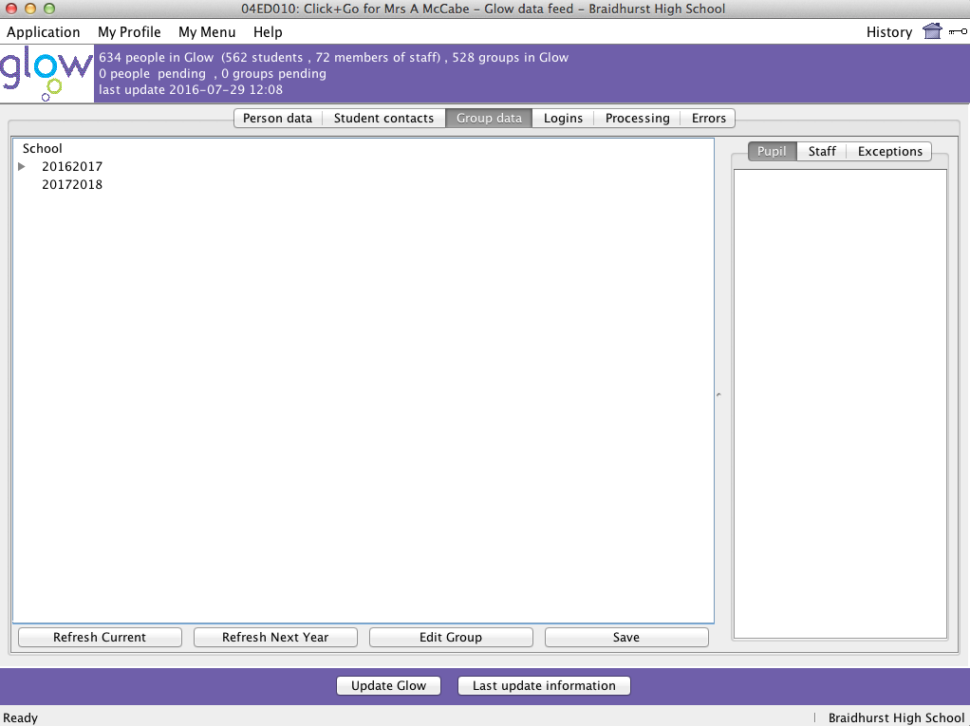

Once the process is complete the number of groups you have in Glow should now be much higher.

It may take some time for the groups to all move across so don’t log out of Click & Go until there are no groups pending or until only the S1 groups are pending.

Click **Refresh Current** again.

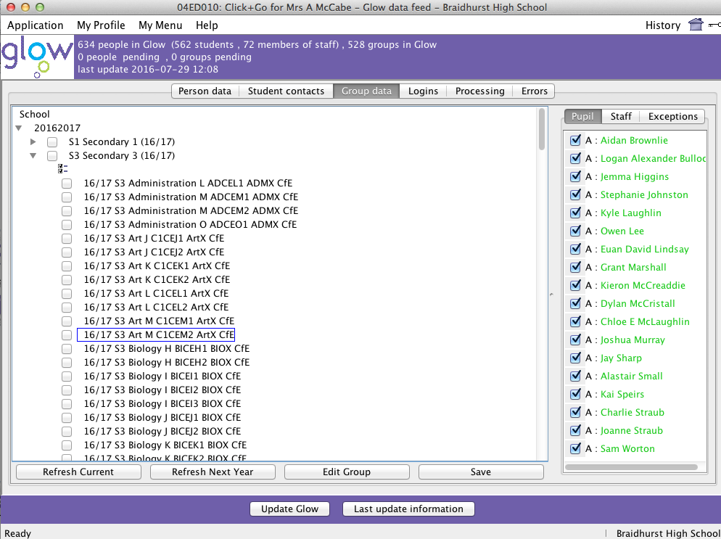

Once the data has loaded check that the classes are all okay.

The year groups and classes should both now be in black text.

If you click on a class the pupils will appear in the side panel in green text as they are waiting to go to Glow.

24 hours after this the class data appears in Glow.