

BEGINNING of Year arrangements

**PRIMARY SCHOOLS**

**Beginning of Year arrangements for Glow - Primary Schools**

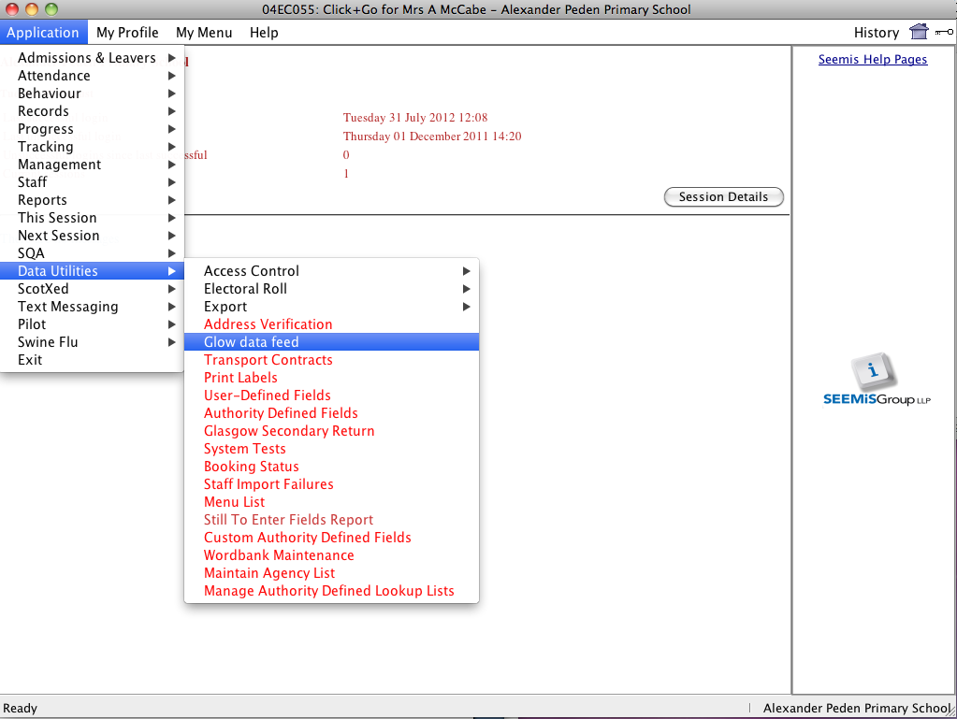

In Click & Go from the **Applications** Menu choose **Data Utilities** and **Glow Data Feed**.

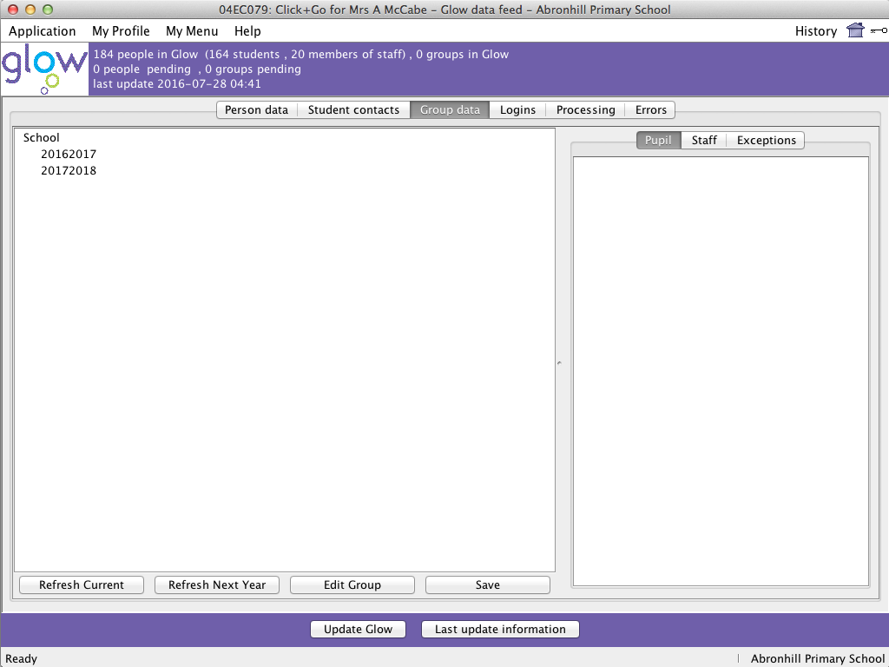

Click on the **Group data** tab.

Notice that at the moment you have no groups in Glow



Then click the **Refresh Current** button.

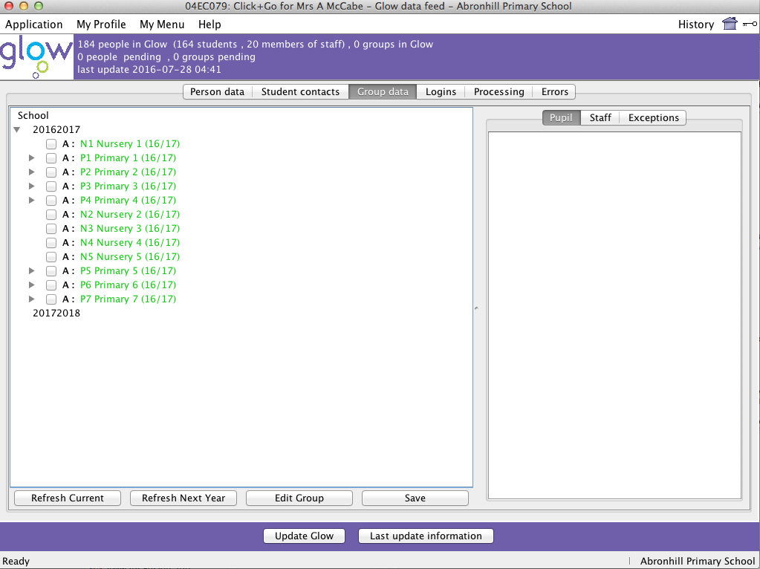

Expand the year data by clicking the + or triangle next to 2016/2017.

You will see all your year groups.

The data will be in green if the data hasn’t been sent to Glow.

Put a tick in the box beside each primary year group as shown.

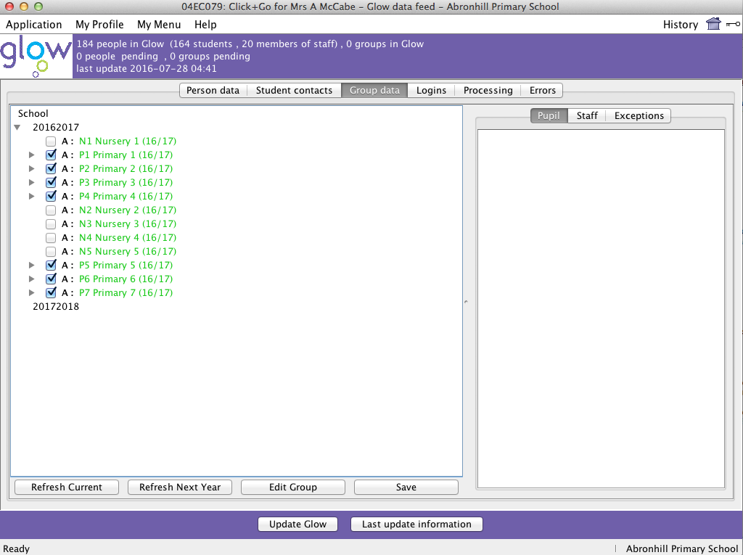

Once all the boxes are ticked click the **‘Save’** button and then ‘**Update Glow’**.

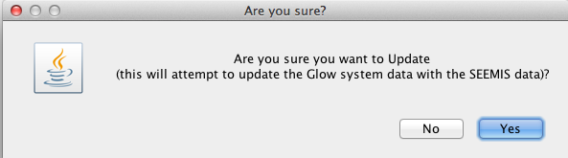

Click ‘Yes’ to confirm you wish to update Glow.

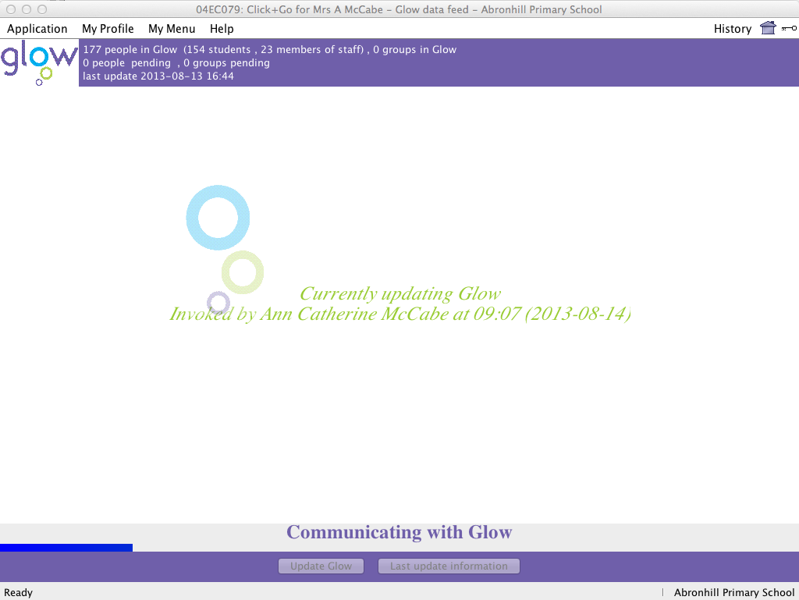

A window like the one on the right appears. This part of the transition is complete and your year groups will now be ready to move across to Glow.

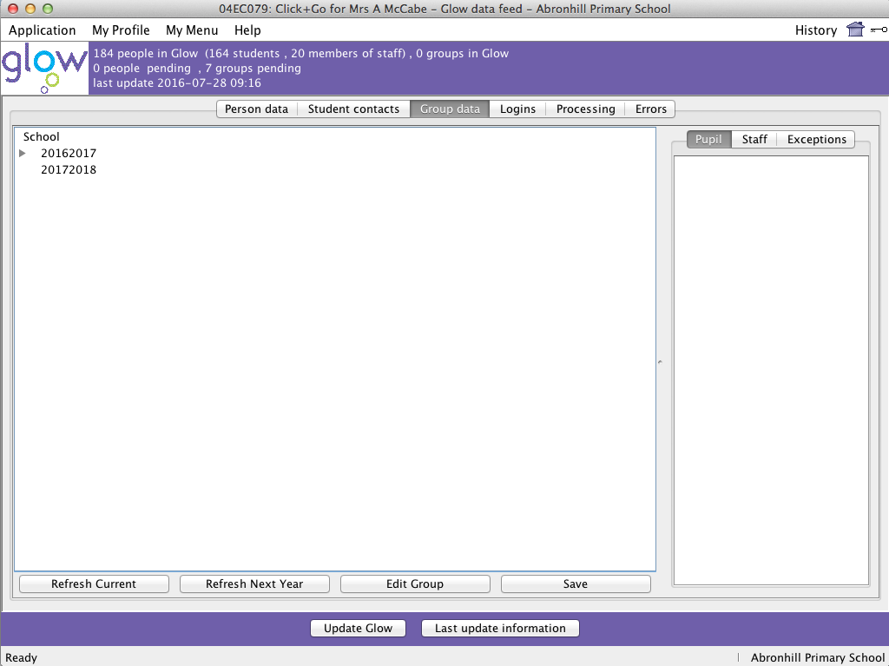You should now see that you have 7 groups pending.

Wait at this point until the groups disappear from pending.

After the process has completed in the top section you will see that you now have 7 groups in Glow.

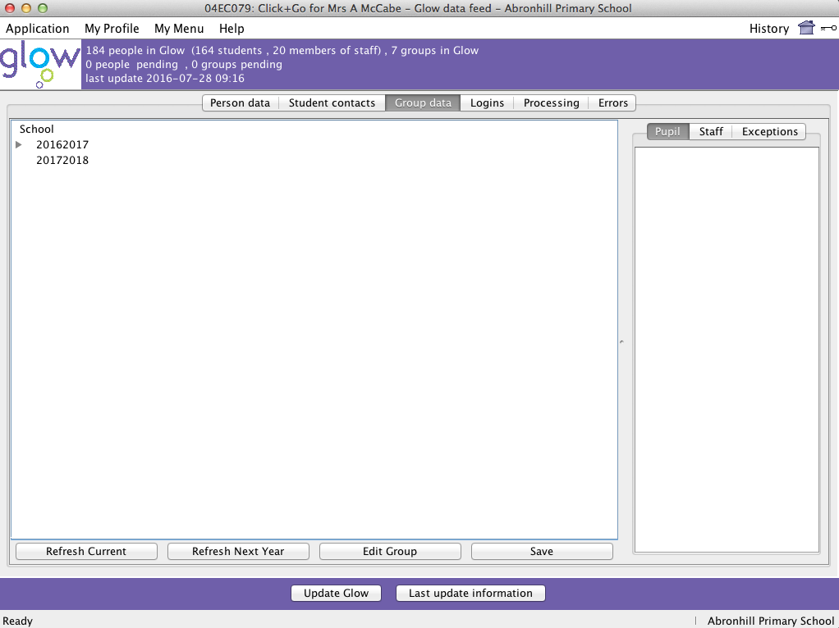

Click **Refresh Current** again.

Once the data has loaded click on the + or triangle beside 2016/17 to expand the data.

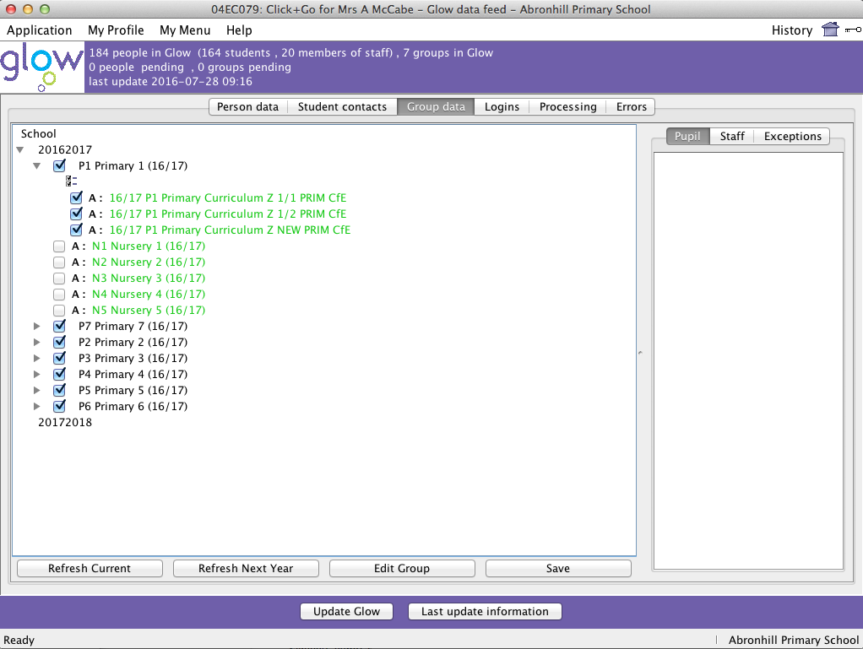

Your primary year groups appear now as black text (don’t worry about the nursery classes which will still be green).

Click on the + or triangle beside each primary year group in turn.

You will see all the classes within that year group.

You want to ensure that all the boxes in each year group are ticked – the way to do this is to tick the box at the top with the double ticks.

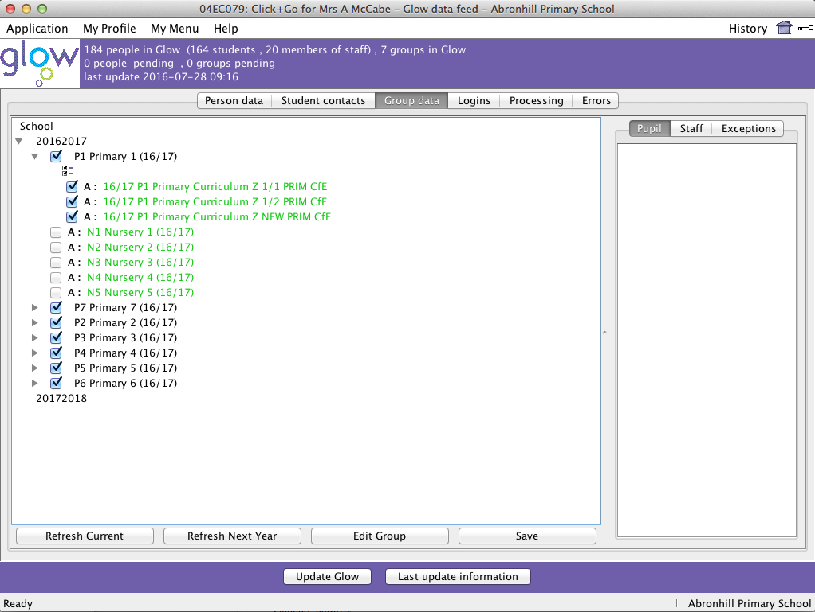

When you have done this for all the classes click **Save** and then **Update Glow**.

Click **Yes** to confirm

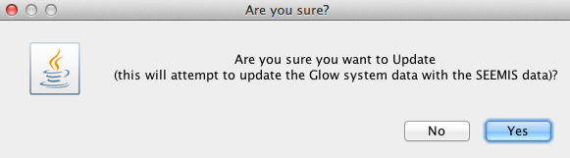

Again your screen will show a number of groups pending.

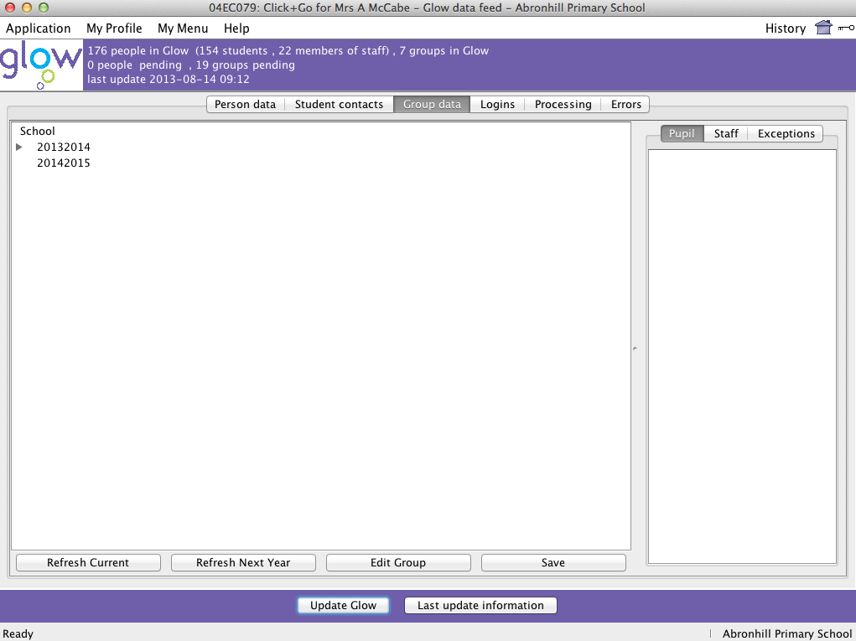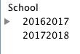

Wait until these groups disappear from this area. This may take some time to happen in larger schools

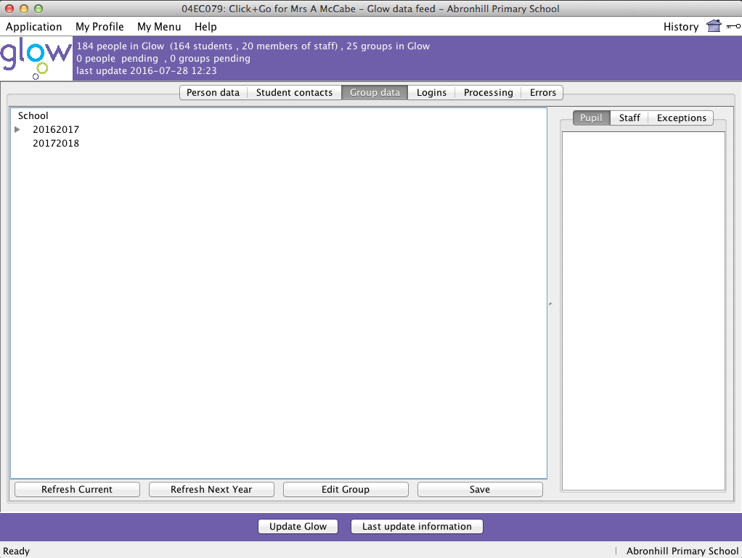

After a short while you should see a screen like this. In the top section the number of groups you have in Glow should now be higher (composite classes count as 2 groups)

Click **Refresh Current** again.

Once the data has loaded check that the classes are all okay.

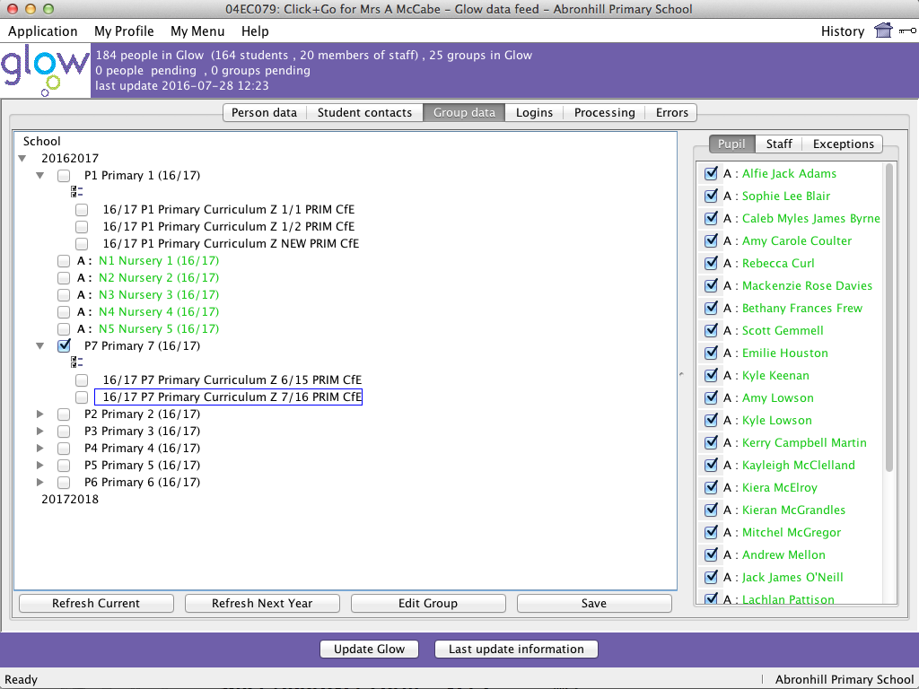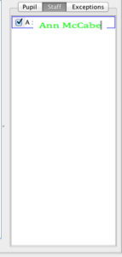

All the classes should now be in black text (don’t worry that the nursery classes will still be green)

If you click on a class you will see the pupils in that class.

Their text may be green.

It may take 24 hours after this before the class data appears in Glow and before the children in each class appear in black text in Click & Go.

Make sure that there are no groups pending before exiting from Click & Go.