School Website – Admin Guide

Adding/Deleting Users

In the original Glow blog the user roles were controlled by the SharePoint group that the blog was created on. In the new blogs service users are added and their roles controlled on the blogs dashboard.
Users can have different roles on a blog, these will come with different permissions:
Administrator – somebody who has access to all the administration features within a single site.
Editor – somebody who can publish and manage posts including the posts of other users.
Author – somebody who can publish and manage their own posts.
Contributor – somebody who can write and manage their own posts but cannot publish them and can’t add images.
Subscriber – somebody who can only manage their profile.
The roles of Administrator and Author are the most commonly used roles.

You need to remember that as users are given permission to a blog by their Glow Username that the permission to the blog will not disappear when that user leaves your school. Because of this you will often need to visit the User’s section of the blog to add/remove staff or to change their permission.

Adding a User
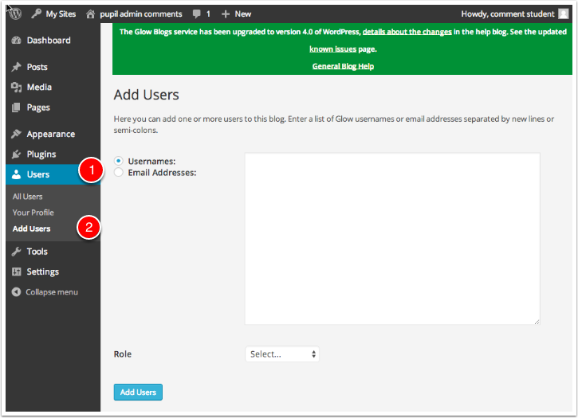
In the Dashboard click on Users and Add Users.

If you click on the Add Users tab you can type or paste names in

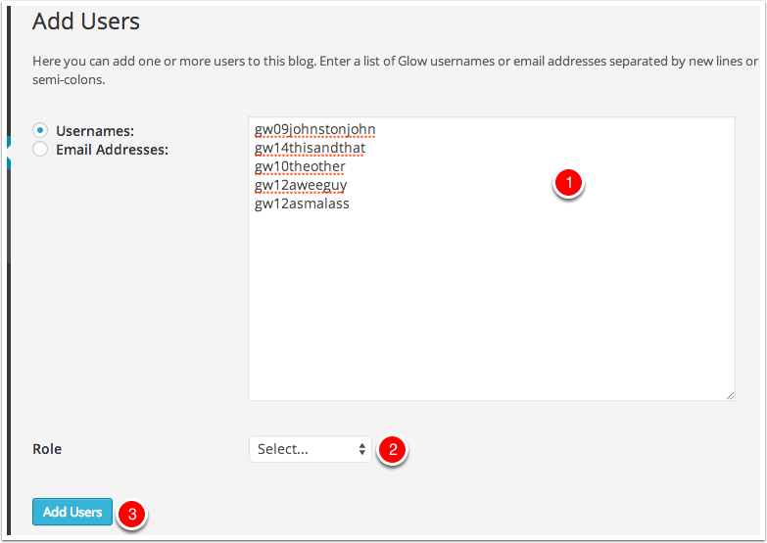
- Type or paste the list of users you want to add to the blog into the username fields.
- Choose the Wordpress role you want those users to have from the popup.
- Click Add Users
You will see a message at the top of the Add Users screen telling you users have been added.
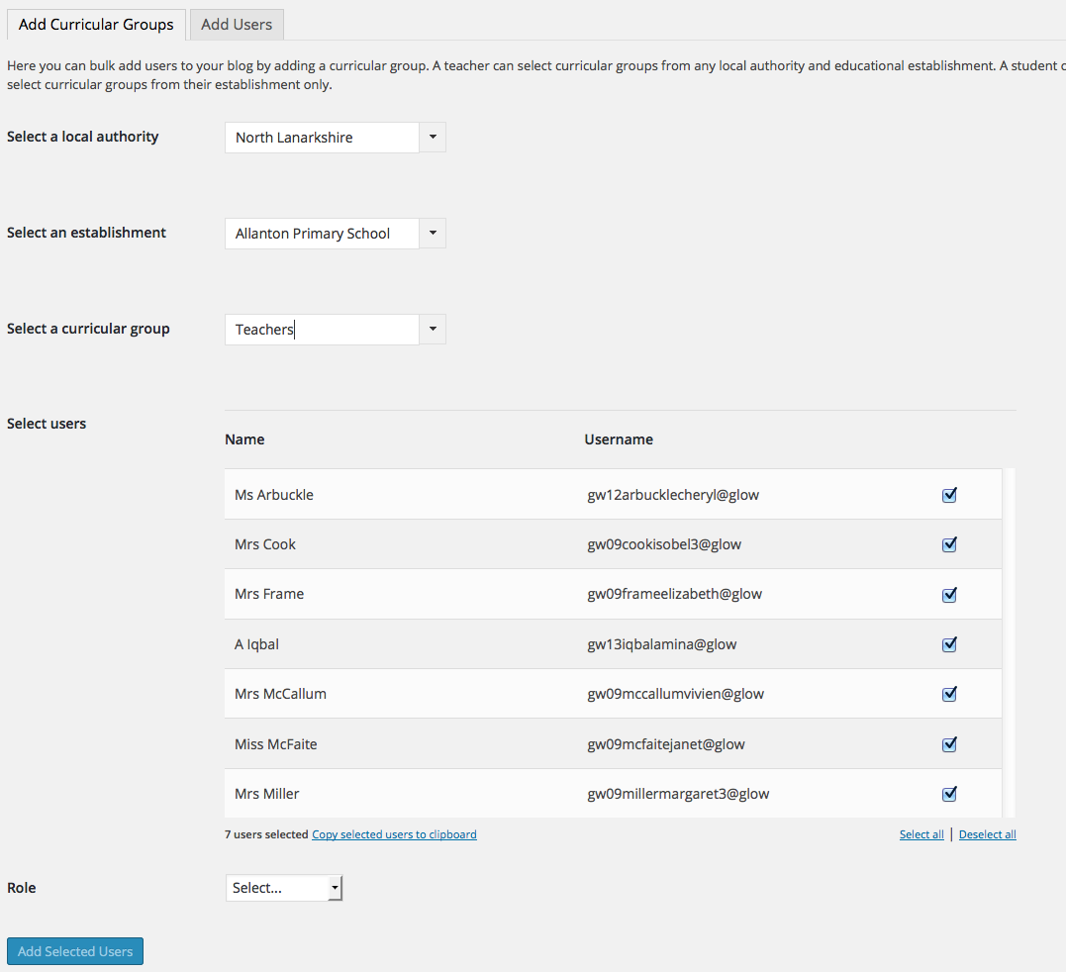
The blog update on 28/1/2016 added in another way to easily add in all your staff.
- Select your Local Authority
- Select your school
- Type in Teachers
- Deselect any staff you don’t want to add
- Choose a Role
- Click Add Selected Users

After users are added to the blog they can be managed from the All Users screen
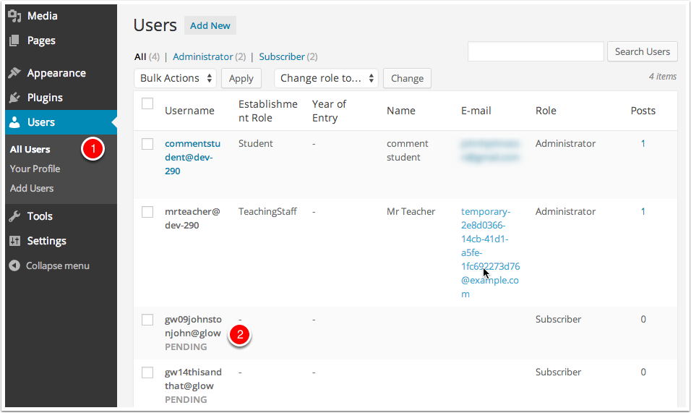
You can view user’s information and change or remove their role on the blog.
Users that have been added who have not visited and logged into the blogs are added as pending
Glow users will have the account on the blogs service created when they visit the blog home page for their LA after clicking the tile in RM Unify.
Administrators can remove users from their blog or change their roles on this screen.

Removing a User
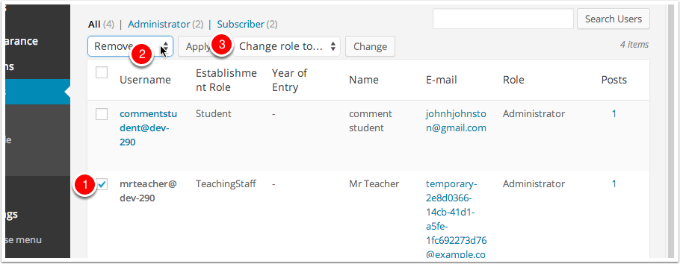
To remove a user:
Check the box beside their name (you can delete multiple users at once) [1]
Select Remove from the Bulk Actions pop up [2]
Click Apply [3].
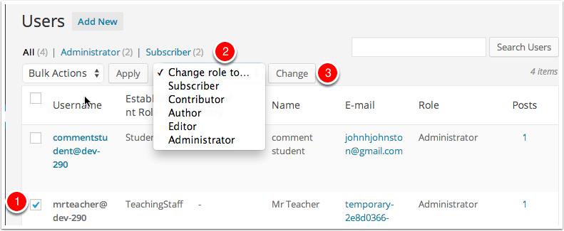
You will be taken to the Delete Users screen where you can make decisions to delete the posts from the user or attribute then to another user.

Changing a Users Role
To change a users role
Check the box beside their name (you can change multiple users at once) [1]
Select a new role from the Change role to... pop up.
Click Change [3]
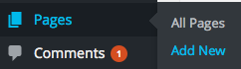
Adding a Page
In the Dashboard of the blog in the sidebar click on Pages and Add New.

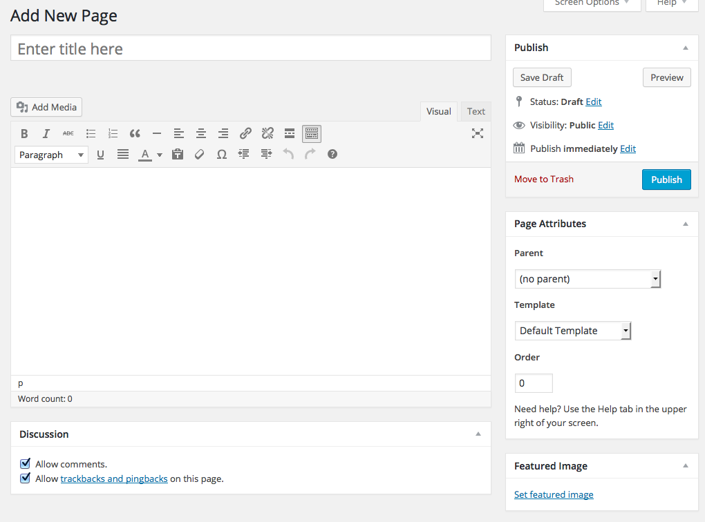
- Enter the page title

- Add your page content here

- Choose whether you want to allow comments on the page

- Click Publish.

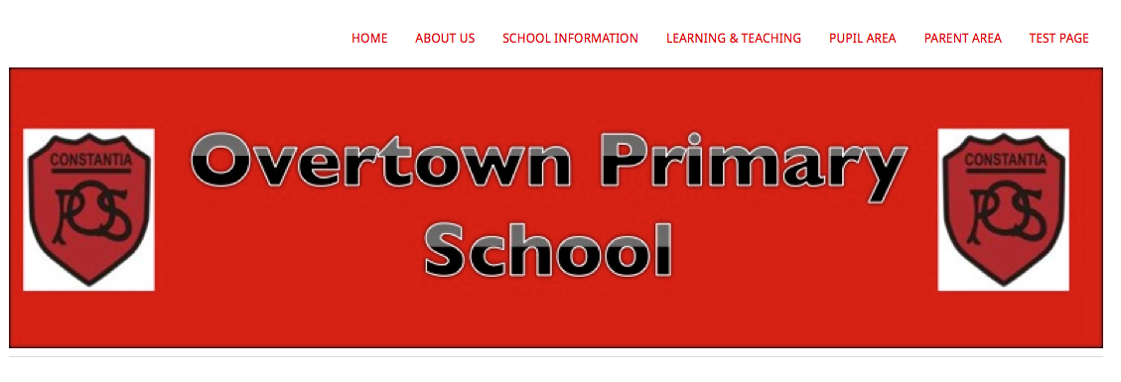
If you have drop down menus taking you to the pages of your blog you will find that the new page you make appears as a new section of its own.

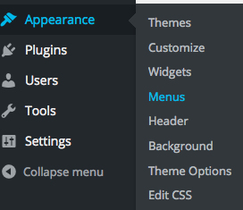
You now need to go into the menus and move the page to its correct position.

To do this in the Dashboard click on Appearance and then Menus.

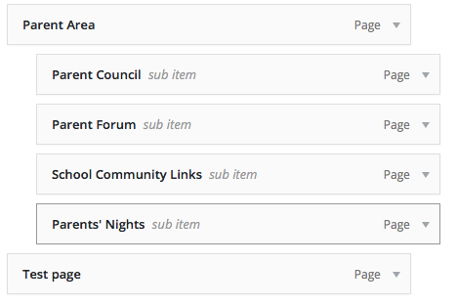
The new page you added will be at the very bottom of the menu.
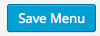
Drag the page into the required position and then click Save Menu at the top or bottom right
of the screen.

Adding a Header
You will probably want to add a header to your blog to give it an identity and make it more attractive.
For the Yoko Theme the suggested image size required is 1102 x 210
For the Twenty Fourteen theme the suggested image size is 1260 x 240
You may want to make your header in an art package such as paint or in PowerPoint.
All you need is a finished image in the size you require.

To add a header
From the Dashboard click on Appearance and then Header or from the blog itself click on the blog name in the Admin bar and choose Header.
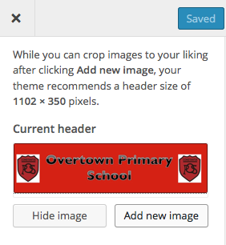
Click on Add New Image

You can either upload a file from your computer or choose one you have already uploaded to the Media Library.
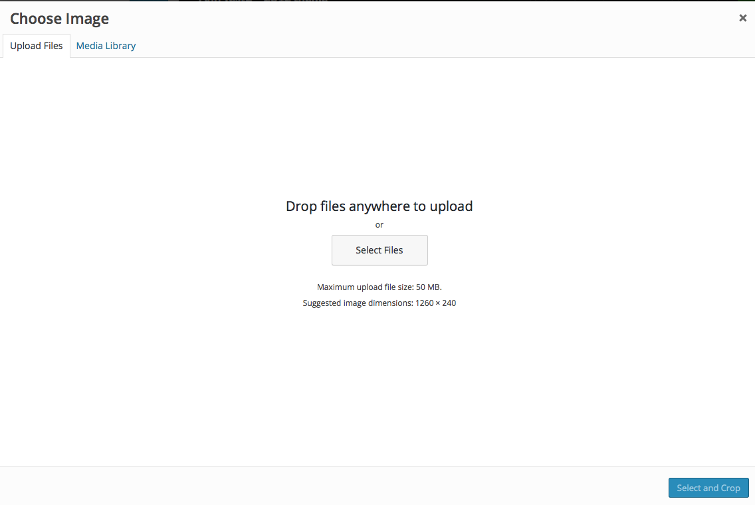
To upload a new file click on the Upload Files tab and then click on Select Files.

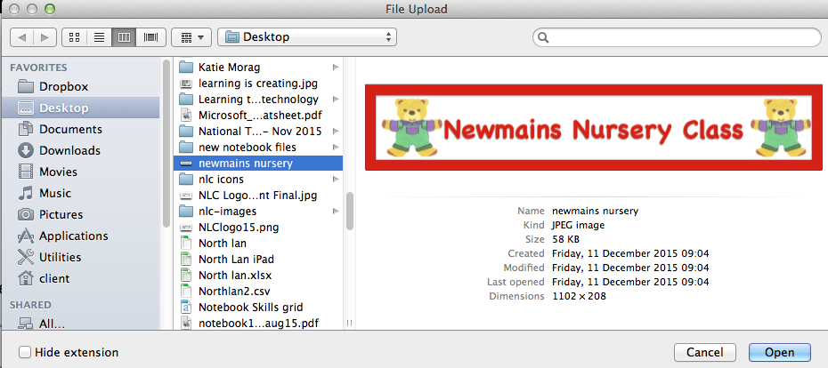
Navigate to where you file is stored and click Open.

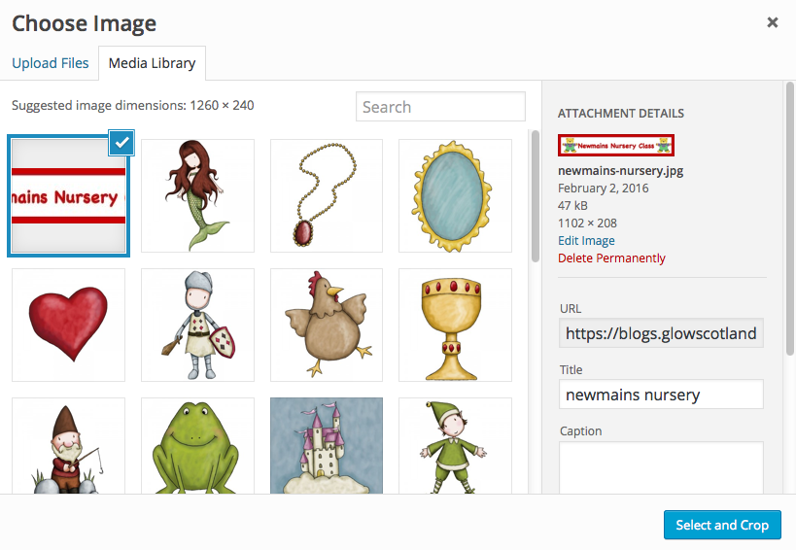
Your file will upload to the Media Library and will be selected.
Click on Select and Crop.

On this screen if your image is the correct size you will want to click on Skip Cropping.
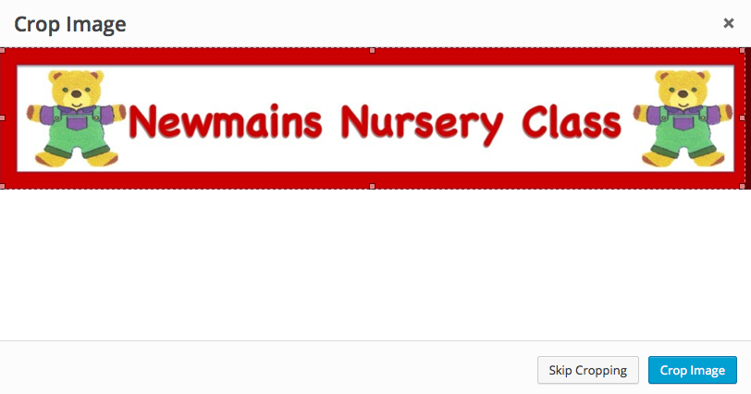

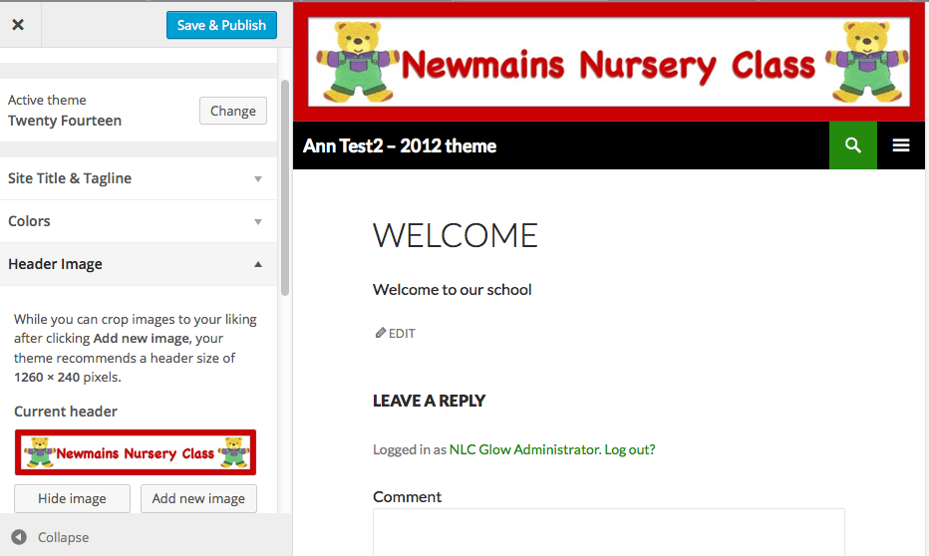
You will be taken back to your blog and the header will show at the top of the blog.
Click on Save an Publish if you are happy with what you see.
Then click x to close the sidebar

