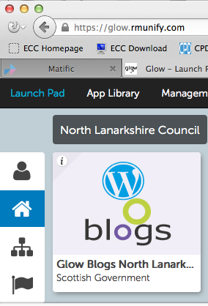
Accessing the school website/ blog
Staff can only add to the school website blog if they have been given permission to the blog. There is a separate document for adding users to a blog and changing their permissions.
The first time staff visit the school website/blog they must log into Glow and click on the Blogs tile.

Then choose My sites and find the school website.
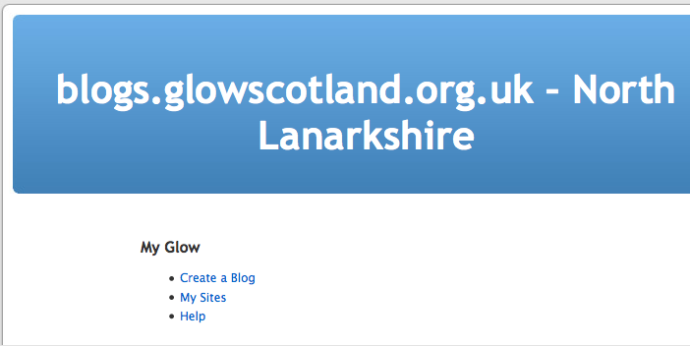

Click on Visit to go out onto the Internet to look at the pages and posts.
Click on Dashboard to configure the blog and to add posts and pages
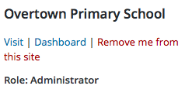
The Role will show what permissions you have on the blog. The permissions will usually be Author, editor or Administrator for staff members.

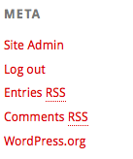
On the first visit to the blog the system checks your permission to the blog to see what you are allowed to do.
After that first visit you can just go to the address of the blog and then use the Meta widget in the sidebar to Log in and Log out of the blog.

Your school website blog will look something like this

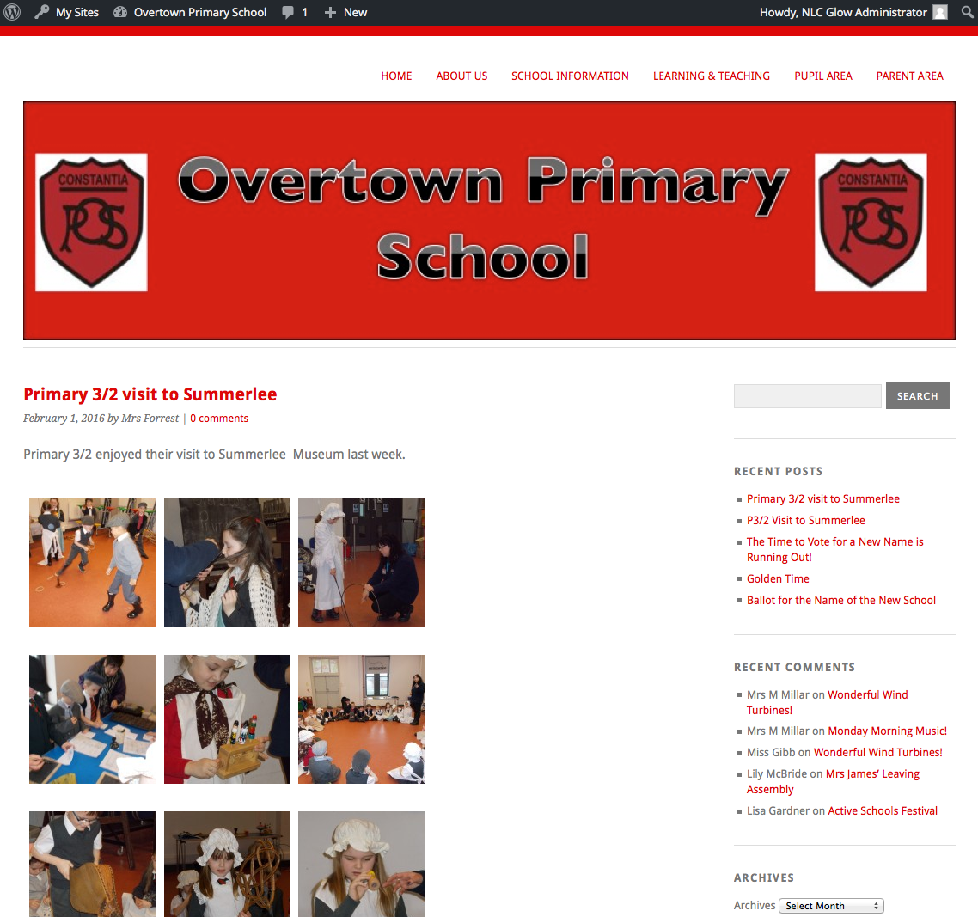
Along the top are dropdown menus that take you to the static pages on the blog. These pages will usually contain much of the general information about the school and after being set up initially they will not need changing very often.

Here you will find Widgets or web parts. These widgets allow you to show recent comments, categories etc.

The many body of the page will show the blog Posts.
The posts usually will contain information about news and events and achievements and awards for all the classes of the school. It is likely that all teachers in a school will add posts to the blog.

Adding Content to Blog Pages
There are a couple of different ways of accessing the blog pages to add content to them.
- Use the drop down menus, choose a section and a page and when the page loads click on Edit.

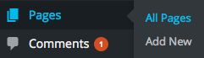
- Go into the Dashboard of the Blog and in the sidebar click on Pages and then All Pages.
Click on the Title of the page you want to edit and it will open.

You add content to posts and pages in the same way except you don’t have to name your page as it is already made

Creating a New Post
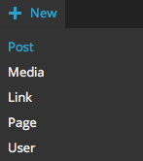
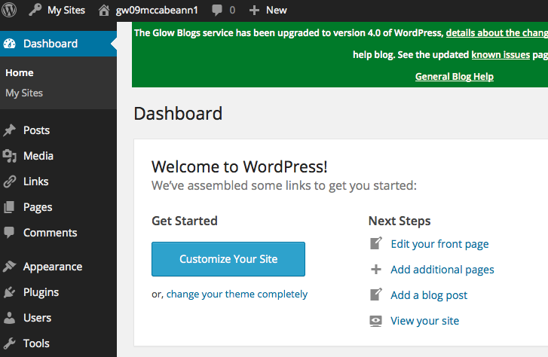
In the right hand side of your blog page click on Site Admin. You will be taken to the dashboard of your blog.
To add a New Post either click on Add a Blog Post in the Next Steps section or click on +New and choose Post from the drop down list.

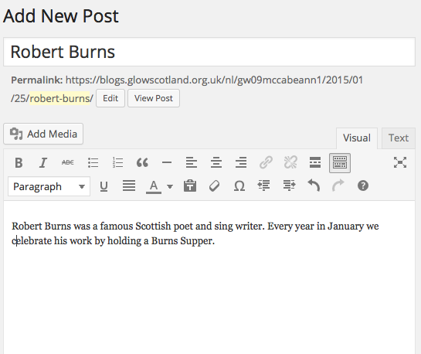
Add in a Title.

Add your text in this area.

Click on Add Media.
Not every post you write in your blog will have a picture.
You must make sure that any picture you add to your blog does not break copyright.

You are okay to use:
- Photographs you or your pupils have taken
- Clipart that has been especially created for schools such as LTS Clipart.
- Clipart that is free to use such as the wpclipart 5.0 files in the pictures folder on a school computer.

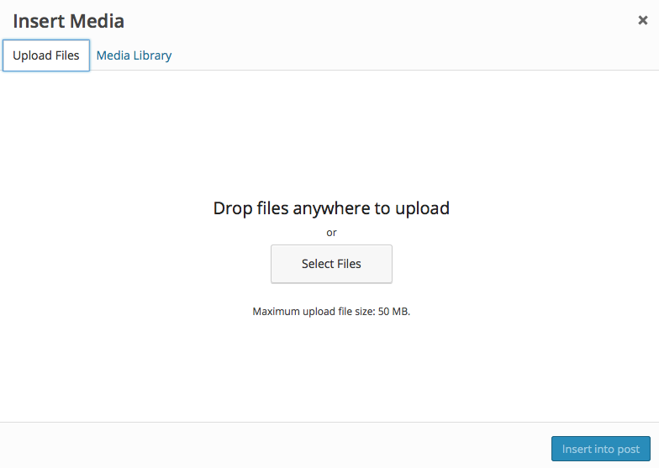
Click on the Upload Files Tab.
Either drag your file here or click Select Files and navigate to your picture.

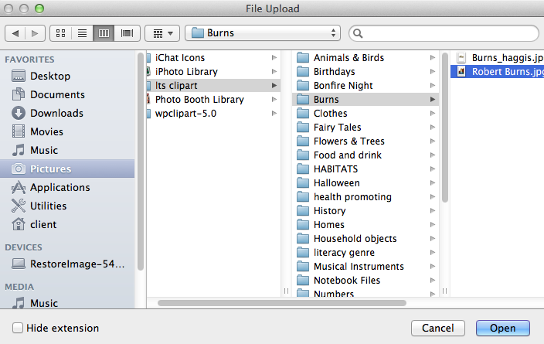
Click on the file to select it and then click Open.

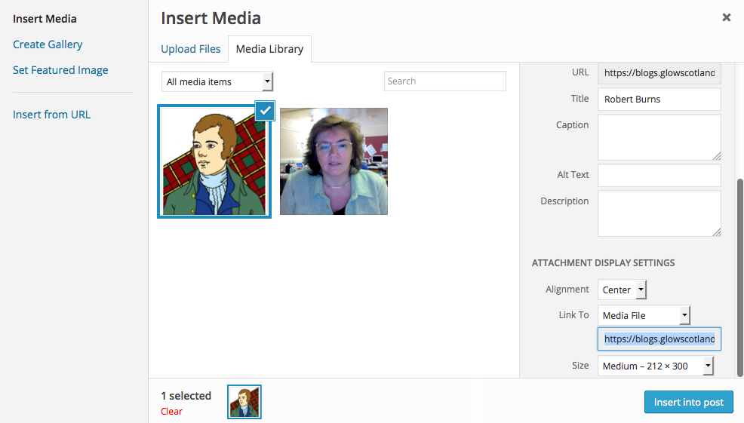
Make sure your image alignment is set to Center and the size is set to Medium.

Click on Insert into Post.

If you delete a graphic by accident from a post click on the Add Media icon again then click on the Media Library Tab, find the image you need and click on Insert into Post.

Categorising
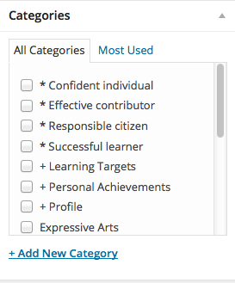
To make it easier for users to find the posts that interest them whoever set up your blog may have added in Category sections.

Categories
Tick one or more categories from the list shown.
You will need to think about what categories your
piece of writing is suitable for.

Check your work over before you click on Publish

It should have
- A title
- A picture if required
- A piece of text
- One or more categories ticked
Once your work is saved the Publish button will disappear and an Update button will appear instead.

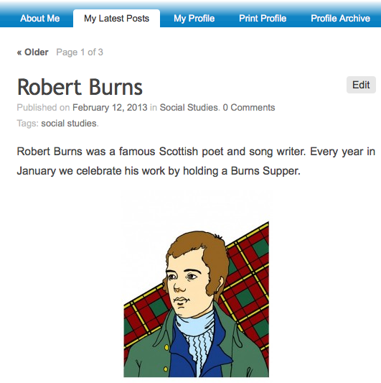
View your post

Click on your blog name in the top left hand area of the screen.

The post will show when it was created, what category it is in, and whether it has any comments.

Most of the time you will want to create a New Post – make sure you don’t select New Page by mistake .

Adding Media to your Posts
You already know how to add an image to your posts.
Now we are going to look at adding other kinds of media to posts.
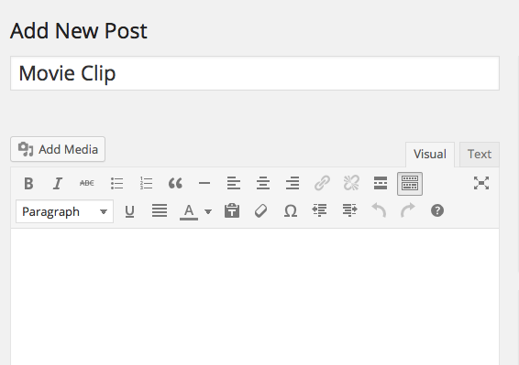
Adding a Movie Clip to a post
Click on New Post
Add a title
Click on Add Media.

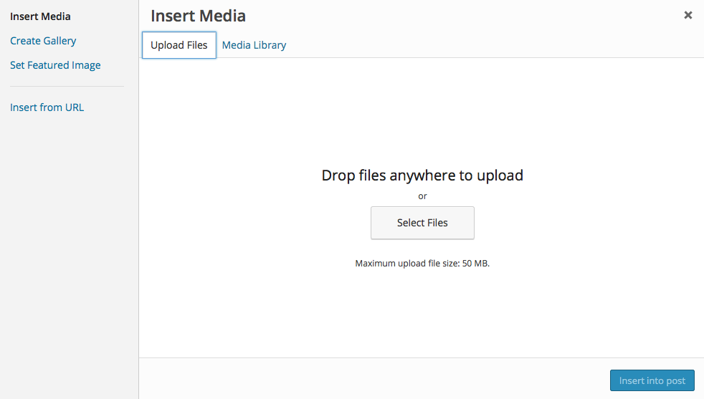
Click on Upload Files tab
Either drag files into place or click on Select Files

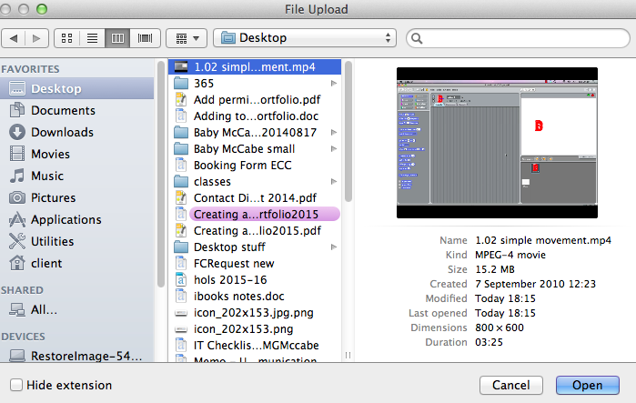

Navigate to where your video file is stored.
You can add many different types of video files to your post but the files must be smaller than 50mb in size.
Click on your file to select it and click Open.

Accepted file types in Wordpress
http://en.support.wordpress.com/accepted-filetypes/

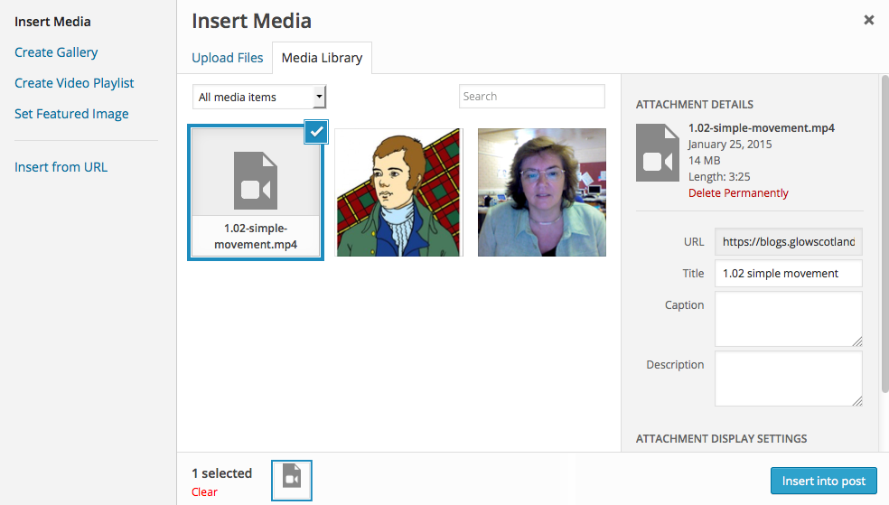
Click Insert into Post.

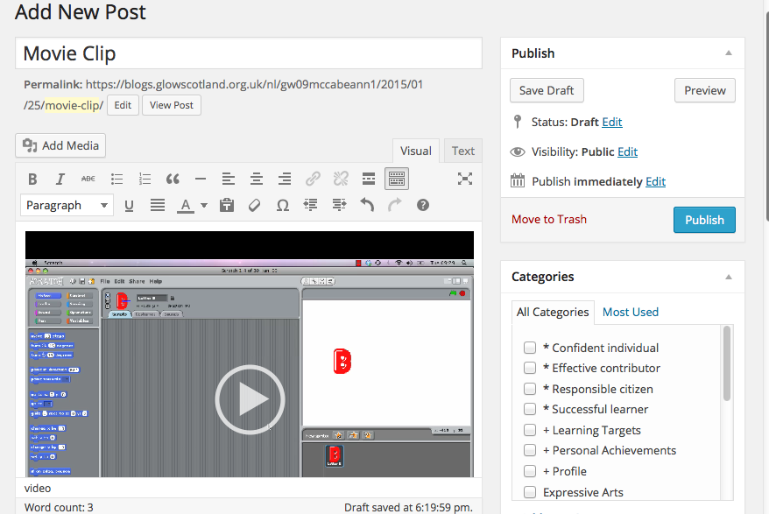
Depending on your browser the movie will either appear in your post or appear as a link in your post.
You can add text in the post as well if you wish.

.

Categorise your post and then click Publish.

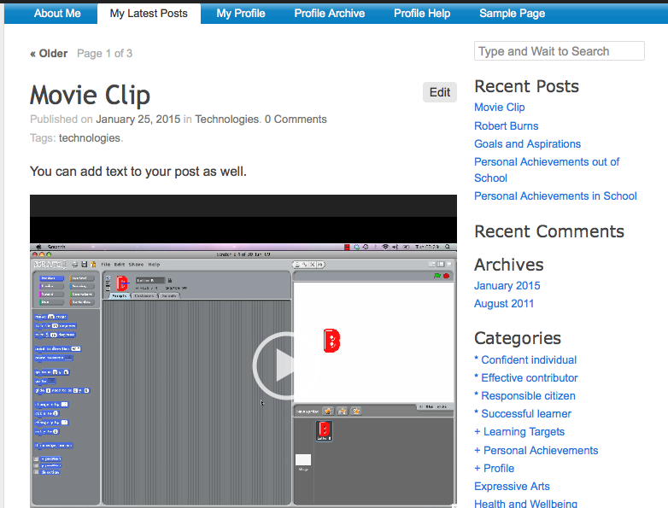
Click on your blog name at the top left hand side of the screen to go and view your post

Your post will be displayed like this.

Click the Play button to view the movie.

Adding an MP3 file to your post
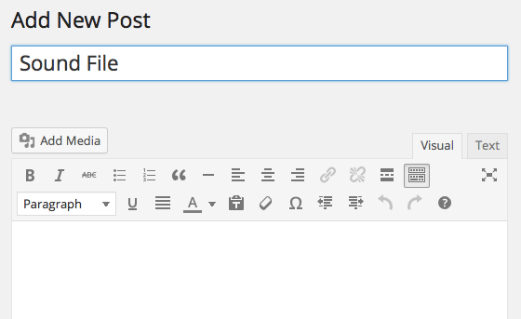
Click on New Post
Add a title
Click Add Media

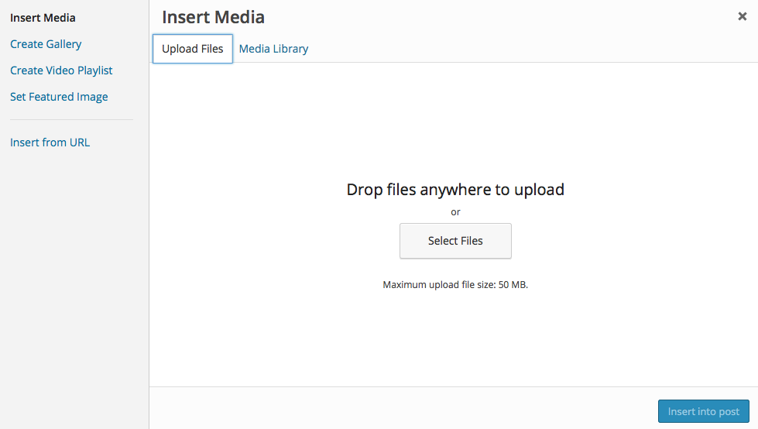
Click on Upload Files tab
Either drag files into place or click on Select Files

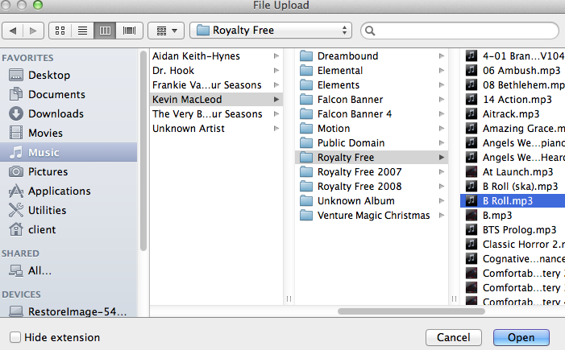
Navigate to where your audio file is stored.
The file must be smaller than 50mb in size and be in mp3 format.
Click on your file to select it and click Open.

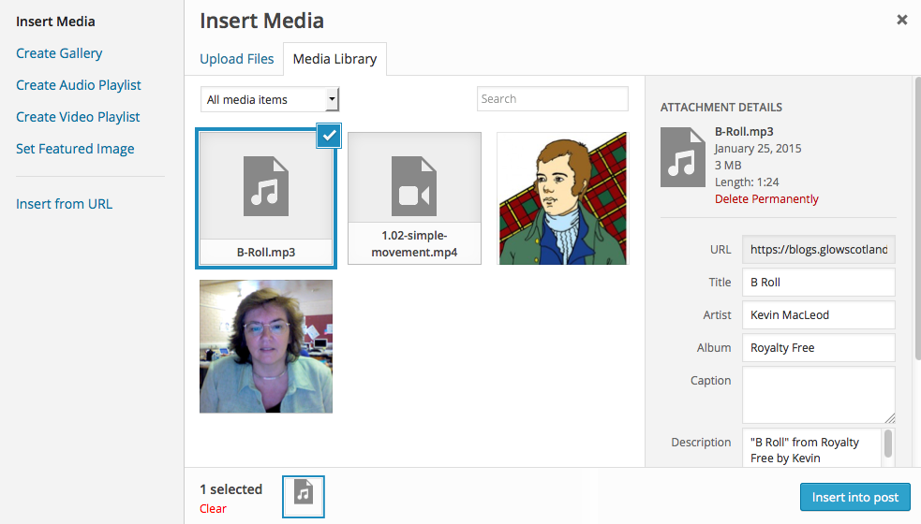
Click Insert into Post

You can also add text to your post if you wish.

Categorise your post and then click Publish.
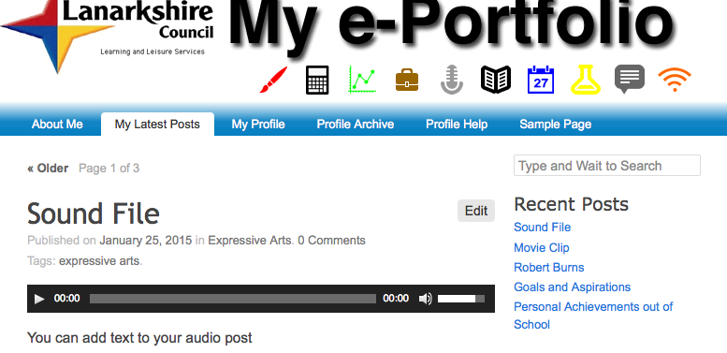
Visit your blog
Your file will appear like this.
Click the play button and the mp3 file will begin to play.

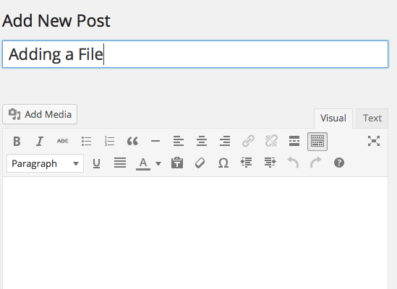
Attaching Documents to your blog
You can attach other files such as Word and PowerPoint documents and pdfs.
Before you start make sure the file has a sensible name as the name of the file will be the link people see.
Click on New Post
Add a title
Click Add Media

Click on Upload Files tab
Either drag files into place or click on Select Files

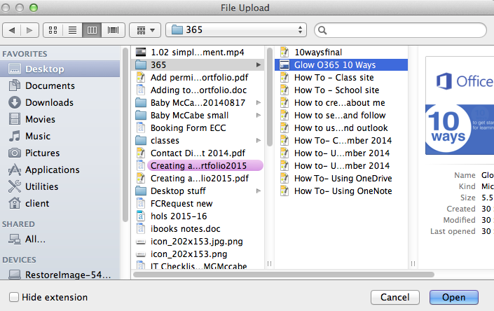
Navigate to where your media file is stored.
The file must be smaller than 50mb in size.
Click on your file to select it and click Open.

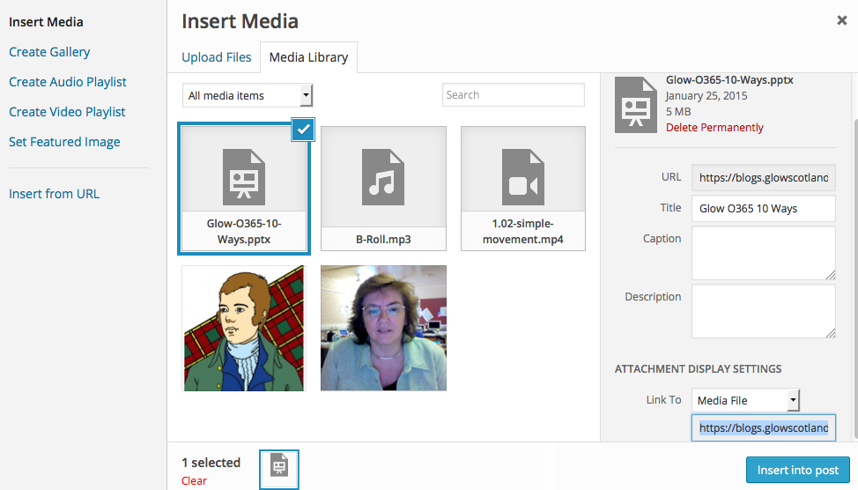

Click Insert into Post.

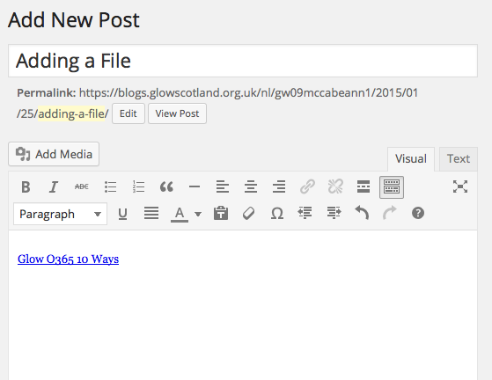

You will not see the file displayed in your post. You will only see its title.

Categorise your post and then click Publish.

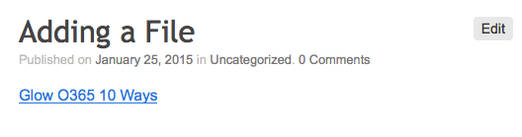
Visit your blog
Your file will appear like this.

Click on the file name. In some cases a copy of the file will download on your computer. You will need to have the correct software available on your computer to open that type of file. In other cases the file may open in your Internet Browser

Adding a Gallery of Photos to your Post

Image Galleries allow you to display a grid of photo thumbnails that link to fullsized versions. If used with the lightbox plugin the larger images will be displayed without leaving the webpage and can be browsed through easily with mouse or arrow keys.

It is a good idea to resize your photos to a reasonable size before adding lots of photos to your blog.

Click on New Post
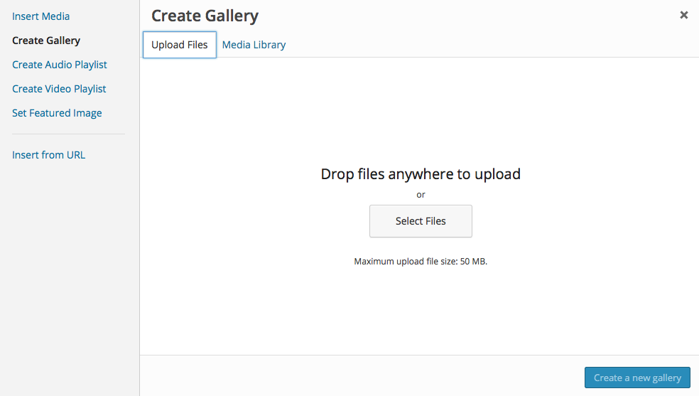
Add in a Title.
Enter any text you want in the post.
Click Add Media

Click Create Gallery in the Sidebar and then click on the Upload Files Tab.

Drag your files into place or click Select Files and navigate to where your pictures are stored.
You need to select all the files you want.
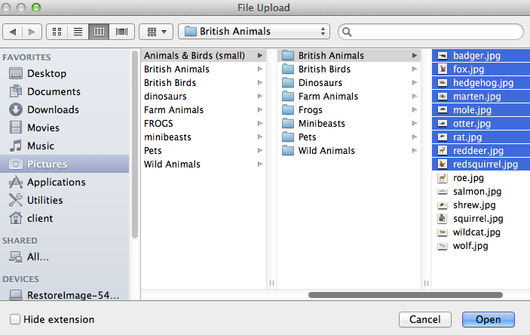
If the files are in a list like this you can click on the top file and then holding down the shift key click on the bottom file.
If the files are not together cmd or ctrl click on all the files you need.
When all the files you want are selected click Open.

You will see progress bars on the image thumbnails as they upload.
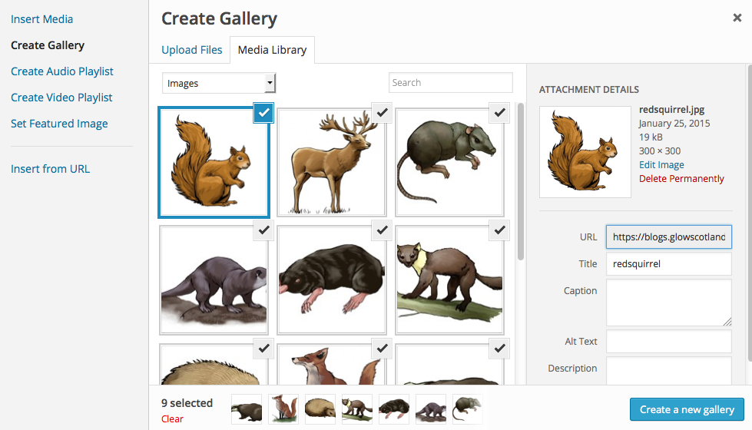
Click Create a new gallery.

You can add captions to each image if you wish.
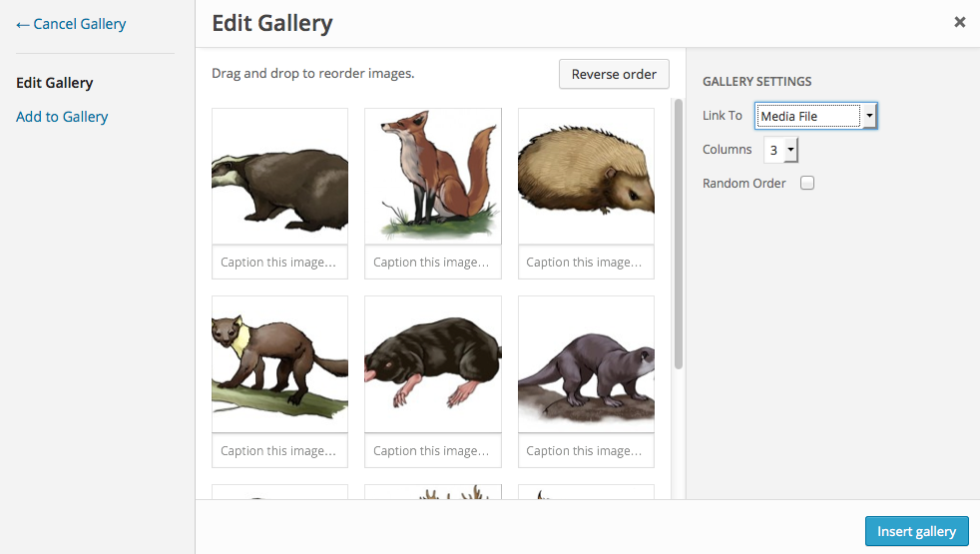
Make the changes you want to the Gallery Settings.

Make sure Link thumbnails to Media File is selected.

Choose a number of columns – 2 or 3 columns will produce the best results.

Click Insert Gallery.

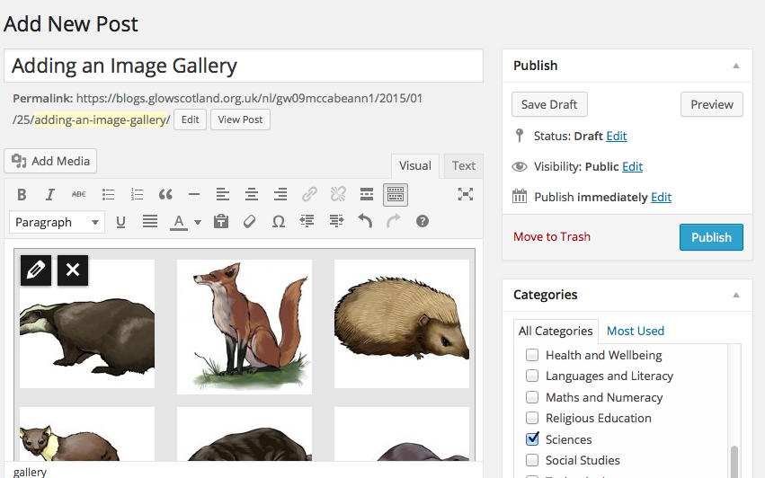
If you select the gallery with the mouse you will see a pencil icon and an x. Clicking the pencil icon will open the Gallery editor again, allowing you to change the settings and add images.
Categorise your post and click Publish.

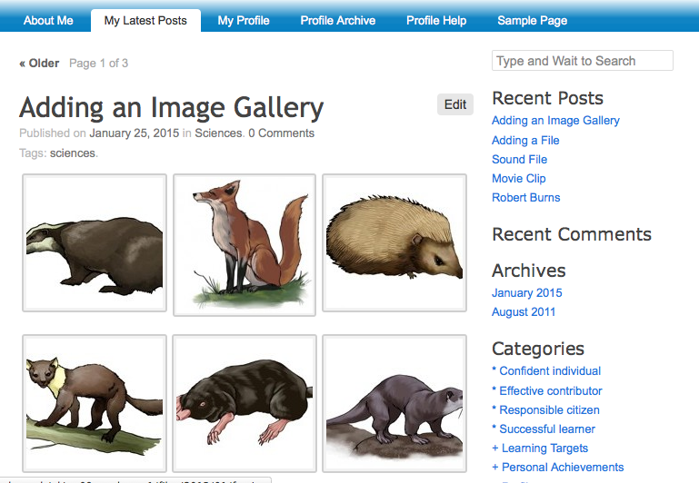
Visit your blog to view your Gallery.

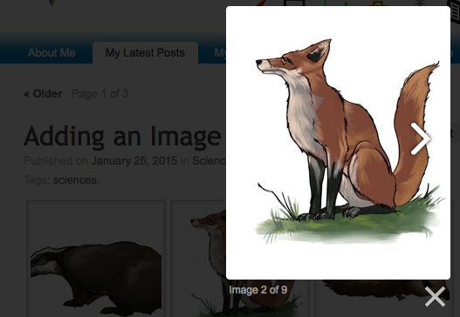
Clicking on the thumbnails will show the full-sized pictures you can click the left & right sides of the images to move through the gallery.
You can also use the arrow keys on your computer keyboard to move through the images.

Adding a Link
You may want in a post to link to another page in your blog, to a specific post in your blog or to an external website.
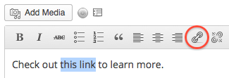
To do this
In your post enter the text you wish to make your link
Highlight the link text.
Click the link button on the toolbar.

In the popup that appears, enter the URL you want to link to.
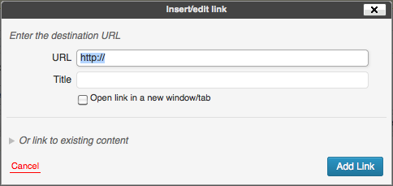
URL: The URL of the link (include http:// at the start for external websites)
Title (Optional): Title of the link when a visitor hovers over it (a small tooltip will appear with the title)
Open Link in a New Window/Tab: If this box is checked clicking on your link will open up a new window/tab.
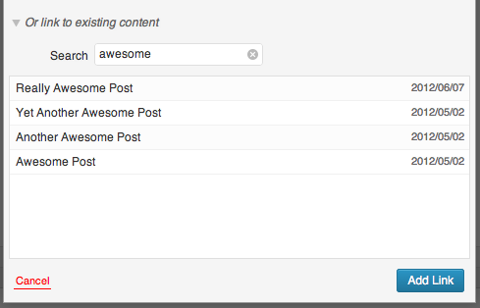
Or, if you want to link to one of your existing posts or pages choose Or link to existing content and use the search box to quickly find what you’re looking for. Simply enter a keyword or two that appears somewhere on the post or page you want to link to.

Click the title of the post or page you want to link to, and the URL and Title fields will be filled in automatically.

After you’ve entered the URL, click Add Link.
The highlighted text will be underlined and blue to let you that it is linked.

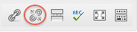
Removing Links
To remove a link, highlight the text and click the broken link icon:

Comments

Users can comment on any post in the school blogs
Administrator’s comments appear instantly in the blog.
If you have set the permissions on a blog to allow users to comment on posts the comments do not appear until they have been authorised by the owner of the blog or by a administrator.
Adding a comment to a post
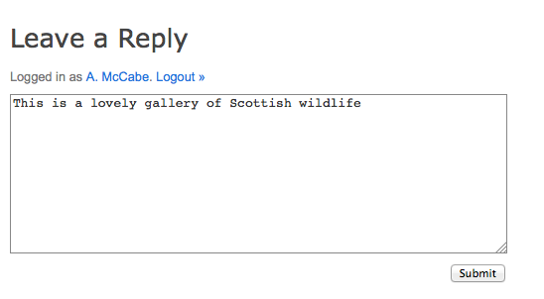
- Once you have found the post you would like to comment on click on the title of the post.
- This will take you to the post. Underneath the title there is a link for Comments which you can click on. There will be a box where you can type your comment for the pupil.
- Click on Submit when you are happy with your comment and this will appear in the pupil’s e-portfolio underneath the appropriate post.
Depending on how your blog has been set up you may be able to use the right-hand menu to check in the Recent Comments section to go to a comment and read it.

