Adding a Gallery of Photos to your Post

Image Galleries allow you to display a grid of photo thumbnails that link to fullsized versions. If used with the lightbox plugin the larger images will be displayed without leaving the webpage and can be browsed through easily with mouse or arrow keys.

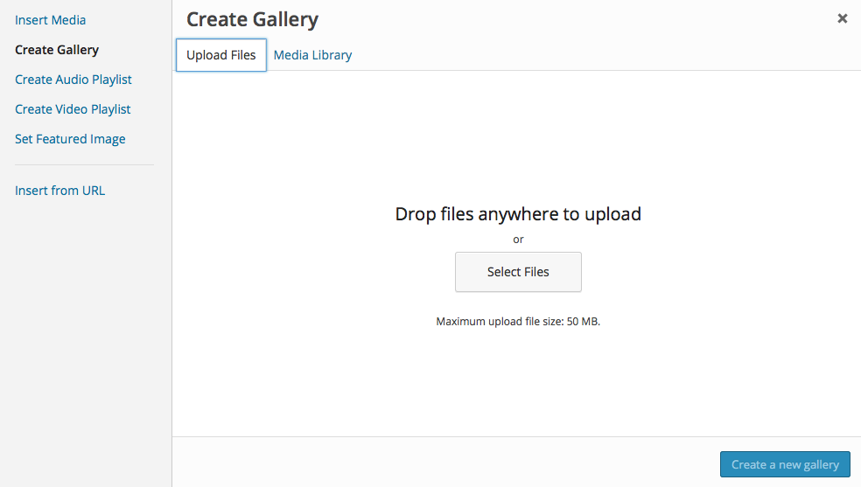
Click on New Post
Add in a Title.
Enter any text you want in the post.
Click Add Media

Click Create Gallery in the Sidebar and then click on the Upload Files Tab.

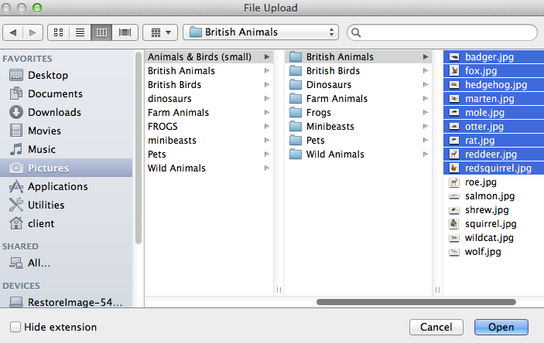
Drag your files into place or click Select Files and navigate to where your pictures are stored.
You need to select all the files you want.

If the files are in a list like this you can click on the top file and then holding down the shift key click on the bottom file.
If the files are not together cmd or ctrl click on all the files you need.
When all the files you want are selected click Open.

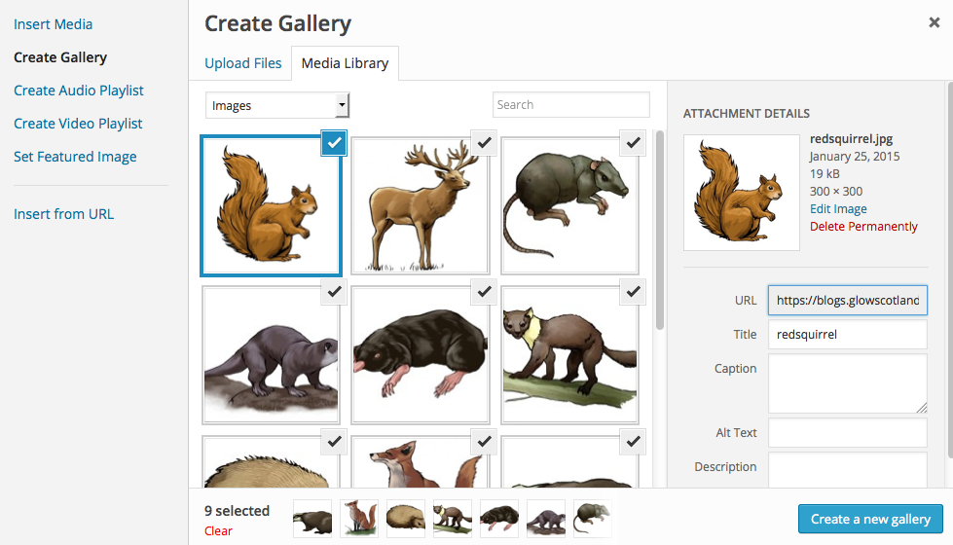
You will see progress bars on the image thumbnails as they upload.

Click Create a new gallery.

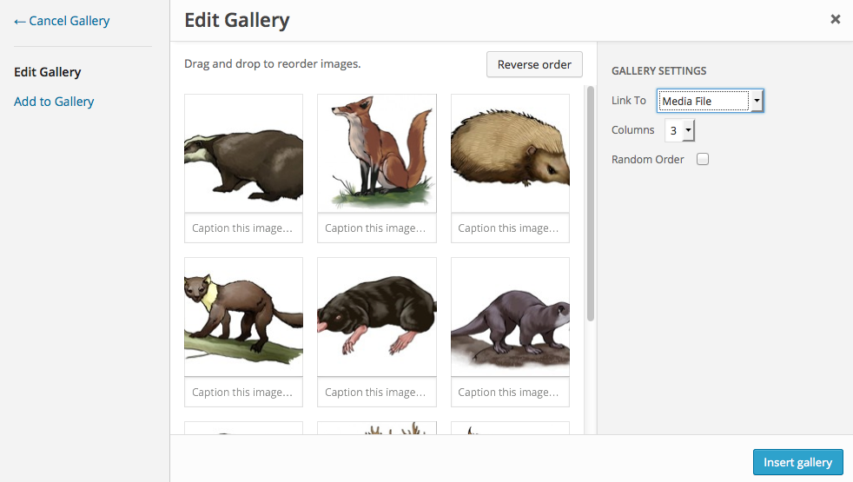
Make the changes you want to the Gallery Settings.

You can add captions to each image in turn if you wish.

Make sure Link thumbnails to Media File is selected.

Choose a number of columns – 2 or 3 columns will produce the best results.

Click Insert Gallery.

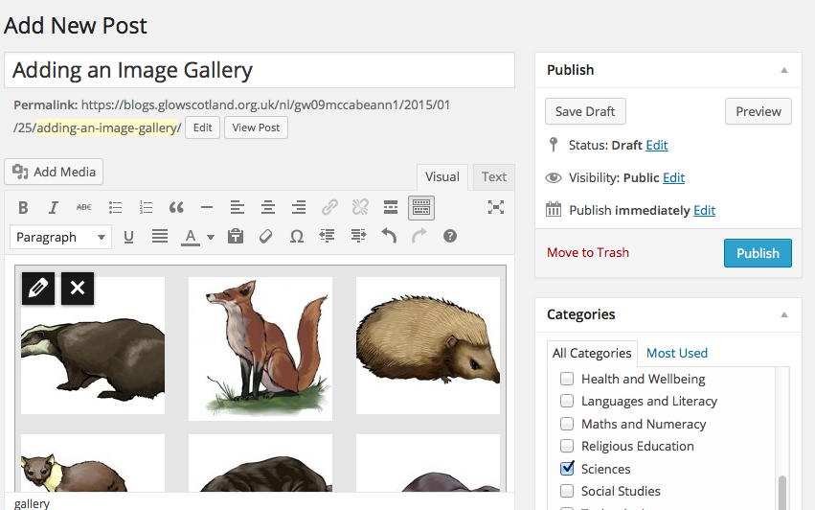
If you select the gallery with the mouse you will see a pencil icon and an x. Clicking the pencil icon will open the Gallery editor again, allowing you to change the settings and add images.
Categorise your post and click Publish.

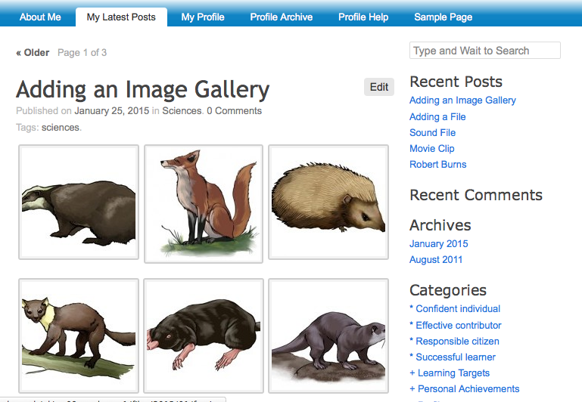

Visit your blog to view your Gallery.

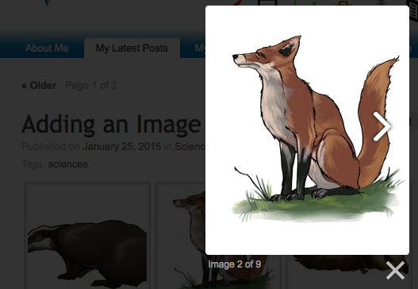
Clicking on the thumbnails will show the full-sized pictures you can click the left & right sides of the images to move through the gallery.
You can also use the arrow keys on your computer keyboard to move through the images.

Some browsers do not support this feature.

If you have activated the Jetpack plugin it can have a slideshow feature activated (Jetpack – Settings – activate Shortcode embeds). This is useful if you want to upload 20 photos of your new P1s but don’t want parents having to scroll down a long page containing 20 photos.
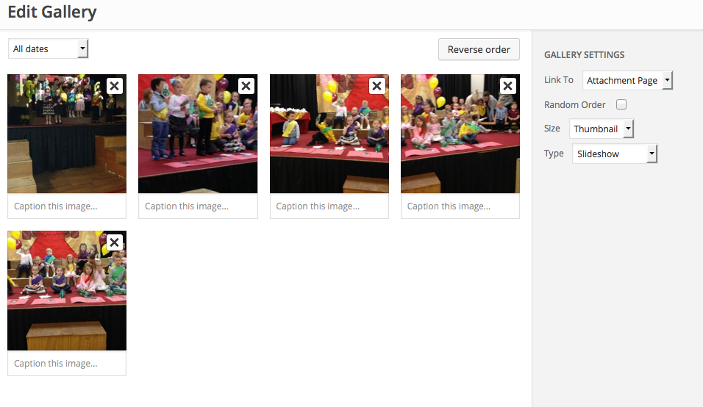
At the Gallery Settings section you can choose under Type either thumbnail grid or Slideshow

