Creating a page
A page is just like a post except it is not in the chronological flow of the posts. Pages are often used for About or contact information. Blogs that are setup as school websites often uses pages as these can be organised into groups and hierarchies.

1. Log on to your blog dashboard
Click on Site Admin in the sidebar of your blog.
If you are not logged into glow you will be redirected to the glow logon screen
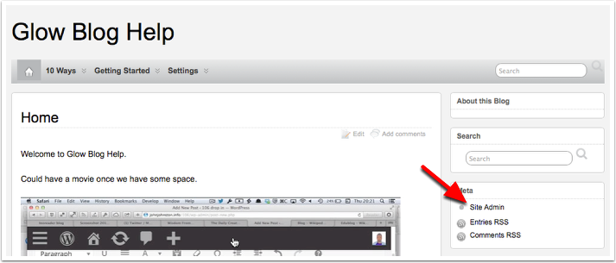

2. New Page
Once in the Dashboard you can create a new page from the Popup button on the top right of the Dashboard [1]
Or click on Pages [2] in the left hand navigation and then Add New[3]
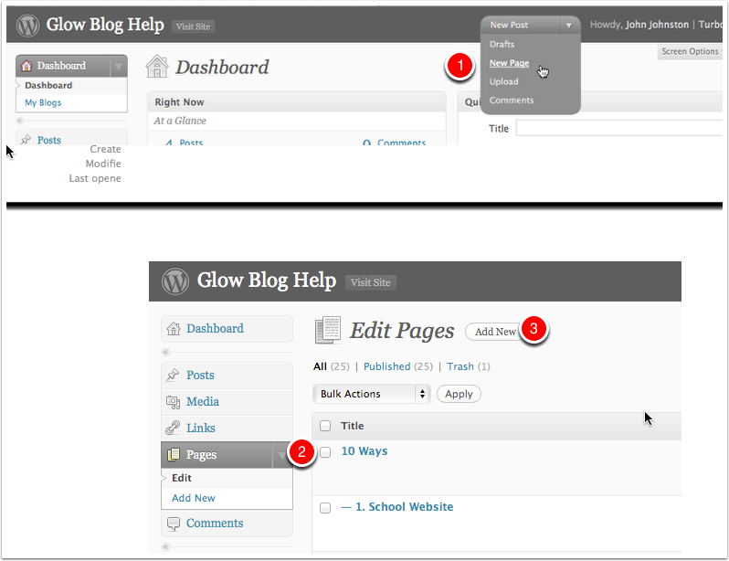

3. Editing the New Page
Pages are edited in the same way as posts and support the same features, you can add, links, embed images and media etc.
When you are ready to publish the page you do it in the same way as for posts, you click Publish.
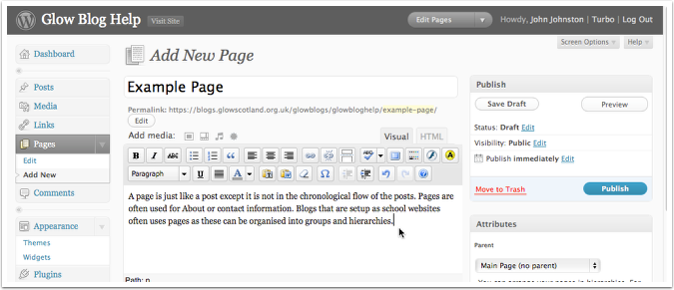

4. Page Attributes
These can help organise your pages and structure your site. If your site supports pages in menus it may display child pages under the parent in drop down menus.
Templates may be available, depending on theme, that will affect the appearance or layout of a page.
The order will affect the order of pages in the list, if you add the Pages widget or in menus if your theme supports them.
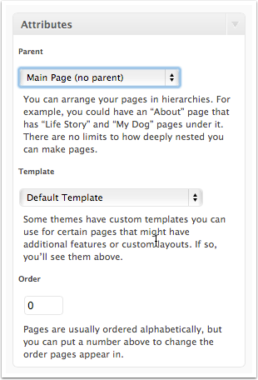

5. Comments
Like posts pages support commenting, it may not be appropriate to have comments on pages and you can turn them off at the bottom of the Page Editor.
