Widgets
Widgets are used to add features and functionality to the sidebar (usually) of your blog. Widget placement is dependent on themes.

Widgets
This blog has just been created with a standard set of widgets.
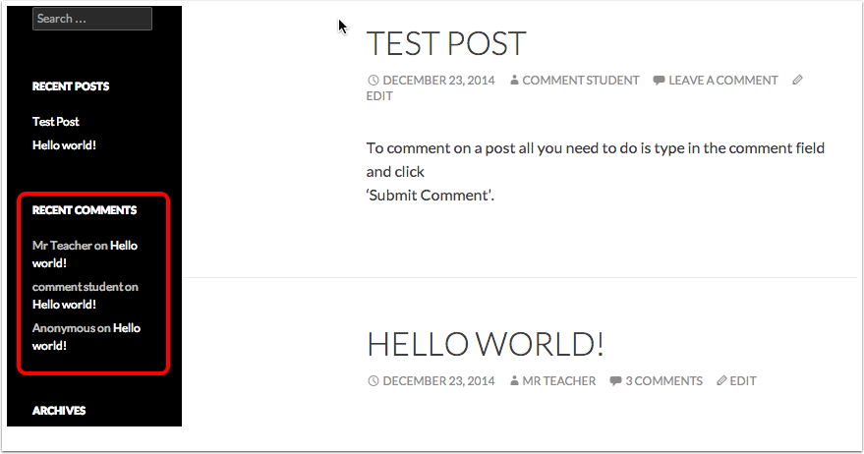

Widgets Dashboard
You can access the widget dashboard from the Appearance section. You may have to show that section using the drop down disclosure arrow.
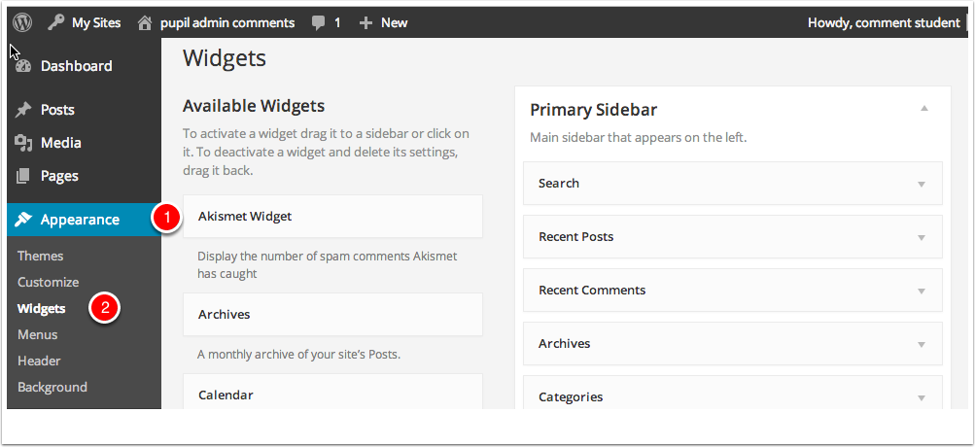

Adding Widgets
On the Widget page of your dashboard you add widgets to the sidebar by dragging them.
After adding widgets many need to be configured. For example adding a text or about widget will need some text filled in. The Widget will need to be Saved [1] too.
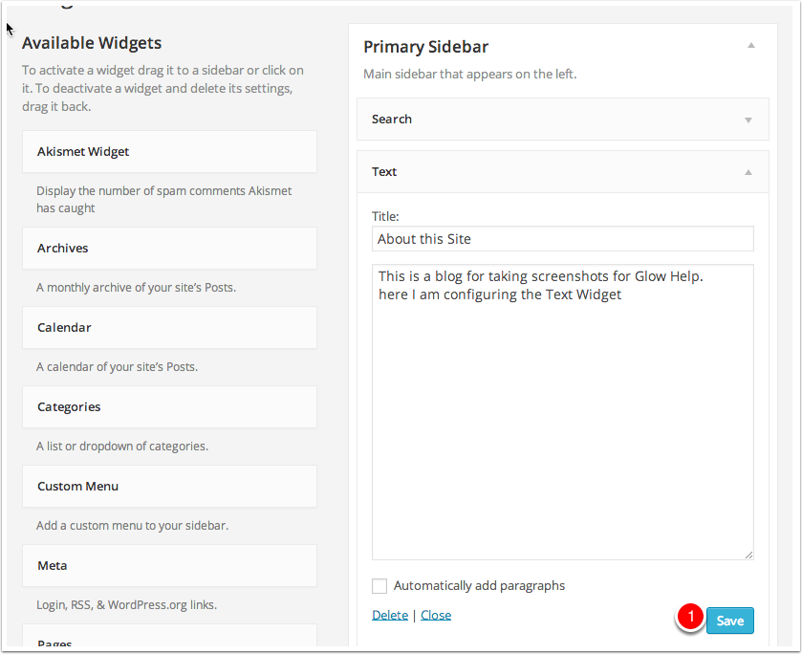

Text Widget
The above widget on the side bar. We have also added a Tag Cloud Widget.
