Glow Blogs User & Roles
In the original Glow blog the user roles were controlled by the SharePoint group that the blog was created on. In the new blogs service users are added and their roles controlled on the blogs dashboard.
Users can have different roles on a blog, these will come with different permissions:
Administrator – somebody who has access to all the administration features within a single site.
Editor – somebody who can publish and manage posts including the posts of other users.
Author – somebody who can publish and manage their own posts.
Contributor – somebody who can write and manage their own posts but cannot publish them.
Subscriber – somebody who can only manage their profile.
The Subscriber role can be used to allow Glow users to see a private blog.
The roles of Administrator and Author are the most commonly used roles.
Note: in the 'old Glow ' environment user roles were set in the Glow group the blog belonged to. This mapped roles from Glow to wordpress, the contributor role mapped to author. This can lead to confusion, if you make users contributors in Wordpress they will not be able to publish the posts that they create.

Add Users Dashboard
On the Dashboard the Add Users screen is accessed from the Users section of the left hand navigation, you may have to expand the Users section by clicking on Users [1] before clicking Add Users [2].
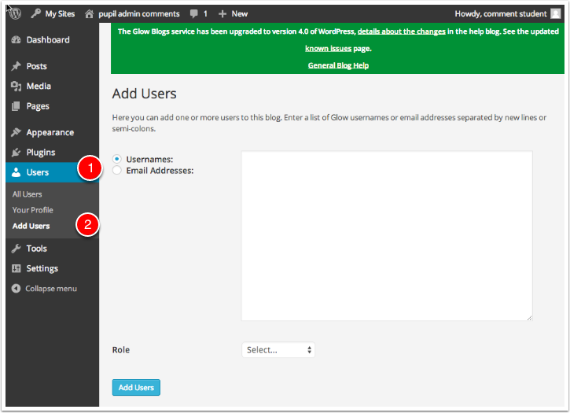

Add Users
To add users you
- Type or paste the list of users you want to add to the blog into the username fields. Alternatively you can use an email address if they have already logged on to Wordpress and added an email. At this time it is best to avoid using the Email Address option. At the time of writing we believe that the username is the best option, there may be problems with how we are dealing with email addresses.
- Choose the Wordpress role you want those users to have from the popup.
- Click Add Users
You will see a message at the top of the Add Users screen.
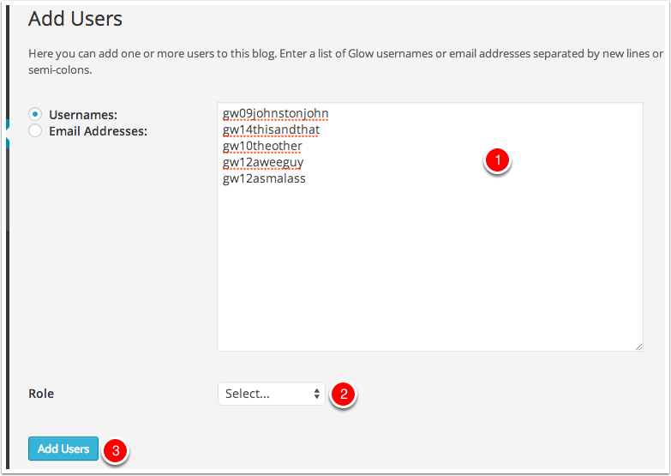

Users Authors & Users
After users have been added to the blog they can be managed from the Authors & Users screen [1].
You can view information about the users and change or remove their role on the blog.
Users that have been added who have not visited and logged into the blogs are added as pending [2]. Glow users will have the account on the blogs service created when they visit the blog home page for their LA after clicking the tile in RM Unify or by logging on by click site admin on a blog or visiting a page on a Glow only or private blog.
Administrators can remove users from their blog or change their roles on this screen.
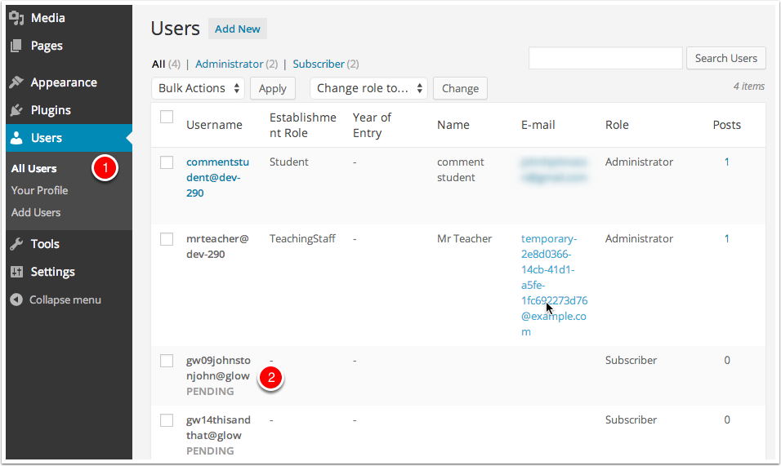

Removing a User
To remove a user:
- Check the box beside their name (you can delete multiple users at once) [1]
- Select Remove from the Bulk Actions pop up [2]
- Click Apply [3].
You will be taken to the Delete Users screen where you can make decisions to delete the posts from the user or attribute then to another user.
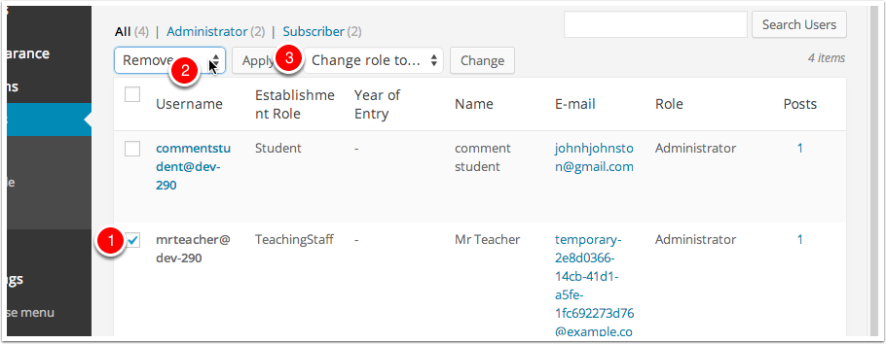

Changing a Users Role
To change a users role
- Check the box beside their name (you can change multiple users at once) [1]
- Select a new role from the Change role to... pop up. [2]
- Click Change.[3]
