Creating a blog
This document covers the new service using Wordpress 4.0
You need to be aware of several things factors you create a blog. The settings involved can be changed at a later date.
Any Glow user can create a blog.
A blog can be public, private or Glow only. A public blog can be viewed by anyone with an internet connection. A private blog can only be viewed by users with a Wordpress role on the blog. A Glow only blog can only be viewed by a Glow user who is logged onto glow.
Only a Glow user who has a teacher or non-teaching staff Glow account can make a blog public. A pupil can create a blog and make it either private or Glow only. If a pupil wants to have a public blog they need to give a member of staff an administrator role on their blog, that staff member can then make the blog public.
Users should consider the consequences publishing to a public blog. Publishing publicly can give pupils a real audience for their work, make tasks more authentic but they need to be aware internet safety and data protection issues.
Users can have different roles on a blog, these will come with different permissions:
Administrator – somebody who has access to all the administration features within a single site.
Editor – somebody who can publish and manage posts including the posts of other users.
Author – somebody who can publish and manage their own posts.
Contributor – somebody who can write and manage their own posts but cannot publish them.
Subscriber – somebody who can only manage their profile.
The roles of Administrator and Author are the most commonly used roles.
Note: in the 'old glow' envirnoment user roles were set in the Glow group the blog belonged to. This mapped roles from Glow to wordpress, the contributor role mapped to author. This can lead to confusion, if you make users contributors in Wordpress they will not be able to publish the posts that they create.

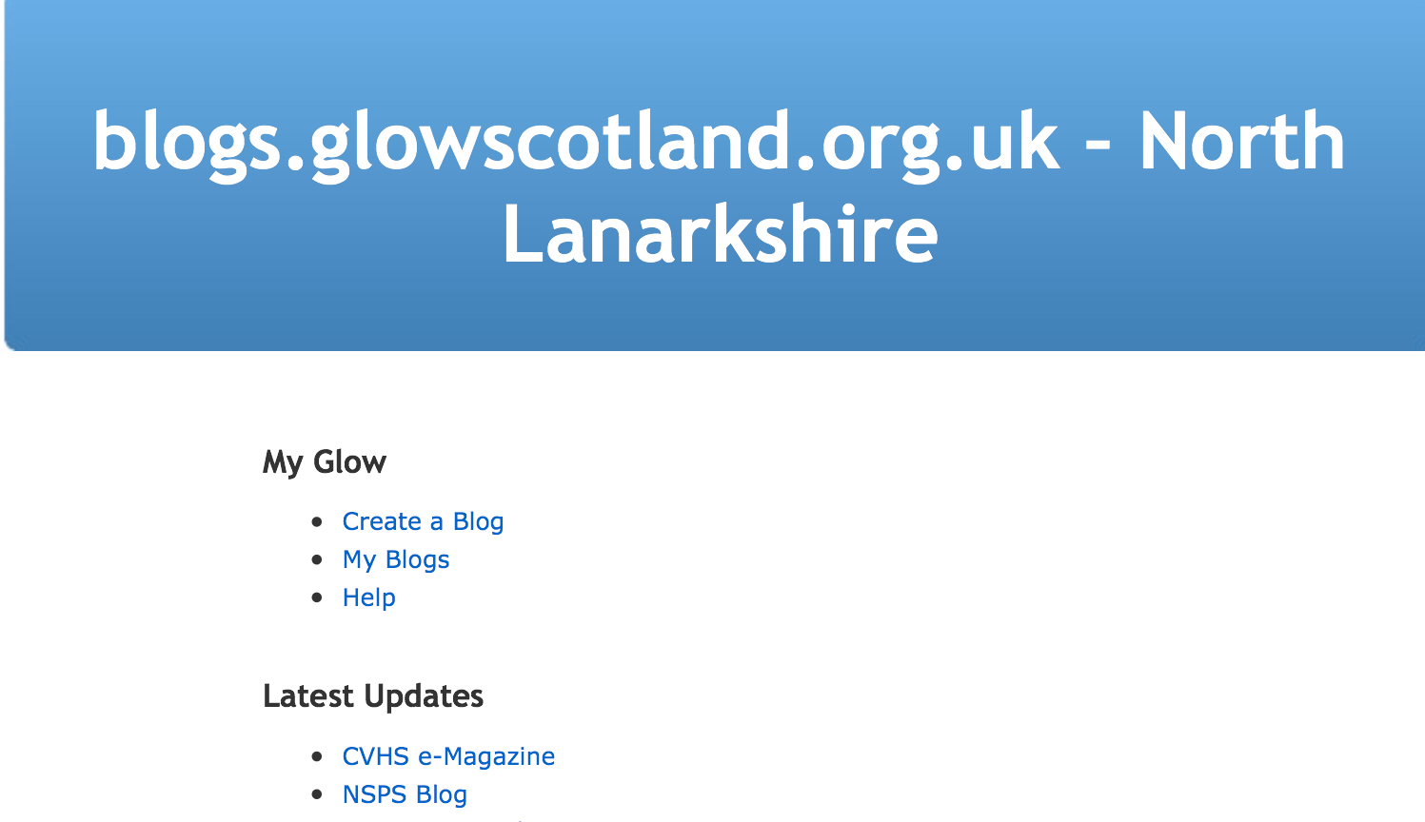
Create a Blog
To create a blog you log onto Glow and click on the blogs tile. You will go to the blog home page for your Local Authority.
Click on Create a Blog

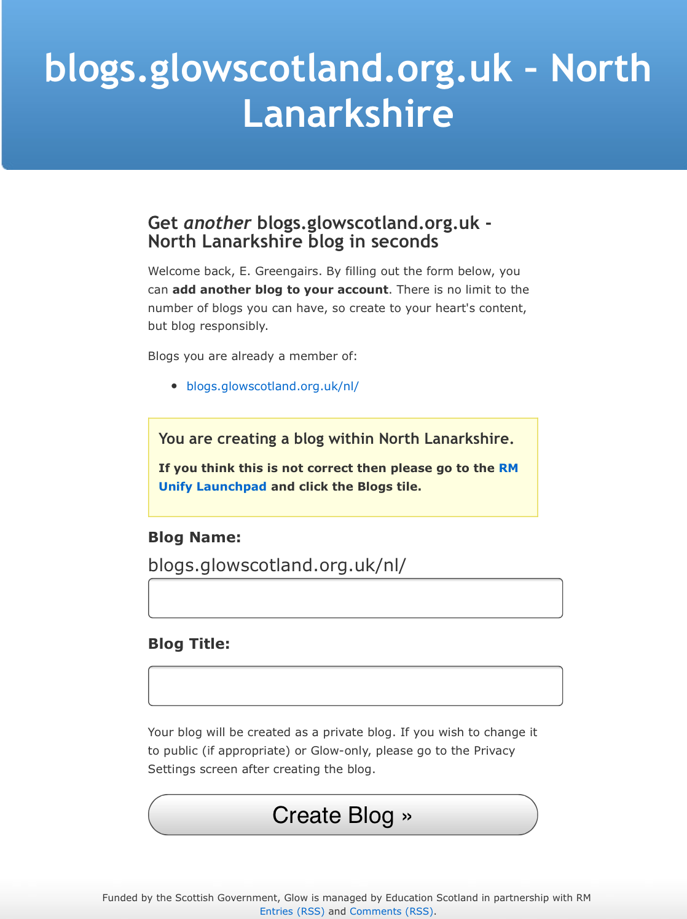
Name your blog
After clicking Create a Blog you will be taken to a page that lists the blogs you are already a member of and has fields to create a new blog.
Be aware that the fields for this are firstly the blog name as part of the url and secondly the Title of the blog. You can change the Title in the dashboard of your blog at any time.

Your blog will be created
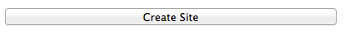
The next page will let you know the blog has been created and give you links to the blog itself and the dashboard.
Remember that your newly created blog will be private and the only person that will be able to view it will be yourself unless you change the privacy settings.
Customising your blog
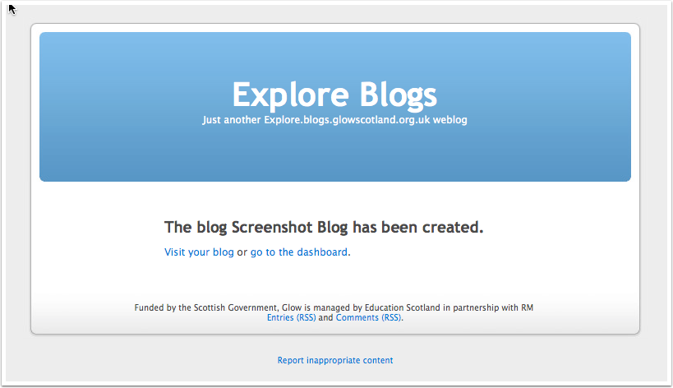
Click on Dashboard
Your blog will have the default K2 theme. This theme is very easy to use and the blue header at the top of the blog can easily be replaced with your own header image.
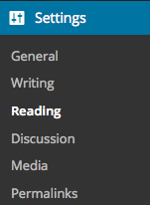
The First thing you probably want to change will be the Privacy settings especially if you want to make the blog public for parents to see.
The Settings menu is at the bottom of the left hand navigation menu.
Click on settings and then Click Reading

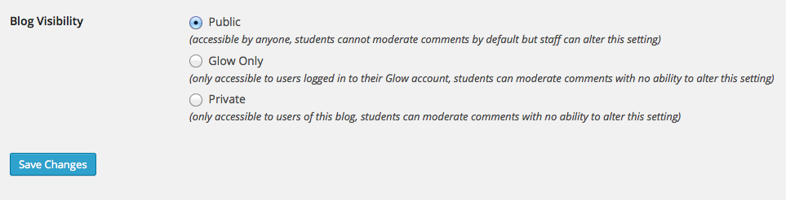
Choose the radio button for the setting you want and click Save Changes. Most of the time you will want to make your blog Public especially if you want parents to see it.
Your blog is now Public.

Adding Users & Setting Roles
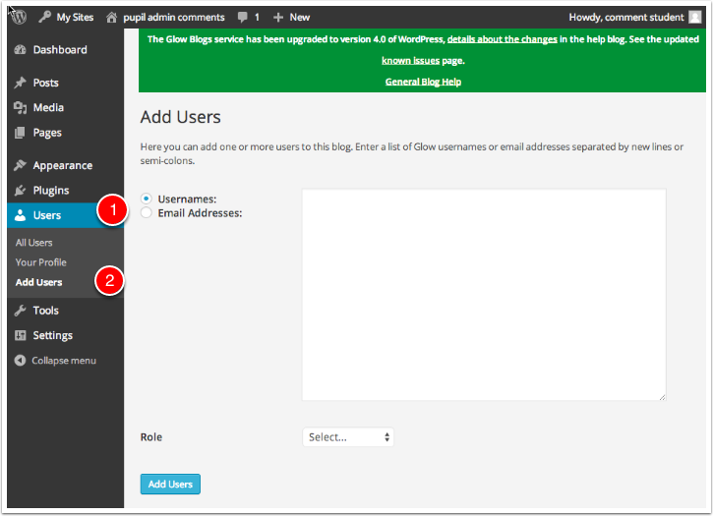
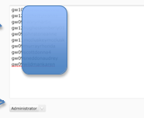
The roles of Administrator and Author are the most commonly used roles.
- Click on Users [1] in the Sidebar
- Then click Add Users [2]
To add users you:
- Type or paste the list of users you want to add to the blog into the username fields. You can use their Glow email address instead.
- Choose the Wordpress role you want those users to have from the popup.
- Click Add Users
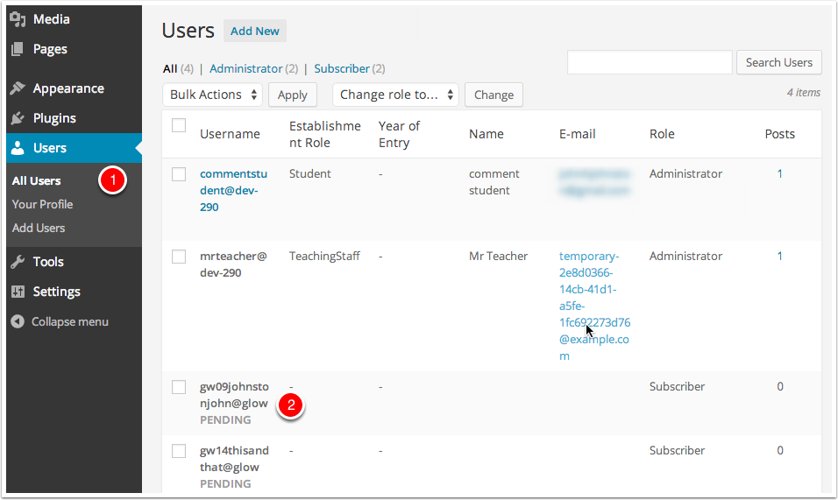
You will see a message at the top of the Add Users screen telling you users have been added.

All Users
After users have been added to the blog they can be managed from the All Users link.
You can view information about the users and change or remove their role on the blog.
Users that have been added who have not visited and logged into the blogs are added as pending [2]. Glow users will have the account on the blogs service created when they visit the blog home page for their Authority after clicking the tile in RM Unify or by logging on by clicking site admin on a blog or visiting a page on a Glow only or private blog.
Administrators can remove users from their blog or change their role on this screen.

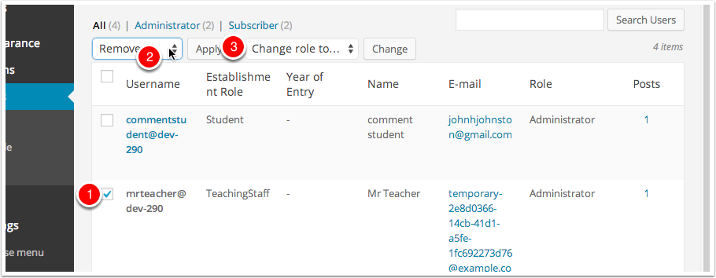
Removing a User
- Check the box beside their name (you can delete multiple users at once)
- Select Remove from the Bulk Actions pop up.
- Click Apply.
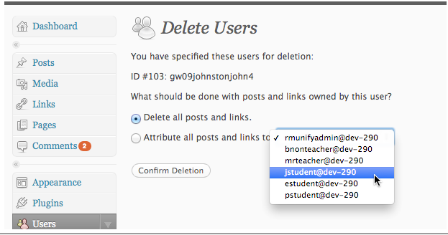
You will be taken to the Delete Users screen where you can make decisions to delete the posts from the user or attribute them to another user.

Changing a User’s Role
- Check the box beside their name (you can change multiple users at once)
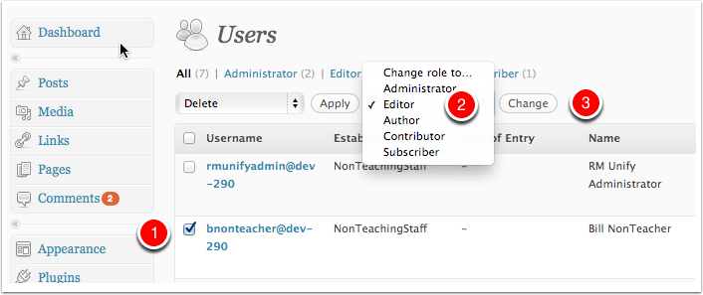
- Select a new role from the Change role to… pop up.
- Click Change.

Managing Themes
You can change the way your blog appears and functions through Themes.
When you set up a new blog it has the theme Twenty Fourteen applied as standard. Some themes are suitable for different purposes, For example the Suffusion theme provides custom templates for pages and extensive menus customisation. It is favoured for a lot of school websites.
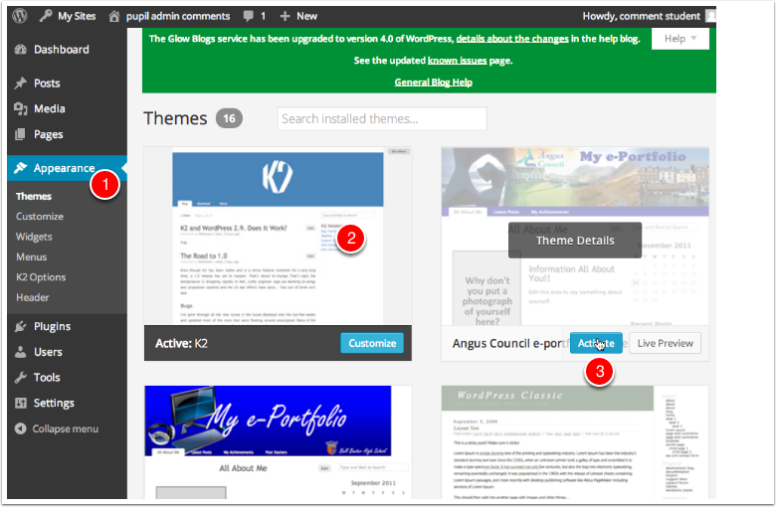
Themes are managed from the Theme page of the Appearance section of the dashboard [1].
This page shows the current theme [2] and Thumbnails of all of the other themes. You can Preview each theme and activate them from the links under each thumbnail. clicking on the thumbnail will preview that theme[3].

Adding Widgets
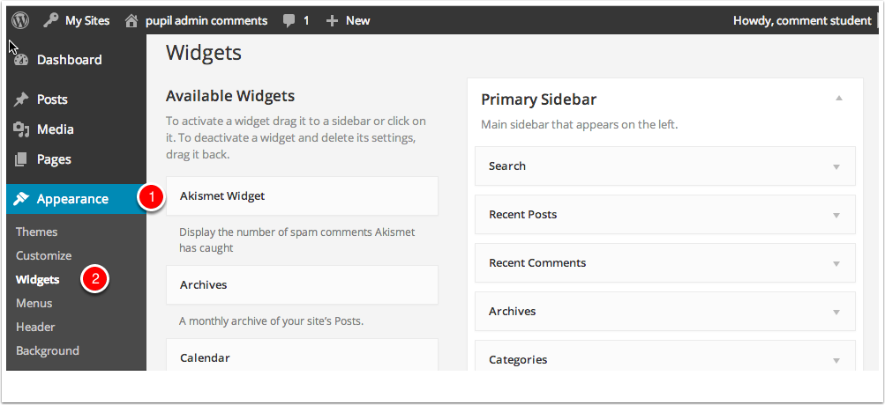
Widgets are used to add features and functionality to the sidebar (usually) of your blog. Widget placement is dependent on themes.
Widgets Dashboard
You can access the widget dashboard from the Appearance section.
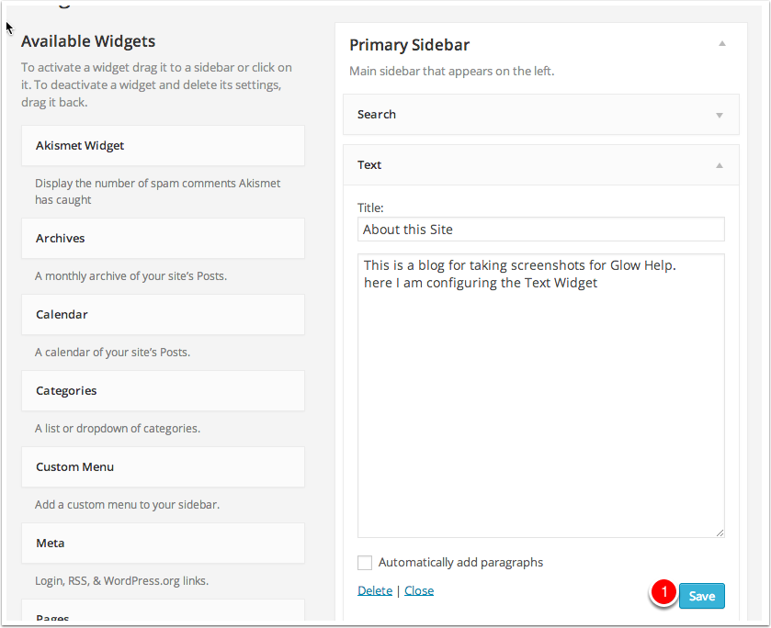
On the Widget page of your dashboard you add widgets to the sidebar by dragging them.
After adding widgets many need to be configured. For example adding a text or about widget will need some text filled in. The Widget will need to be Saved [1] too.
The Twenty Fourteen theme adds many widgets in as standard.

Some Widgets you may want to add to your blog
Text or About Widget – allows you to add in some information for your users
Recent Posts – choose number of posts to display from 5-15
Recent Comments choose number of comments to display from 5-15
Categories – will show the categories posts are organized under – useful if users only want to look for posts by a certain class or about a certain thing.
Meta – Allows staff to get into the dashboard of the blog to create posts

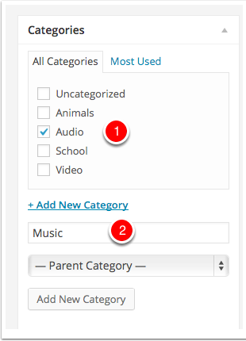
Adding Categories
Categories are powerful ways to organise your posts.
Categories can be added to a post in the post editor.
Lists of categories can be displayed in a blog widget.
Categories can be added by checking item in the Category list [1] in the Post editor. New Categories can be created in the post editor using the field at the bottom of the list[2].
Categories can be used to produce a page of posts with
the same Category.
You can add a list of Categories to the side bar by using the Categories Widget. You can do this from the Widgets page in the dashboard.

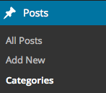
You can add several categories to your blog at one time by Clicking on Posts and then Categories in the sidebar.

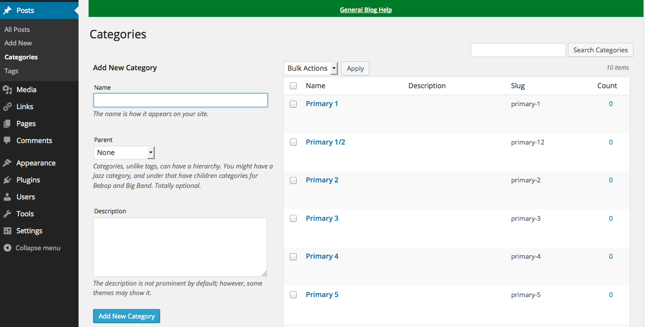
Add in a name for your Category and click on Add New Category. This is useful if at the start of setting up your blog you want to add in categories for staff to use such as class names and whole school

Plugins
Plugins are programming scripts that add additional functionality to your blog. These are often features which either enhance already available features or add them to your blog.
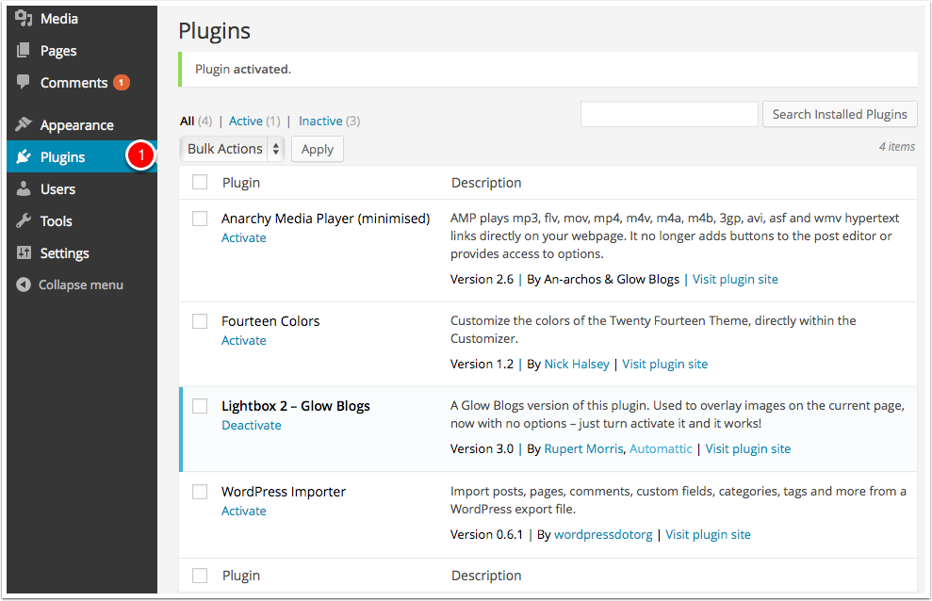
Manage plugins settings
Click on Plugins [1].

Individual plugins can be activated or deactivated with the Activate and Deactivate links that appear under the plugin name in the list.

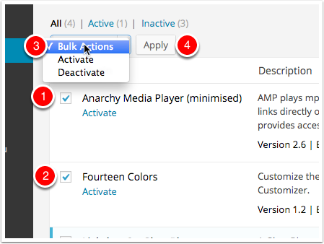
Activating several plugins
You can activate or deactivate more than one plugin at a time by checking the boxes beside their name [1 & 2].
You then choose the Action from the popup at the top of the list [3] (or the one at the bottom) and click Apply [4].
Fourteen Colors
This is a new plugin, it is used along with the new default theme TwentyFourteen. Once activated it adds settings into the Appearance-> Customise -> Colors section.
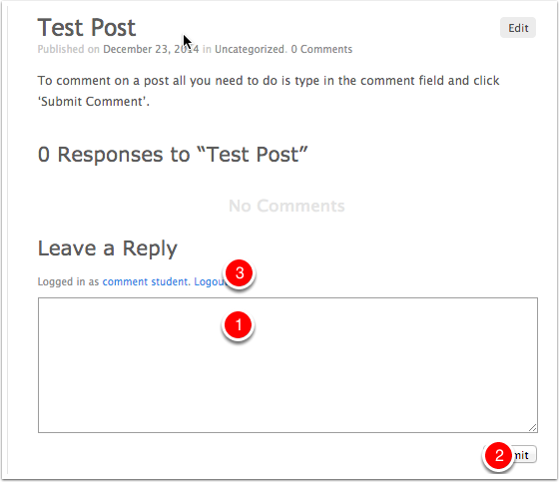
Comments
Comments allow your blogs's readers to have a discussion with you and each other.
Comments can be activated on a Page or post. Once you approve a comment, it appears underneath your content. You can allow comments to appear unmoderated or moderate them first.
To comment on a post all you need to do is type in the comment field [1] and click
'Submit Comment'[2].
You might have to fill in a name and email if you are not logged into glow [3].

Customising Header
Most of the blog themes will allow you to add your own image to the header of your blog

