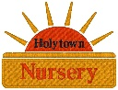

Smoking

North Lanarkshire Education Department works a No Smoking Policy in all establishments this includes vapes.

We at Holytown Nursery adhere to these guidelines. Anyone wishing to smoke must do so outside of the gates and away from the building entrances.

On returning from smoking staff must ensure they wash their hands thoroughly.

Updated March 2026 by Lindsay Kean
Review Date March 2027

Holytown Nursery Class – NO SMOKING

