Green Group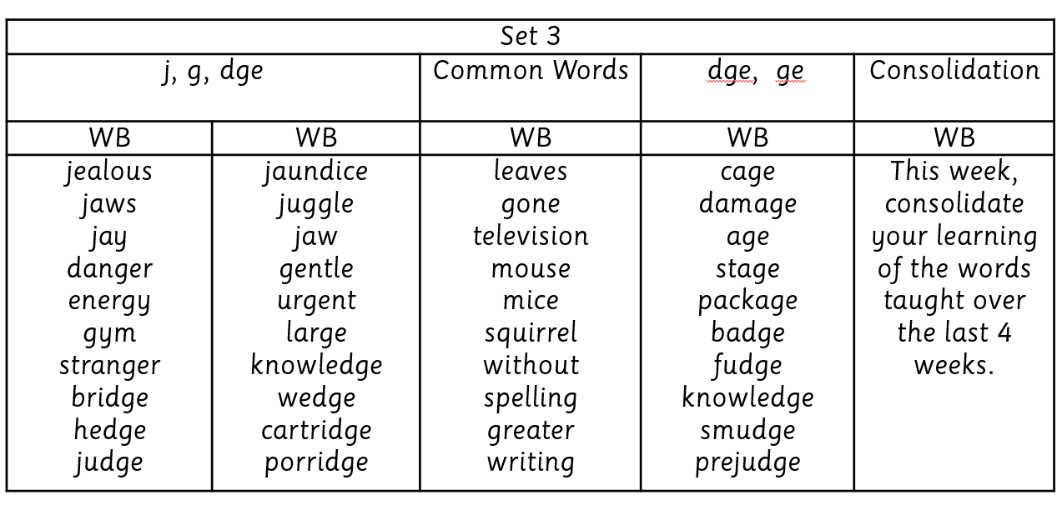
Yellow Group
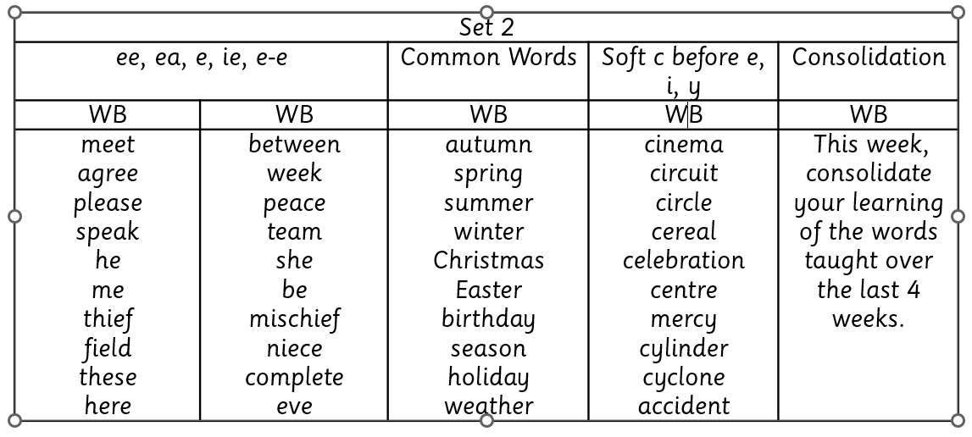
Red Group
Spelling lists in tub sent home.

