


Homework Grid P5/4 – October 2026
Must do tasks -
Literacy - Spelling    Please ensure that you are learning your spelling words and can read, write and spell these accurately.  These have been placed in your spelling wallet. | Literacy - Reading    Blooms question of the month:  📚 Understanding  Choose an important event from the novel. Retell what happened in your own words, then discuss: Why do you think it happened, and what might have happened if the characters had made a different choice? For example, if Johnny did not go on Titanic. | Numeracy and Mathematics  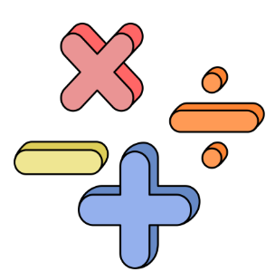  Topics:  Addition and Subtraction  Multiplication and Division  Topmarks and Videos  Mathsframe: Multiplication and Division  Hit the Button  NRICH: More Dicey Operations  Keep learning multiplication and division facts.  BBC Bitesize is a good resource to find other information on these topics.
Health and Wellbeing  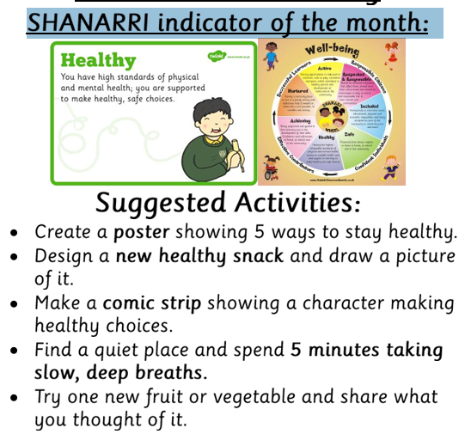 | Life Skill of the Month  Active Listening!  👂 Listening Detective  Ask someone at home to tell you about something they enjoy. Listen without interrupting, then:  - Share three things you heard.  - Ask one curious question about what they told you.  - Tell them how you showed you were listening.  If nobody is free, listen to a short story and try the same challenge. | Music  Practice some of the song as and patterns that you have been learning in Kodaly. Teach someone at home how to sing one of the songs. This will also help with your active listening task.  Coca Cola went to town.  Pass the beat along the line.  Radioactivity and Marie Curie  Explain to an adult what you know about Radioactivity and tell them all about Marie Curie and why she is an important person in history.

