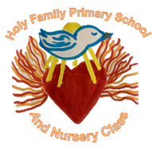


Homework Grid P7/6 – October 2026
Must do tasks -
Literacy - Spelling  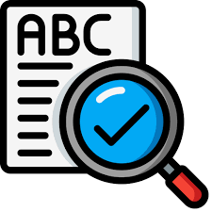  The Spelling grid for the Purple group can be accessed below. The Lime group have a copy of their Spelling grid. Look at the Spelling grid for your group. Continue to practise your spelling words regularly. Use the strategies that work best for you. Think about the range of strategies that we use in class. | Literacy - Reading    Blooms question of the month:  📚 Understanding  After reading your class novel at home this week;  - Describe the setting in your own words.  - Summarise what you have read.  - Record the main ideas from the chapter. | Numeracy and Mathematics  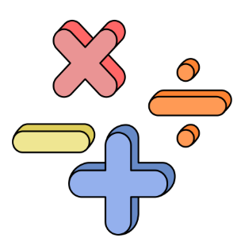  Topic: Number and Number Processes  Create a number riddle for someone else to solve. Give clues for your number.  e.g. I am a 3 digit number. My hundreds digit is 4. My tens digit is odd. My ones digit is 2. I am smaller than 422.
Health and Wellbeing  SHANARRI indicator of the month:  Healthy  Create a fitness circuit at home. Think of 5 different activities you could include such as jogging on the spot, star jumps, squats, balancing and stretching. You could invite a family member or friend to join in.  Record how you feel before and after taking part in the circuit. | Life Skill of the Month  Learn to tie shoelaces and school tie  If you normally need some help with your shoelaces and tie, try to focus on learning to do these this month.  You could practice on a daily basis before school. You could also have a go after PE.  Have a look online for some videos to help you. | IDL- Glasgow  Carry out research and then create a fact file on Glasgow. You could include information such as population, landmarks/places of interest, famous people from Glasgow etc.  RME  Class Mass- all are welcome to join us for our class Mass at 9.30 am on 2/10/26.  Confirmation- Children preparing for Confirmation will have workbook activities to complete.

