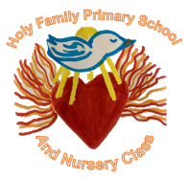


Homework Grid P5/4 – September 2026
Must do tasks -
Literacy - Spelling    Please ensure that you are learning your spelling words that are given out/posted on the website. | Literacy - Reading    Blooms question of the month:  📚 Remembering  Who is your favourite character in Kaspar, and what three things can you remember about them?  Can you create a visualiser like the one created in class of a different character? Remember their characteristics and descriptions. | Numeracy and Mathematics  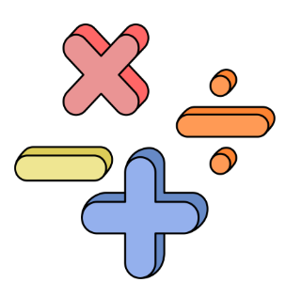  Topics:  Estimation and Rounding  Place Value  Addition and Subtraction  Top marks and Video  Rocket Rounding - Topmarks  Place Value Millionaire Game  BBC Bitesize is a good resource to find other information on these topics.
Health and Wellbeing  SHANARRI indicator of the month:  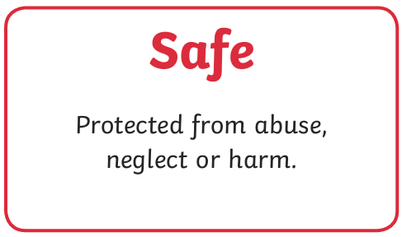  Task:  Draw a shield and divide it into 4 sections. In each section, draw or write:  - A person who helps keep you safe.  - A place where you feel safe.  - A rule that helps keep people safe.  - Something you can do if you feel unsafe or worried. | Life Skill of the Month  Learn to tie!  Shoelaces and School Ties  This skill could be practiced every day getting ready for school. This would really help you at PE and throughout the school day.  There are videos you can watch to help. | Topic  Enterprise  Think about a business idea that we could implement in school. Create and design a poster which your business idea with a catchy name and logo.  Rights Respecting Schools  Explain to an adult about the UNCRC and what this means for us. Discuss our Class Charter and how we created this.  Create an Acrostic poem for UNCRC which describes it.

