Homework – W/B 26th May 26 – P6.
Spelling – See TEAMS. Any issues, let me know.
Reading.
Jammie Dodgers – Continue with reading novel as home reader. We have a few tasks to complete this week.
The Borrowers – Continue with Borrowers until finished.
If you have already finished, I would like you to complete a book review please. You can type it on word, or you can write on paper – you decide. Please use this checklist to make sure you include everything – this can be done over two weeks if needed! Let’s see your best work!
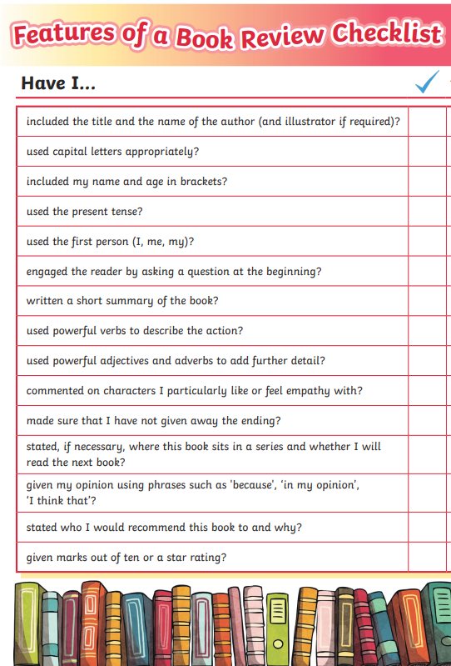
Maths – Practise dividing. Ask a parent/sibling/friend to give you some division sums. I will also set you some on TEAMS.

