Primary 7 Homework 23.3.26
Maths Sheet 19 Equivalent Fractions
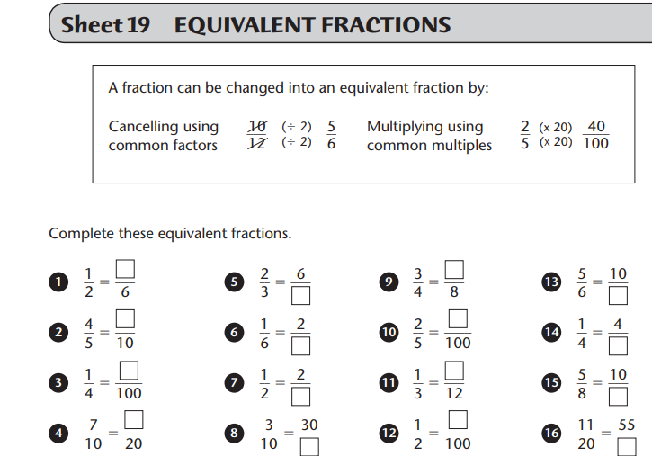Spelling
Green spelling group – re means again
reconstruct, relaunch, reappear, relocate, replenish, reinforce
trans means across
transatlantic, transport, transparent, transplant, transverse, transect.
Yellow spelling group – Common Words
Red – Split phonemes
i-e – side, white, smile, hide, shine
o-e – home, rope, stole, awoke, hope, smoke
Have a great week everyone!

