Primary 7 Homework 16.3.26
Maths Sheet 9 Division
As explained during class time – for homework we will be revising and going over previously taught concepts so that you remember how to do these. There will always be an example for you to follow. Please try these and make every effort to complete homework. You do not need to complete all of these!

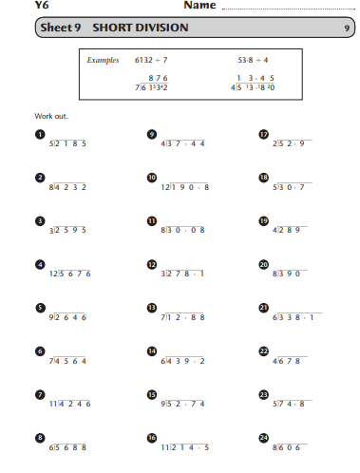
Literacy – Reading/Spelling
Thank you to those of you who shared your research on a famous scientist. We will continue to hear these throughout the week.
Debating and presenting information - English - Learning with BBC Bitesize
Please click on the above and watch in preparation for our debate and discussive writing. Please read any other useful information you can find on the following topics:
Should smartphones be allowed in school?
Is AI helpful or harmful to education?
Spelling
Super Spellers
Subject Specific
Computing | Maths
computer  interface  software  virus  graphic  interactive  database  document  connection  password  processor  memory | addition  subtraction  multiplication  division  fraction  estimate  co-ordinate  radius  average  horizontal  perimeter  symmetry
Yellow spelling group – a, o, au, aw
almost, called. oxygen, opposite, obvious, because, daughter, cauliflower, awful, crawl, fallen, after, orange, obtain, observe, fraught, pause, caution, brawl, drawer.
Red – Revision and Consolidation – all common words and phonemes.

Have a great week everyone!

