Homework w/b 16th March 2026
Spelling
Whole Class: Can you write 6 silly sentences using as many of your words as possible. Please focus on your handwriting and presentation.
Green Group – Suffix ‘ful’
Useful | Dreadful | Careful
Cheerful | Skilful | Colourful
Beautiful | Plentiful | Wonderful
Disgraceful | Faithful | Eventful

Orange Group – Sound ‘s’
s | ss | c | se | ce
sack | actress | saucer | sense | service
suggest | address | city | cease | peace
scream | assist | circle | practise | sequence
separate | distress | twice |  | sentence
sensible | glass | ice

Maths
Circles
Can you simplify each of these fractions to its simplest form.
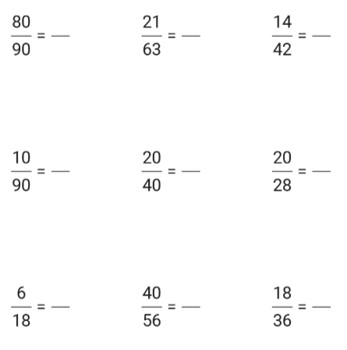

Squares
Can you find each of these equivalent fractions using the fraction bar model to help you.
