Homework w/b 9th March 2026
Whole Class – Prefixes- Write the prefix, the meaning and the three examples in your jotter.
Example: re – means to do again. rerun, repeat, redo. Use a dictionary to help if needed.
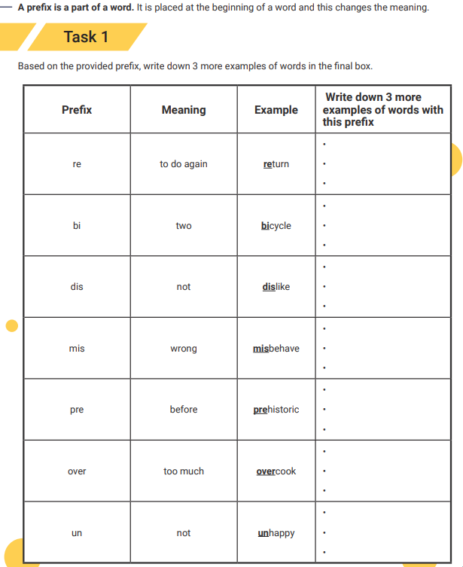
Reading –
Wonder – must have read up to page 152 by Wednesday. I will give you some time in class too.
Why the Whales Came – must have read up to the end of chapter 8 – no further.
Maths: Fractions – whole class
