Homework w/b 23rd February 2026
Spelling – Choose your preferred strategy to practise these words.
Green Group – Week 4
Set 4
Prefix: auto | Tele/bi | Common Words | I before e except after c
Week 1 | Week 2 | Week 3 | Week 4
automatic  autobahn  automobile  autobiography  autograph  automated  automatically  autographically  autobiographer | telephone  telepathy  television  telegraph  telescope  bilingual  bicentenary  biceps  bifocal | evidence  metaphor  research  aisle  consequence  exaggerated miscellaneous  competition  experience | mischief  niece  belief  cashier  relieved  ceiling  receipt  conceive  deceit  perceive

Orange Group – week 4
Set 12
Prefix: ch, tch, t |  | Common Words | Sh. V dbl cons
Week 1 | Week 2 | Week 3 | Week 4
charge  change  challenge  kitchen  stretch  butcher  watch  picture  creature  signature | chance  chief  child  birdwatcher  fetch  itchy  wretch  furniture  culture  mature | Glasgow  Edinburgh  Dundee  Aberdeen  Inverness  Stirling  Ireland  Scotland  England  Wales | collect  happen  necessary  annoyed  traffic  beginning  address  brilliant  collection  successful

Red - phoneme sound (ie)
ie
tried cried fried died
dried supplied replied
lied tie

Reading Groups –
Wonder – Ensure you have read up to 132. If complete, continue reading ‘jack’ (133-159).
Why the Whales Came – Check with Miss Fagan on Monday

Maths – Revision – Properties of 3D Shape – write the answers in your homework jotter. (Draw the shape then answer how many faces, vertices and edges)
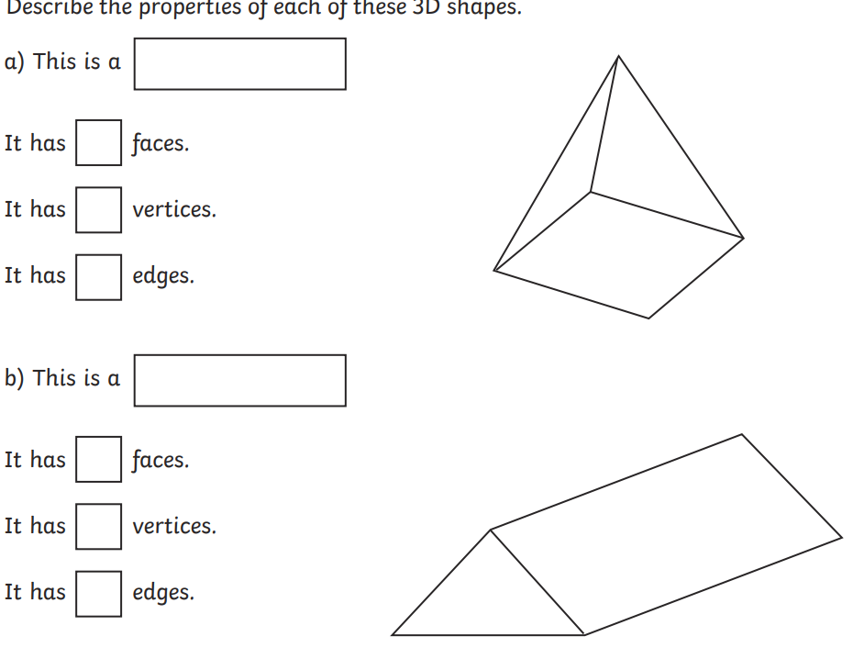
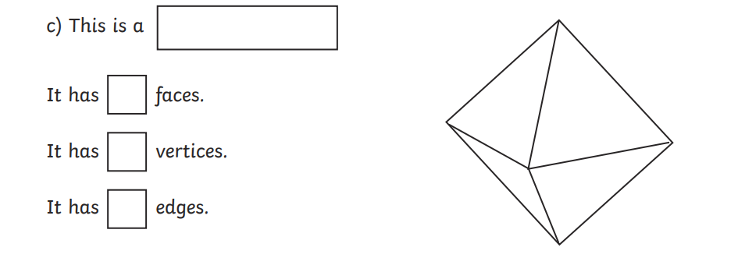

*When complete, practise all times tables.

