Consequences of Space Debris

1. Damage to Satellites

Space debris can collide with functioning satellites, damaging or destroying them. Satellites are crucial for communication, GPS, weather forecasting, and scientific research. Losing these satellites could disrupt many services we rely on daily.

2. Threat to Space Missions

Furthermore, debris poses a risk to astronauts and spacecrafts alike. Even tiny fragments can cause severe damage due to their high speeds, making space missions and spacewalks more dangerous.

3. The Kessler Syndrome

The Kessler Syndrome describes a situation where space debris collides with other debris, creating even more fragments. This leads to a chain reaction, potentially making space around Earth so crowded with debris that launching new satellites or missions could 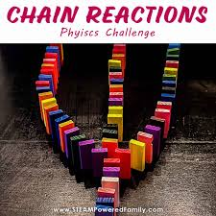become impossible.

4. Increased Costs for Space Missions

Additionally, because of the threat from debris, spacecraft and satellites need extra shielding, which increases the cost of missions.

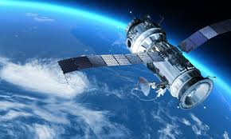

5. Environmental Impact

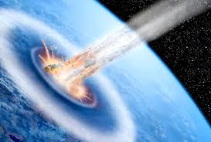Some debris in low Earth orbit eventually falls back to Earth, where most of it burns up in the atmosphere. However, larger pieces can reach the ground and cause damage.