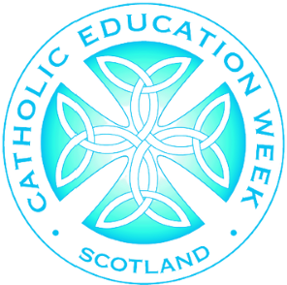
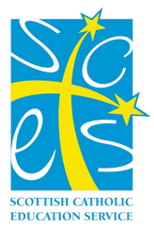
Catholic Education Week

Prayer Breakfast
GOOD MORNING!
Our School are taking part in this year’s
Wednesday 16th November

8.20am
Holy Family Primary School
and Nursery Class

Communion Participation Mission
Catholic Education Week
Prayer Breakfast

08.20 Welcome
08.25 Morning prayer led by our children followed by breakfast
08.50 Short presentation about St. Margaret of Scotland
08.55 Holy Family Prayer
09.00 Close and Thanks
Communion Participation Mission

