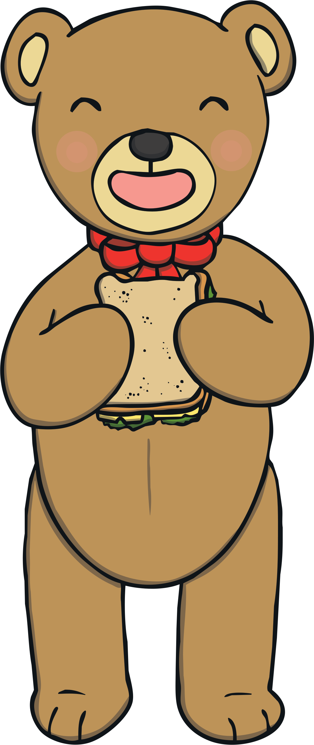
Hello children,

My name is Buttons the Bear. I have a special invitation for you! I would like to invite you and your favourite teddy bears/cuddly toys to a teddy bears’ picnic! We cannot be altogether, so you can have your picnic with your family and take photographs to show me!
I need your help to make invitations, picnic food and decorations. Please can you help me? What food could we have? What decorations could we make? What are your teddy bears/cuddly toys called?

Our picnic will be on: Tuesday 23rd June 2020
Time: 12pm
Place: You choose the perfect spot for your picnic

I would love to see your picnic photographs on
Twitter. Have fun!

From Buttons the Bear

