Holy Family Nursery Class
Support for learning policy and procedures

Rational
At Holy Family Nursery Class we believe that all children learn in different ways and may require additional support for a variety of reasons at different times in their education. For some children, the support they require will be of a long-term nature, whereas for others it may only be for a temporary period in their schooling.

A child has additional support needs where, for whatever reason, the child is likely to be unable, without the provision of additional support, to benefit from school/nursery education provided or to be provided for the child or young person.

Additional support means provision which is additional to, or otherwise different from, the educational provision made generally for children of the same age in schools (other than special schools) under the management of the education authority for the area to which the young person belongs.

Aims
We aim to support all our children to achieve their potential and become:
• Successful learners
• Confident individuals
• Responsible citizens
• Effective contributors

Staff will strive to create a supportive climate in school in which the contribution of each child is of equal value. Through a consistent, equitable and transparent approach we also aim to:

• Ensure all children’s needs are recognised early on in their nursery/school life and appropriate support given
• Detail an identification and review system to best meet the needs of
pupils requiring additional support
• Outline the roles and responsibilities of teachers, school staff and
specialist support services
• Ensure the views of pupils and their parents/carers are taken account
of when making decisions which affect them

GIRFEC
All support given to a child will be done in the framework of Getting it Right for
Every Child (GIRFEC). This is an integrated framework for promoting children’s
development and wellbeing.

The GIRFEC approach aids school and nursery staff to focus on what makes a positive difference for children and young people and how they can act to deliver these improvements and outcomes. GIRFEC is embedded within all existing policy, practice strategy and legislation affecting children, young people and their families.

Children’s wellbeing is at the heart of GIRFEC. This means focusing on the wellbeing of every child to ensure they are Safe, Healthy, Achieving, Nurtured, Active, Respected, Responsible and Included (SHANARRI).

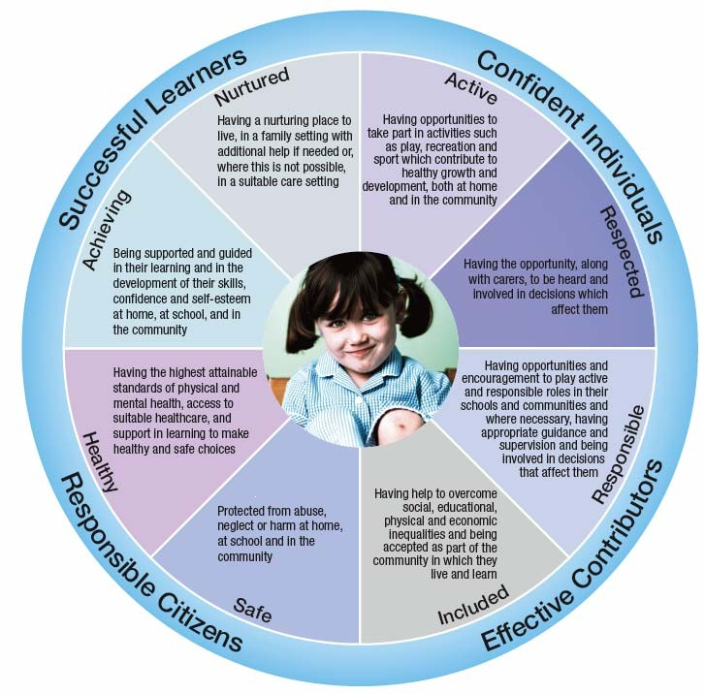

GIRFEC ensures the right support is offered at the right time by the right people. Along the learning journey some children, young people and families may require a bit of tailored support. In this case a Getting It Right For Me plan will be devised to ensure a consistent approach to planning, delivery and coordinated support

In Holy Family Nursery Class all staff are trained in using the Solihull Approach in our practice. This provides a framework that is important in our work and helps children, adults and staff process emotions and anxieties that can be overwhelming and can affect emotional and cognitive learning.

Why the Solihull Approach is important in our work?
- This approach supports adults caring for a child to develop a more receptive relationship with the child. We will value children and treat them with respect
- It can reduce anxiety in adults and children which will enable them to manage the child’s anxiety and behaviours during times of stress. Adults will remain calm when addressing inappropriate behavior and the management of this will be treated in a consistent manner by all staff
- Nursery staff are in a key position to influence the social and emotional wellbeing of the child. We will develop a positive self-image through regular praise and encouragement
- Nursery staff have the potential to enhance the relationship between the child and adults caring for them within Holy Family Nursery Class
- If we enhance the relationship we will enhance the life chances of the child
- The use of Emotional and Physical Containment from all involved may be helpful when we are working with particularly challenging or difficult situations
- We define Containment as – to show the child you are listening, offering cuddles, being held securely and validating the child’s feeling: ‘this must be awful for you’.
- We offer quiet spaces to offer support to the child and families
- We know that containment can diffuse a situation as it is about connecting with each other first. We recognise behaviour is a method of communication and we use three key questions to support us in this.
- Age and stage of child
- Communication ability?
- What changes has there been recently?
- When a child is distressed staff will work closely and positively with the child. If appropriate it will be made clear to the child the reason why this behavior is unacceptable focusing on the emotion ‘it is ok to be angry, but it is not ok to hit out at others’.
- We use the shared language of ‘Reciprocity’ this involves the positive interactions between each other. We are aware that children cannot cope with too much stimulus and may tune out or withdraw attention. We also know that an overload of language and questioning can also cause children to tune out and switch off.

The UNCRC Article 3 states:
In all actions concerning children, whether undertaken by public or private social welfare institutions, courts of law, the best interest of the child.

The role of GIRFEC within support for learning and additional support needs policy is:
- To ensure all staff are aware of the policies and procedures.
- To ensure staff are consistent and work together in their approach. All staff follow agreed strategies for managing unwanted behavior such as distraction, ignoring and cooling down time.
- To make sure staff record and monitor incidents of unacceptable behavior
- Ensure that parents/carers are told about any inappropriate behavior at the right time and in a respectful way. Ensuring privacy and confidentiality are in place.

Identification and Assessment of Additional Support Needs
Early Years Practitioners know the children in their group well, therefore are best placed to monitor individual progress and identify those in need of support.

Assessment
We assess each child’s learning and support needs through a consideration of:
• Formative and Summative assessments
• Norm referenced tests
• Criterion referenced assessments
• Checklists of behaviours and skills
• Children personal plans and previous records and through information provided:
• By parents

• Through consultation with other professionals
• In examples of past and current work
• In minutes of review meetings and case conferences
• Through psychological assessments
• By children’s interviews
The assessment will enable staff to build a profile of:
• The child’s needs as a learner
• Curriculum issues
• Social skills and relationships
• Emotional behaviour
• Barriers to learning

Staged Intervention
Staged intervention is a process used in Holy Family Nursery Class to identify, assess and support learning needs.

Stage 1
A child is identified as having additional support needs. These needs can be met within the resources of the school or nursery class. For example, differentiation, a particular teaching style, visual timetables.
The nursery staff on discussion, plans for, evidences and monitors this intervention i.e. forward planner.

Stage 2
A child is identified as having additional support needs. These needs can be met within the resources of the nursery, not normally found in the playroom, for example, Support for Learning Teacher. The Class teacher/nursery staff, on discussion, plans for, evidences and monitors this intervention.
Where this support, however, is intensive (one-to-one/therapist) and enduring (likely to last more than 12 weeks) and essential to allow access to, an elaborated, reinforced, or extended curriculum, a Getting It Right For Me plan (GIRFME) will be required.
The plan is drawn up by the child’s teacher/key worker (supported by S/NMT) who will also write and/or co-ordinate the long-term and short-term targets. At this level of individualisation, Mrs Patricia Mackay depute head teacher has the overview of all pupils with additional support needs.

Stage 3
At this stage other services within education but out with the school/nursery are involved in the pupil’s plan, for example, Sensory Support, Psychological Services, and Support & Micro technology.
A GIRFME plan is drawn up by the keyworker who will also write and/or co-ordinate the long-term and short-term targets. At this level of individualisation, the head teacher has the overview of all pupils with additional support needs.

Stage 4
At this stage it is recognised that a child/young person may require additional support from services out with education, for example, Speech & Language Therapy, Social Work, Occupational Therapy.
A small number of our children may have additional support needs arising from complex or multiple factors which require a high degree of co-ordination of support from the education authority and other agencies and for these children a co-ordinated support plan (CSP) will be required.
All services and agencies involved with the child/young person will play a part in the drawing up of the CSP. The CSP co-ordinator will arrange the meetings and write the CSP. A CSP is a statutory document that is subject to regular monitoring and reviews for those pupils who meet the criteria for requiring one.

Transitions
All children and young people go through transitions in their education. Early or timely planning is required to ensure continuity and progression between stages, breaks in education or a change in circumstances. In our nursery/school we plan for effective transitions for our children by:
• Adhering to legislative timescales
• Effective communications between establishments and agencies
• Shared joint assessment of support requirements
• Ensuring continuity of support
• Informing and involving children/young people and their parents/carers
• Focussing on solutions, not problems
• Specifying the least intrusive methods of support required to meet anticipated needs
• Discussing and passing on information held in files, pupil profiles etc.
• Follow-through.
Early or timely planning is also of particular importance when the learning of the child/young person has been interrupted. A range of factors may give rise to learning being interrupted such as:
• Family circumstances – e.g. leading to a young person being taken into care
• Health – e.g. hospitalisation/a long period of absence from establishment
• Social and emotional – e.g. bereavement, asylum seekers, exclusion from school

Since factors will impact differently on our children it is important that we tailor support to the needs of the individual child and that such support is appropriate and proportionate to their needs. The duration of such support will vary accordingly to the needs of the individual pupil and their situation.

Managing transitions often involves a higher number of professionals hence the process of planning for additional support has to outline the liaison between sectors in education. Where other agencies are involved, the co-ordination of support has to outline the ways in which professionals across other agencies will work together to meet support needs both in the current educational establishment and the establishment that the pupil will transfer to.
Under current legislation in our school, at least twelve months before the change is about to happen (six months for the under-fives) we will:
• Seek advice/information from all appropriate agencies
• Seek and take account of the views of the child/young person and their parents/carers.
• Inform the child/young person and their parents/carers of decisions made
• Take account of this information and make necessary arrangements before the change takes place
At least six months before the change is about to happen (three months for the under fives) we will:
• Decide what agencies need to be informed of the child/young person’s needs
• Inform those agencies of the date of change, the child/young person’s support needs and the provision to be arranged before the change to enable the smooth transition (with the necessary consents).
• Provide the parent/carer and the child/young person with copies of any information passed on to the appropriate agencies, for example, any other local authority, health board, colleges of further and higher education
Where child/young people have interrupted learning and require additional support then the establishment should act as soon as information becomes available.

Roles and responsibilities
Senior Management Team
The SMT will ensure the effective management of provision for each individual child’s needs through the management of:
• Staffing and deployment of staff
• Staff roles and responsibilities
• Resources
• Accommodation
• Budgets and finance
• Curriculum
• Links with external agencies

Early Years Practitioners
Nursery staff are responsible for educating children in their class
and:
• Respond to individual needs
• Use a range of assessment techniques and teaching strategies to support children
• Maintain records of progress and next steps
• Consult with children’s parents and other staff and visiting specialists as required to ensure appropriate interventions for the child.
• Establish next steps, as appropriate
• Review regularly, and in consultation, the progress of children

Additional Support Needs Assistants (ASNAs)
ASNAs in our nursery support the raising attainment of all children. They always work under the supervision and direction of the Class Teacher/nursery staff. They are allocated to our school in line with North Lanarkshire’s resource allocation procedures. Support is specified with a particular pupil and in response to meeting particular needs. Flexibility will be clarified where an assistant meets the needs of more than one child in the class and or where an assistant is withdrawing support and encouraging independence. Duties may include:
• Assisting with mobility of individual children, their personal care and handling of special equipment
• Keeping children on task
• Conducting learning tasks as directed by the class teacher
• Providing pastoral support for children
• Liaising with all staff to support children
• Participating in relevant staff development
• Consulting with staff over progress of children

Parents/carers
We recognise the full involvement of parents and carers as highly important. We acknowledge that they play a key role in enabling us to make effective provision, and that children and their parents / carers hold information that supports positive outcomes for our pupils.
We involve parents / carers and children:
• When a child has been identified as having additional support need
• When there is a change in a child’s circumstances that requires a review of provision
• On a regular basis to review short term and long term targets
We work with parents to actively involve them in their child’s learning.
• Be invited to attend regular meetings to discuss their child’s progress.
Parents are invited to 2 parents’ evenings each session. If a parent is unable to attend on the given date an alternative time will be offered.
• Where there is a need for a Co-ordinated Support Plan, be fully involved in the planning and review.
• Where there is a need for a GIRFME Plan be aware of the learning plan set for their child.

Staff Development
In Holy Family Nursery Class we provide opportunities for staff to increase and extend their skills and knowledge and to reflect upon the professional development they require to meet the needs of all pupils. Staff have access to development opportunities within and out with the school

Monitoring
Self-evaluation of the quality of learning and teaching and support for all children is the responsibility of all teaching/nursery staff and the senior management team.
Quality indicators described in “How Good is Our School? 4” and ‘How Good Is Our Early Learning and Childcare’ will be used to evaluate the ongoing effectiveness of this policy within the school/nursery.
In practice this will include:
• Observation of children in school and nursery classes
• Consulting class teachers/nursery staff, support for learning teachers, and where appropriate, any other staff working closely with our children
• Monitoring child attainments
• Speaking to parents/carers
• Speaking to children
• Consulting children’s profiles

Written August 2019
To be reviewed August 2020

