Microsoft Teams

Pupil Information Booklet
Updated August 2022

Contents
- Accessing Teams………………………………………………………Pg3

- Inside Teams……………………………………………………………Pg5

- Accessing Files in Teams………………………………………….Pg6

- Responding to Posts…………………………………………………Pg7

- Participating in a Team Meeting………………………………Pg8

- Downloading Microsoft Teams App…………………………..Pg9

- Accessing ‘Home Learning’ and resources………………....Pg10

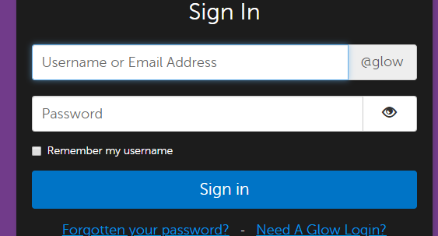Accessing Microsoft Teams
1. Log into glow by entering your login details. Using Google Chrome is recommended.

2. Once logged in you will be in the space called the ‘launch pad’. From here find the ‘Teams’ tile and click on it. You may need to scroll down to find the tile depending on what your launch looks like (and how many tiles there are).
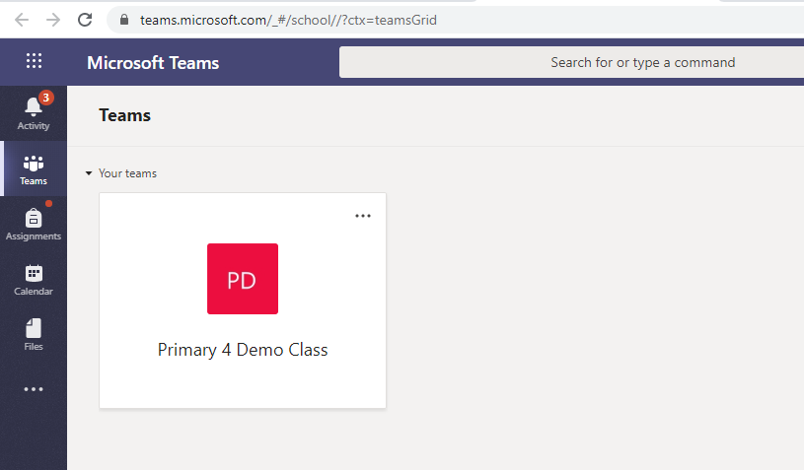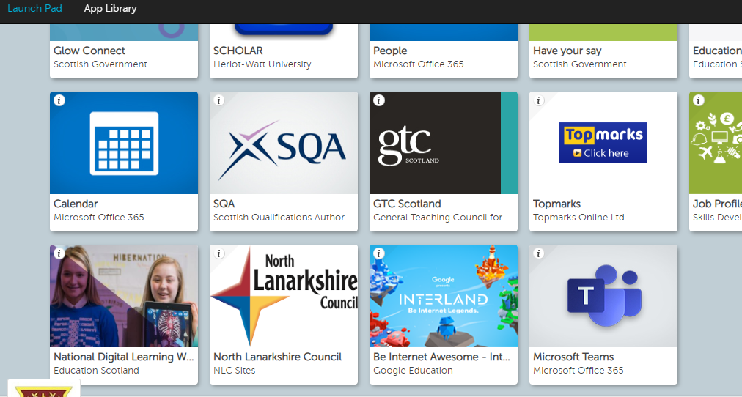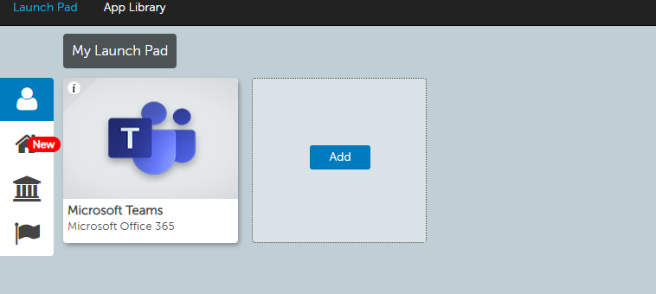
3. Once you have clicked the ‘Microsoft Teams’ tile it will open a new tab and take you into teams. You will see a page that will display the teams that you are a member of. You should see your class team with your class teacher’s name on it or any other teams you are accessing. Click the team you want to access.
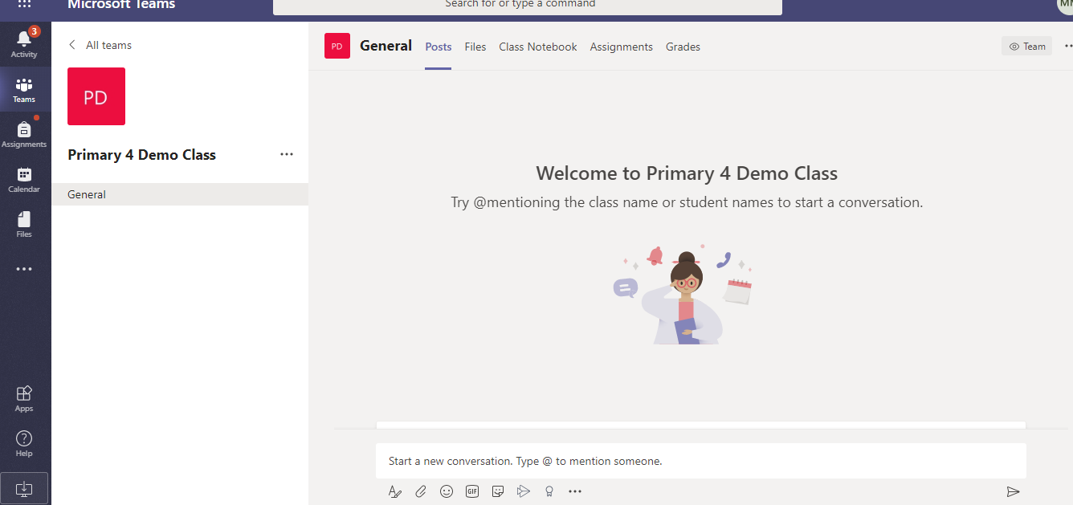

4. If your screen does not look like the image in the previous step and looks like the image in this step, don’t worry. Microsoft Teams has taken you straight into one of the teams.

5. If you have been taken into the wrong team, click on ‘all teams’ or ‘Teams’ on the sidebar to go back to the grid of all teams you are a member of.
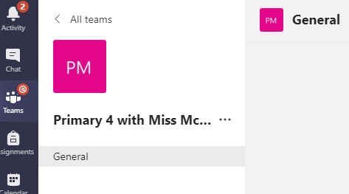

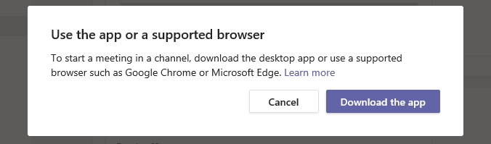
6. Depending on the browser you are using, you may get a message saying that the browser is not supported by Teams and asks you to download the app. You can either download or access by using the Google Chrome broswer. There is a section detailing the benefit of using the app over accessing through the Glow site on page 8.
Inside Teams
1. Once inside the team you will see different sections along the top. The class teacher will post suggested activities in the ‘Posts’ section. Children will also be able to reply to teacher questions, quizzes or comment on posts in this section. The teacher may post links to other websites or attach resources which can be downloaded or opened online.

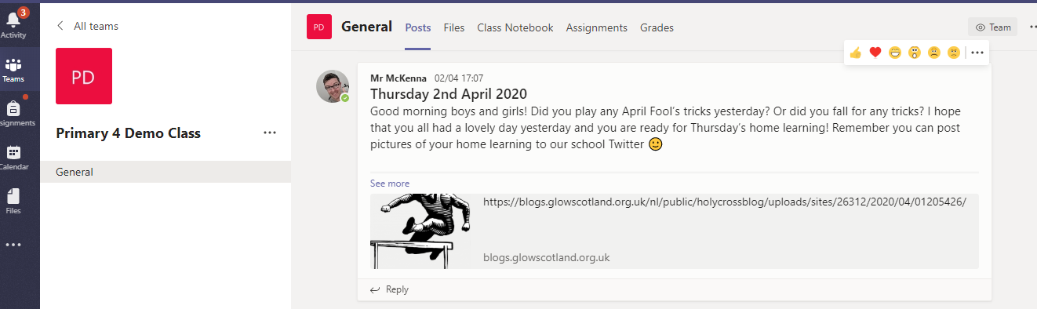2. In this image you will see an example of a teacher posting information for the day. In order to expand the post so that all information can be viewed, click on ‘see more’.

Accessing Files in Teams
1. The files section of the team may also contain documents or resources that can be downloaded to be used at home. This section can be accessed by clicking ‘files’ from the options at the top of the team.
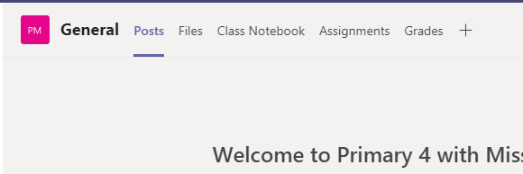

2. Click on the ‘HOME LEARNING’ and ‘class materials’ folder to access the daily planned learning and resources that the teacher has uploaded here or to view previous learning activities. You will see a list of resources if any have been uploaded. To access and download files, hover the mouse to the right of the file until three dots appear. Click the three dots and then select download from the menu. The file will be downloaded to the device. To just view the file online only, double click the file name and it will open. 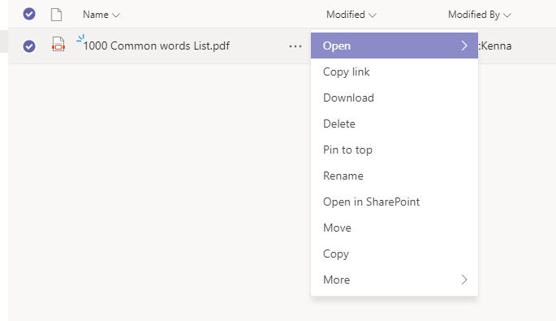

Responding to Posts
1. The class teacher may post questions to reply to in the ‘Posts’ area of Teams. To respond to the teacher post click reply, type the message and click the paper plane to post the message back. 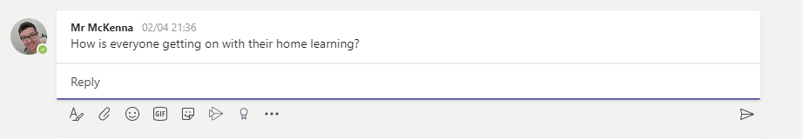
Click here to reply
Post reply

2. Pupils may want to share some of your work with the teacher. Pupils can upload documents and attach them to their reply. To do this, click on the paperclip and select upload from device.
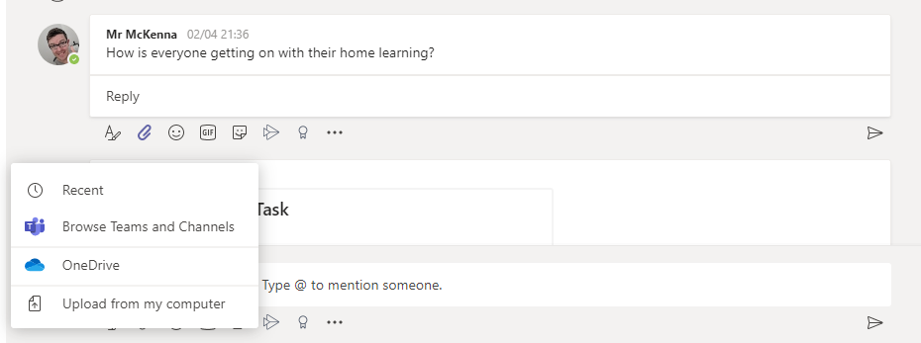
3 .Post reply
- This menu will appear. Select upload from my computer and search for the file you want to upload
- Click the paper clip

***All pupil comments are monitored by the senior management team. Pupils should be sensible at all times when using this function within Teams.

Participating in Teams Video Meeting
A member of staff may host a video conference call with the members of the team. Only the member of staff will be visible and only their audio will be heard. North Lanarkshire Council has turned off the function for pupils to turn camera’s on in line with safeguarding procedures.
A member of staff may use this function to read to pupils, present an assembly or to share information. However, it is most likely that all communication will be through the posts section.
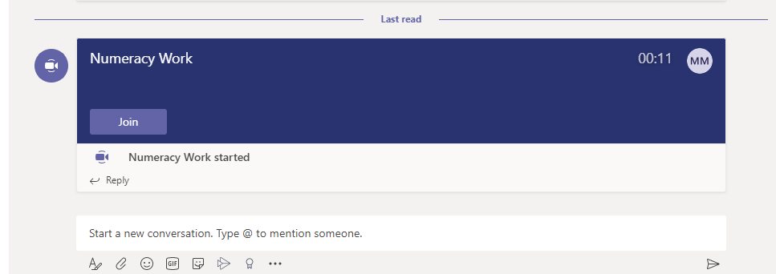
If a video meeting is taken place, a purple join button will appear on the ‘posts’ section of the team that the meeting is being held in. To join the meeting, you should click ‘join now’.

Once the ‘join’ button has been selected, a box will appear with the meeting title. Turn the audio slider to off and click ‘join now’. You will now be in the meeting.
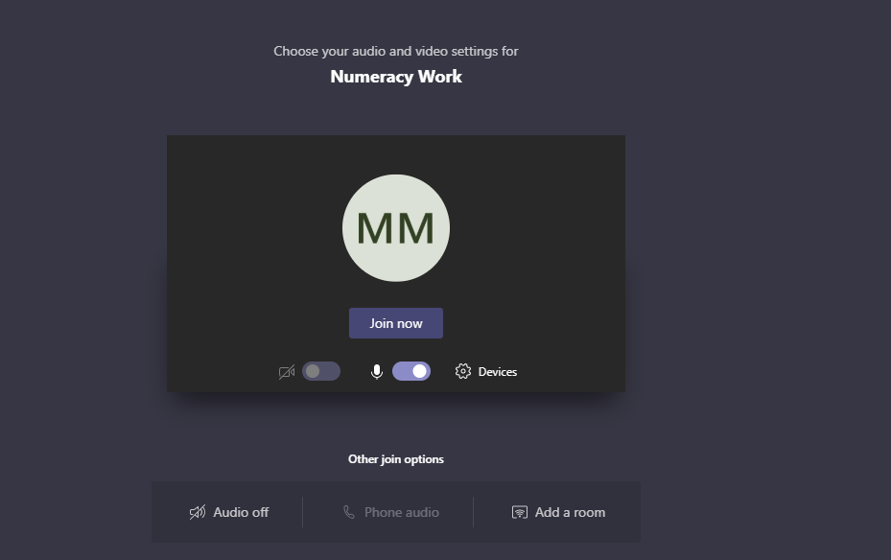

Downloading Microsoft Team App
The Microsoft Teams App can be downloaded as an app to computers, tablets and mobile phones. Due to the global pandemic, schools and businesses across the globe are using Microsoft Teams. Therefore, accessing Teams through an app and not through a web browser can be more reliable.
Using the Teams App also only requires you to log in once and therefore, you are not required to log in via Glow each time. Below are the steps for downloading the app and logging in for the first time.

Downloading on a computer
- The Teams desktop app can be downloaded from https://www.microsoft.com/en-ww/microsoft-teams/download-app

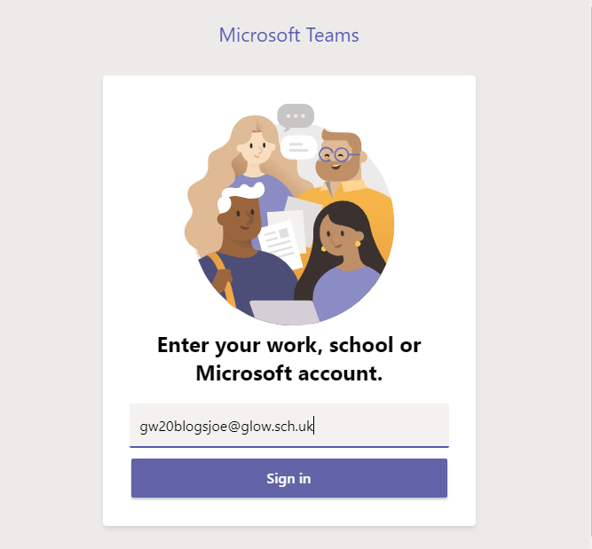2. Once the app has downloaded you will be required to sign in using the Glow email address as a one off step. This is the pupil username with @glow.sch.uk added to the end. Click on the Teams desktop icon to launch the app and add the email address. Click sign in.

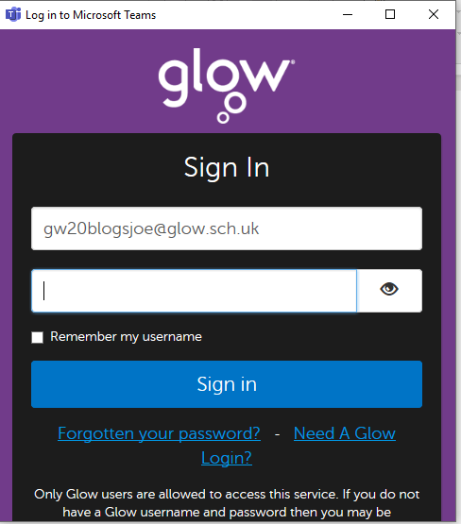
3. You will then be taken to the Glow sign in page. The password for the Glow account should be entered and sign in clicked. Teams will then be logged in on the desktop app. You are not required to sign in each time the app is opened unless you sign out.

Download on tablets or mobile phones
The Microsoft Teams app can be downloaded from Apple App Store and Google Play Store for free. The sign is procedure is the same for both the desktop computer app and mobile app. Follow the steps above to log into a mobile device.

Accessing Home Learning
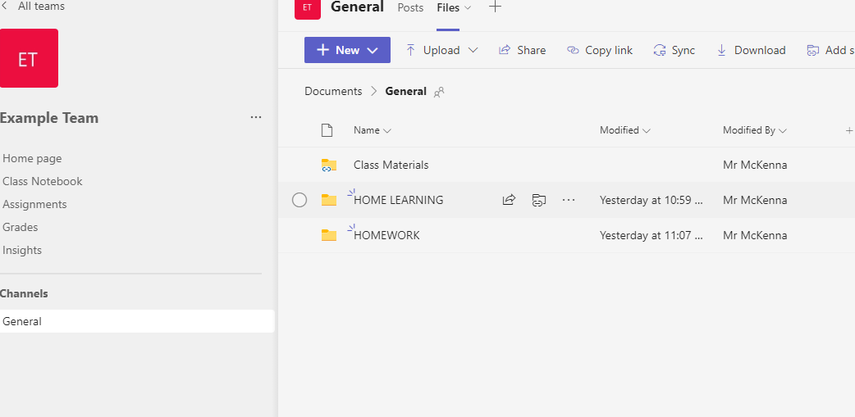
- From the Team channel list select ‘General’, click on ‘Files’ and then ‘HOME LEARNING’ folder to access learning overview grid or ‘Class Materials’ to access the required for the learning task as outlined on the learning overview grid.

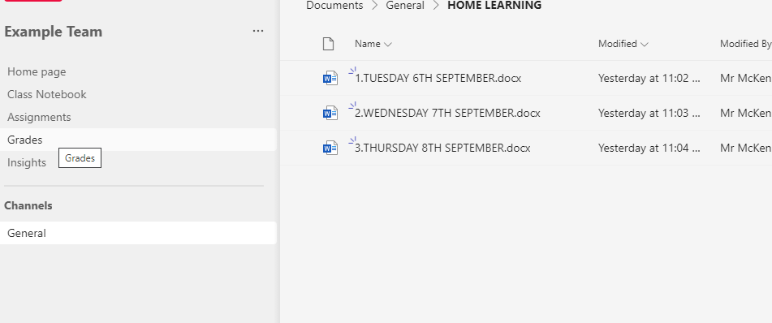
- Within the ‘HOME LEARNING’ folder you will set the daily learning grid which will detail the learning for that day along with times to be online for live lessons. These will be uploaded each morning into this folder.

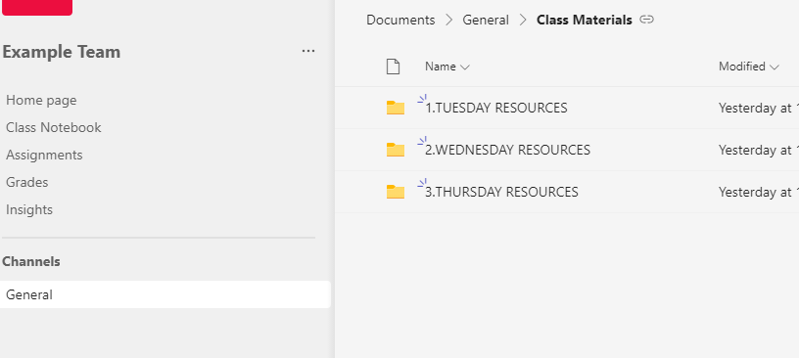
- Resources for each planned learning will be uploaded into the ‘Class Materials’ folder and will be clearly dated for ease of access.

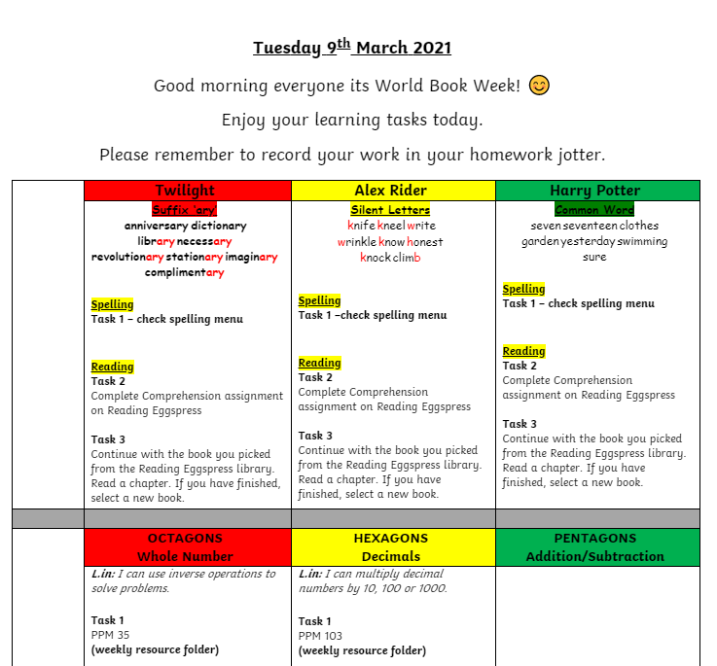
- Learning grids will explain what tasks pupils should complete. Pupils will know which group they are in.

