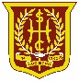Remote learning during Self Isolation, Positive PCRs and other Covid related absences

If your child is unwell with Covid or any other illness there is no requirement for them to undertake any school work while at home. Rest and recovery are the top priorities!
If your child has a positive PCR or is self isolating but doesn’t have symptoms and is well they can keep busy by learning online. Please see below learning opportunities.
Core resources:
Your child can continue to complete class homework set on their class ‘Team’.

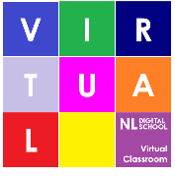
By logging into Glow and clicking the NLC Virtual Classroom tile your child can access activities appropriate to their learning needs. Please phone the school if you need to know which coloured platform within the Virtual Classroom your child should access.

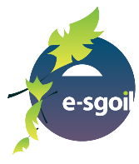
We can also register your child for Esgoil; the Education Scotland online learning platform if they are off school for more than a few days.

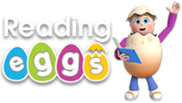
Your child should have their Sumdog and Reading Eggs/Reading Express login details. These platforms will support class learning.
We will put the code to join the Friday online live assembly on the main page of your child’s class team.

Additional resources

No learning is ever wasted. BBC Bitesize, Cbeebies and other educational platforms provide great learning opportunities.
Building and creating using Lego, junk or art materials etc are also valuable opportunities to develop a whole host of skills.

If you need support accessing any of the digital platforms please give us a phone on 01236 632124 or sent us an email
enquiries-at-holycross@northlan.org.uk

Thank you

