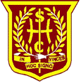
UPDATE May 26th 2020

Reporting on your child’s progress, 2020

Your child’s End of term Report will follow in an email in the coming days. The report provides a summary of your child’s progress prior to the school closure in March. Please be assured that when school does reopen, teachers will work with your child to establish the next steps for learning.
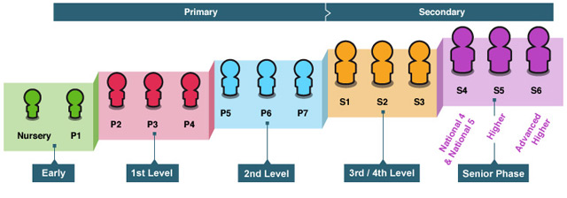

Children make progress every day. The pace of learning depends on many factors including, attendance, time keeping, and understanding of particular blocks of learning and health and wellbeing. During this period of lockdown all children will have continued to learn whether from the school blog, other resources or learning wider skills from parents and carers.
Under normal circumstances in P1, most pupils will be ready to move on to Curriculum for Excellence First Level experiences and outcomes. Some children will require more time while others might be ready a little earlier.
By the end of P4 most pupils will have achieved First Level, some pupils may require a little more time and/or support, others may be ready to move on before the end of P4.
By the end of P7 most pupils will have achieved Second Level, some pupils may require a little more time and/or support, others may be ready to move on before the end of P7.
All children are going to need a little more time to cover then curriculum and adjust to school life. We will of course address this on our return.
For P7 pupils, we continue to work closely with St Maurice’s to ensure all information regarding learning and wellbeing is shared to ensure as smooth a transition as possible at this unprecedented time.

Session 2020/2021

Following the First Minister’s announcement last week, children will begin to return to school from the 11th of August 2020 if the progress with containing the virus continues. Our local authority are working to ensure a safe return for pupils and staff but we don’t yet know what that will look like.
As soon as we have a clearer outline or more information regarding our return we will let you all know.

Whatever model for reopening we have, we will do our very best to maximise your child’s learning while endeavouring to maintain a safe environment. We always do our best and staff very much appreciate the support and kind messages we have received since lockdown. They have made seismic changes to their working practices and continued to volunteer to support Keyworkers’ families in the St Patrick’s hub and other hubs in NLC.

Communication

The ht@holycross.n-lanark.sch.uk email address and the mobile numbers given in the previous update can still be accessed if you need anything during this time.
We use Twitter @HolyCrossNLC @HolyCrossNCNLC to celebrate learning and to inform parents of learning opportunities and updates for their children. Thank you to everyone who has contributed with likes, retweets, photos and positive comments. Our Twitter account has been changed to a locked account to ensure we know who follows us and that anonymous accounts/trolls do not detract from our intended use of Twitter.

And finally…
We continue to send our good wishes and prayers to our families and community we serve. Please look after one another and keep the important Holy Cross values of Love and Hope in mind at this time.

Best wishes & God bless

Mrs Murphy and the staff of Holy Cross

