
First Level Speech and Language Activities

Barrier Game: Take it in turns to describe items from your house – can you guess what the other person is describing? Talk about colour, shape, size, use  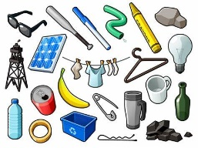 | Think of as many words beginning with ‘b’ as you can. You have one minute!  Bb  Now choose another letter and play again! | Baking with an adult – can you follow the adult’s instructions to make something delicious?    Make sure you listen carefully! | Read a short story and see if you can answer these questions:  Who was in the story?  Where was the story set?  What happened?    How did it end?
Come up with an exciting story about an astronaut. Remember to talk about:  Who is in the story?  Where is the story set?  What happens?    How does the story end? | Work together to build a Lego model. Each person should pick a job  Engineer: describe the pieces and give the instructions    Builder: listen carefully and build the model. | Look at these words and see if you can work out:  How many syllables are there?  Does it rhyme with another word?    What is the sound at the beginning of the word?  Dinosaur  Caterpillar  Flower | Ask a friend or adult to think of an object. Try to guess the object by only asking where questions:  E.g. Would I find this object in my room?  Would I find this object in a school?  It’s tricky!  