Holy Cross Credit Union

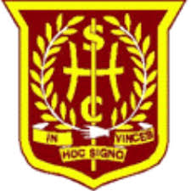

In April 2010 we launched a Holy Cross Credit Union which is affiliated to the local Croy Credit Union.

We are now in the eighth year of our school Credit Union and many children have become regular savers, depositing small amounts of money each week.

If you wish your child to take part in this worthwhile financial experience and encourage your child to save-up then please fill in the permission slip and they will be given a membership card to be filled in.

Do not send money with the slip, they will receive a savings book when we have their details.

I would like my child ___________________class______

to become a member of Holy Cross Credit Union.

Signed ______________________________

