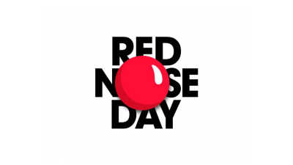
P7 and P1A MAD Groups present
on
Friday 18th March 2022
#RedNoseDay

Bake Sale
Primary 7 will be running a bake sale between 10:30 and 11:30 on the day as well. If you have some spare change, come along and buy a cake!
Red Nose Day
Red Nose Day raises money for children in the UK and around the world who need some support. Greenhill are proud to help this charity. It started in the 1980s and has raised 1.4 billion pounds since it started.
~
Wear Red – everyone will be wearing a red item of clothing and if possible please bring a charitable donation!
Red Art Gallery – P1 – P4 will be designing red noses and P5 – P7 will be learning about famous ‘red themed artwork and creating their own!

For Comic Relief we are asking for each class to come up with their best 3 jokes. We will create a Greenhill joke book.
Selling Red Noses
On Red Nose Day Primary 7 will be selling red noses for £1.50. All donations will be going to the Red Nose Day charity.
Mr. Wisdom’s Beard – Mr. W will be ‘trimming’ his red beard. For 20p you can vote for your favourite style. You can have as many votes as you want.
Guess the Sweets in the Jar
There will be two jars of red sweets (one for infants and one for seniors) and you have to guess how many sweets the jar holds! Closest guess wins the jar. 20p for a guess or 3 guesses for 50p!
!
@comicrelief

