How can parents support what children are learning about rights at school?
- Take time to ask your child what he/she learned recently regarding children’s rights.
- Watch the news with your children and talk about the issues that may affect other children around the world.
- Discuss the ideas he/she is learning in class and try to think of examples from your own experiences, or from the media, of rights being respected or denied.
- Ask your child’s opinion on children’s rights.
- Remind your children about the differences between wants and needs.
- Use Launch Pad with your child to learn about rights.
If you would like more information on Rights Respecting Schools, Please visit:
- http://www.unicef.org.uk/
- http://www.unicef.org.uk/rrsa
- http://www.greenhill.n-lanark.sch.uk/
Right Respecting Steering Group
Greenhill and Drumpark Primary school have a joint steering group that is responsible for the promotion of the UNCRC across the school. The steering group will help to organise a number of different initiatives and events on our journey to gaining our level 2 award.
If you would like to become a member of our RRSA Steering Group, please contact the school for further information.
Rights Respecting Mascot
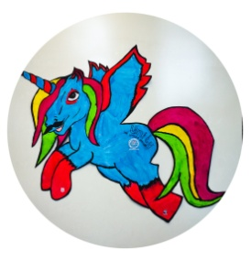
Meet Unity our Right Respecting Mascot. Unity will be on display around our school to show work we have been doing to promote children’s rights. Unity is a unicorn, which is Scotland’s national animal. It is coloured to show the UNICEF and school colours. The name Unity represents the union between Greenhill and Drumpark Primary school.

Rights Respecting Schools Award (RRSA)

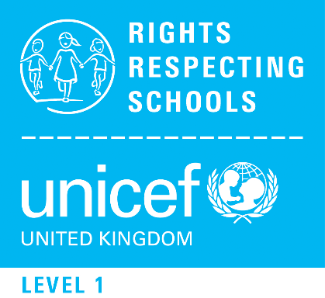

Greenhill Primary and Drumpark Primary are proud to be a Rights Respecting School.
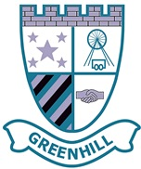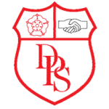

What is a Rights Respecting School?
A Rights Respecting School promotes the United Nations Convention on the Rights of the Child (UNCRC).

Children have their own rights due to their vulnerability and need for protection. For children to reach their full potential these rights must be realised. All children have the same rights no matter where they live.
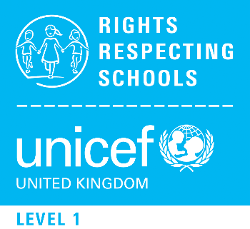
Children’s Rights at Greenhill and Drumpark Primary
Children’s rights are an integral part of our ethos and values at Greenhill and Drumpark Primary school. They support our view that our children achieve most when they feel included and valued.
We are working towards achieving the UNICEF Rights Respecting School Award, based on the UNCRC.
A Rights Respecting School is where:
- Pupils gain self esteem by learning about their rights
- Pupils learn that rights should be respected
- Pupils become active global citizens
- Pupils have a powerful voice.
Every class at Greenhill and Drumpark Primary has written a class charter which includes the rights that everyone in the class has agreed to.

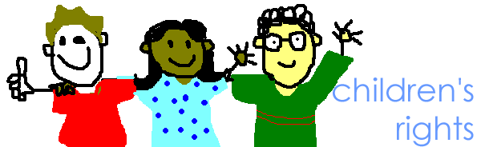

What does the United Nations Convention say on the Rights of the Child?
There are 54 articles or rights. These are some of the rights we learn about at Greenhill and Drumpark Primary.
Article 1 & 2- The right to know their rights;
Article 3- Grown -ups should do their best for all children;
Article 12- The right to be heard and listened to;
Article 13- The right to find things out and say what you think;
Article 15- The right to make and meet friends;
Article 19- The right to be safe;
Article 23-The right to special care and education if you need it;
Article 27- The right to have your physical, social and mental needs met;
Article 28 & 29- The right to an education and to learn;
Article 31- The right to play
Article 29 is particularly important at Greenhill and Drumpark Primary School:
Article 29: Education must develop every child’s personality, talents and abilities to the full. It must encourage the child’s respect for human rights, as well as respect for their parents, their own and other cultures, and the environment.
