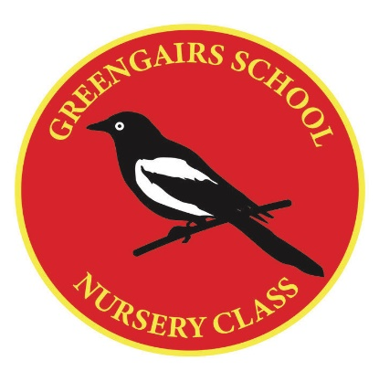
Greengairs Nursery Class
Child Protection Policy

All staff have a responsibility for child protection and training takes place annually to ensure that all staff are aware of the procedures in place.

The Head Teacher Mrs Sneddon is our Child Protection Co-Ordinator within the school and nursery and any concerns must be directly reported to her.

The school and nursery adhere to North Lanarkshire Council Policy – Revised Management Circular C5.

Copies of the detailed Child Protection Policy for Greengairs Nursery Class are available on request.

Updated - August 2025
Reviewed – August 2026

