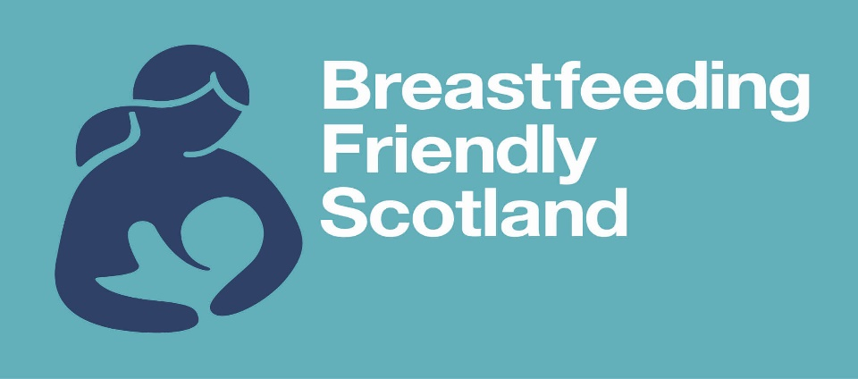

Greengairs Primary School & Nursery


Breastfeeding Friendly Scotland
Policy
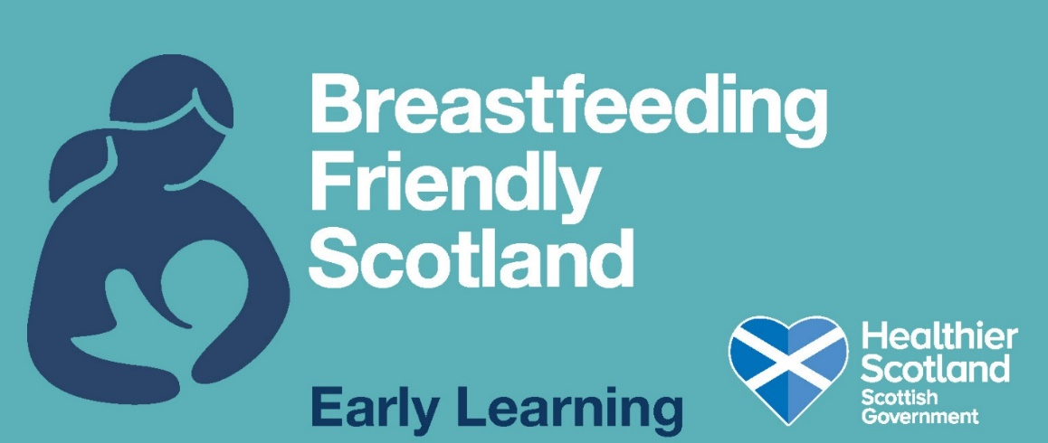

Greengairs Primary School & Nursery recognises the positive health benefits of breastfeeding to babies, young children, and breastfeeding mothers. Our establishment promotes and supports breastfeeding in ways such as:

- Providing an environment where breastfeeding is seen as a natural way to feed babies and young children.

- Supporting mothers who wish to breastfeed in our establishment to do so.

- Providing assurance to pregnant and breastfeeding employees that they will be supported if they wish to continue breastfeeding on return to work, through NLC ‘breastfeeding’ and ‘returning to work’ policies

- Being aware of local services that provide support and information to breastfeeding families should they require it

https://www.breastfeedingnetwork.org.uk/breastfeeding-help/out-about/

This policy takes account of advice given by Scottish government:
Law and Policies Scotland
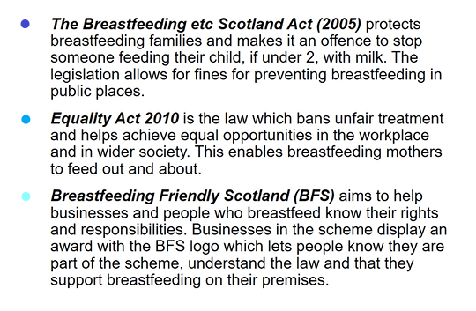
World Health Organisation (WHO) and the NHS recommends… “Exclusive breastfeeding for 6 months followed by continued breastfeeding alongside the introduction of complementary foods for up to 2 years or beyond”.
The Maternal and Infant Nutrition Framework (MINF) aims to “Improve the nutrition of pregnant women, babies, and young children. It supports and promotes the benefits of breastfeeding and the importance of a healthy diet throughout early childhood”.

Curriculum for Excellence
Breastfeeding is important to the overall strategy of improving Scotland’s long-term health. Breastfeeding can be supported through the health and wellbeing area of the Curriculum for Excellence, through the following experiences and outcomes:

- HWB 0-15a I am developing my understanding of the human body and can use this knowledge to maintain and improve my wellbeing and health.

- HWB 0-47b I am aware of my growing body, and I am learning the correct names for its different parts and how they work.

- HWB 0-48a I am learning what I can do to look after my body and who can help me.

- HWB 0-50a I am learning about where living things come from and about how they grow, develop, and are nurtured.

- HWB 0-51a I am able to show an awareness of the tasks required to look after a baby.

- HWB 1-32 I am beginning to understand that nutritional needs change at different stages of life, for example the role of breastfeeding in infant nutrition.

Aims of our Breastfeeding Friendly Establishment:
We aim to promote an environment where breastfeeding is viewed as a natural, healthy way to feed a child.
Objectives:
- To educate and train staff to enable them to support breastfeeding.
- To support informed choices in relation to infant feeding.
- To increase breastfeeding awareness with appropriate sources of support and information.
- To use resources which promote breastfeeding within our establishment, where appropriate.
- To support breastfeeding mothers, and ensure an allocated area for them to do so within our establishment.
- To promote a positive social attitude to breastfeeding.
- To work our way towards meeting the criteria for the Breastfeeding Friendly Award

If you have any enquiries in relation to breastfeeding at Greengairs Primary & Nursery, please do not hesitate to speak to a member of management staff.

