Gteengairs Primary School
Raising Attainment and Achievement and Ensuring Equity for All Policy
Rationale
“Attainment is an individual's passport to personal, social, cultural and economic opportunities. Raising attainment means improving life chances. This does not mean just focusing on exam results, but instead looking at attainment in its widest sense. It is this rich attainment which enables all of our children and young people to make good progress and develop the skills, ambition and know-how they need to improve life chances.”
Raising Attainment, Scottish Government, March 2012
‘Children’s education should develop each child’s personality, talents and abilities to the fullest.’
United Nations Convention on the Rights of the Child, Article 29

THE NATIONAL IMPROVEMENT FRAMEWORK
The National Improvement Framework details key drivers for improvement and describes responsibilities at school level. Evidence from self-evaluation against these drivers will inform the standards and quality reporting and the improvement priorities. This policy is structured around the key drivers for improvement within the National Improvement Framework. This approach is used by Greengairs Primary to review and develop its strategies to raise attainment and ensure equity for all children.

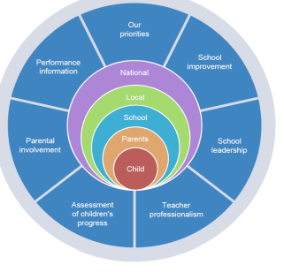
AIMS OF THE FRAMEWORK
• A school ethos that puts the wellbeing of children at its centre;
• An equitable approach to meeting the needs of all learners - a belief that every child matters and can achieve at the highest level;
• A strong focus on the teaching of Literacy, Numeracy & Mathematics and Health & Wellbeing;
• Ensuring high quality learning experiences
across all curricular areas – learners who are engaged and active participants;
• Rigorous assessment procedures and an effective tracking system to monitor the progress of learners;
• Using data intelligently to identify strengths and areas for improvement;
• Leadership at all levels that empowers and builds the capacity focusing on improved outcomes for all learners;
• Professional learning opportunities that continually develop the skills and competences of our staff;
• A strong and effective partnership with all stakeholders, including parents, that positively impacts on the achievement of pupils.

THE IMPROVEMENT FRAMEWORK WITHIN GREENGAIRS PRIMARY SCHOOL
Raising attainment & achievement and ensuring equity for all pupils is the core function of our school community. Attainment is a measure of educational progress assessed against recognised standards while achievement goes far beyond this to recognise the range of skills and personal successes gained in school, at home and within the community, including attributes such as effort, determination and independence. Attainment and achievement opportunities are equally important for children to develop self-confidence and become responsible citizens ready for lifelong learning and the world of work. This policy outlines how we plan to continue to raise attainment and achievement for all of our children.
SCHOOL LEADERSHIP
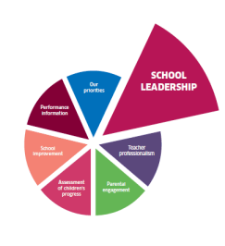
Leadership at all levels is recognised as an important aspect of the success of Greengairs Primary. This includes leadership of learning and leadership of change. In Greengairs Primary the Head Teacher works in partnership with staff, children and parents to develop a shared vision for change and improvement. There is a clear strategic improvement plan which is informed by effective self-evaluation and agreed collegiately with staff. Staff at all levels are empowered to develop leadership. Opportunities for pupils to take on leadership roles, including the leadership of their own learning, are promoted throughout the school. All staff are involved in a rigorous self-evaluation process to ensure a clear understanding of the school’s journey to improvement and what the next steps are to continue to improve. All staff are engaged in the professional review and development process which has a positive impact on school improvement.
Leadership within the school is evident at all levels. Staff are effective in leading School and Cluster Improvement Plan priorities and are well supported and encouraged by the Senior Management Team in leading different initiatives. Many staff have responsibility for different curricular areas and there is a strong involvement in cluster and partnership working. Staff work collegiately to revise school policies and programmes. Staff are involved in sharing good practice through joint planning, peer visits, Professional Learning Communities and staff meetings. Children demonstrate leadership through their roles in the Pupil Council, JRSOs, ECO Leadership committee, Junior Sports Leaders, Rights Respecting Committee, and as Playground Pals. Children have opportunities to take responsibility through assemblies, class jobs,

TEACHER PROFESSIONALISM
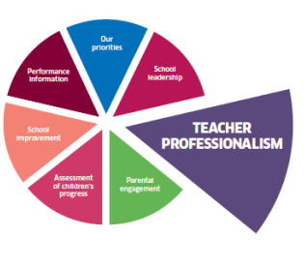
All teachers and support staff in Greengairs Primary engage in Professional Review and Development. Greengairs Primary’s School Improvement Plan clearly details the professional learning required to implement priorities. This is linked to Staff Professional Review and Development and encompasses all forms of professional learning. All teachers record and evaluate their professional learning as part of the requirements for GTCS Professional Update. Staff in Greengairs Primary have opportunities to lead on curricular developments and to be members of Professional Learning Communities within the school, the cluster and the authority.. Professional learning communities are established to share practice and support pedagogical developments. Practitioner enquiry is at the core of professional learning and is key to improving learning and teaching. In Greengairs Primary this is supported by the School Management Team, the Council’s Psychological Service and by Quality Improvement Service. Teachers’ professional judgement within assessment is of crucial importance in ensuring the highest standards of attainment and achievement. There is an effective system in place in Greengairs Primary and in our cluster working to support teachers to engage in moderation activities.

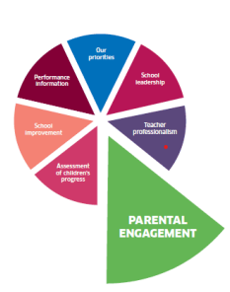
PARENTAL ENGAGEMENT
Parents and carers have a key role in supporting their child’s learning and development in Greengairs Primary. Parents are updated termly on targets and achievements and have regular opportunities to attend school events to see their child’s learning e.g. Meet The Teacher, Showcase/STEM events, Parents’ Night, Assemblies, Shows, etc Information is provided in various formats (leaflets, newsletters, text, emails, Twitter, Group Call and the school website to help communicate what is going on in the school and detail ways they can support their children’s learning and development. Parent consultations happen twice a year and a summative report provides information for parents/carers with regard to progress n the final school term. Arrangements for reporting have changed format as a result of Covid -19 mitigations.
Staff are always willing to meet parents at any time of year to discuss their child’s learning and progress. Parents and carers have planned opportunities to work in partnership with the Senior Management Team and Class Teacher to plan and review pupil targets for targeted support plans. To ensure equity for all children, Greengairs Primary works in partnership with parents and a range of agencies including Social Work, Health, Police and voluntary organisations. This is a crucial element of the implementation of Getting It Right For Every Child in our school.

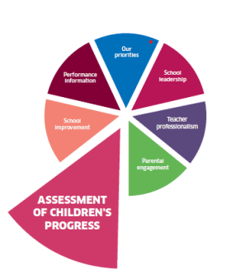
ASSESSMENT OF CHILDREN’S PROGRESS (SEE ASSESSMENT POLICY)
Assessment Strategy
Greengairs Primary has an assessment strategy in line with Curriculum for Excellence. The following key elements are in place:
• purpose and principles of assessment
• links between learning, teaching and assessment
• use of formative assessment
• range of assessment methods
• summative or standardised methods
• arrangements for moderation
• arrangements for tracking and improving children’s progress
• reporting, recognising achievement, pupil passports (profiles)
Greengairs Primary has clear arrangements for moderation to share standards of achievement of a level for Curriculum for Excellence.
Data is used effectively to rigorously analyse attainment to inform improvement.
Greengairs Primary has an effective tracking system to track the attainment and achievement of individual children with appropriate intervention strategies in place to provide support.
In Greengairs we record the Curriculum for Excellence level achieved by individual pupils in Reading, Writing, Listening & Talking and Numeracy. There is also a process in place to track children’s wider achievements and aspects of Health and Wellbeing.
Interventions are put in place for those at risk of missing out.
Greengairs Primary ensures that the tracking of children’s progress is partnered with effective intervention to assess, support and monitor children with additional support needs. This is in line with the Council’s strategy to ensure the implementation of Getting It Right For Every Child (GIRFEC).

WELLBEING, EQUALITY & INCLUSION
Wellbeing is central to the life and work of Greengairs Primary. There is a highly visible nurturing and caring ethos in the school. Relationships between adults and children are extremely positive and children are treated with equality, fairness and respect. There is a positive working ethos and a sense of fairness and equity. Children are respectful of others, confident and articulate in expressing their opinions and ideas. Staff are alert to the social and emotional needs of pupils and ensure these are well supported. Overall there is a strong emphasis on the care and welfare of children.
We use Circle Time and across the school and this clearly impacts positively on pupil resilience and the wider school ethos. Seasons for Growth can be implemented when required to support children experiencing loss. Learners’ needs are very well met through an effective and well documented universal/targeted support process. Staff have a clear understanding of the various strategies that could be employed to provide universal support within a classroom and can identify appropriate strategies to provide targeted support where necessary.
Support for learning is effectively co-ordinated and ensures children experiencing barriers to learning are identified early and are well supported to access the curriculum and the wider life of the school. Pupils are involved in the setting of targets and in evaluating progress towards these.
Support staff are effectively deployed in classrooms to support pupils/staff.
There are enhanced transition arrangements for children with additional support needs.
Staff know their children very well and information is shared appropriately and in advance of transitions.
Information from the Scottish Index of Multiple Deprivation is used to ensure that children from the most disadvantaged backgrounds progress is closely monitored and appropriate interventions are made to support them, if required.
LEARNING, TEACHING & ASSESSMENT
Teachers employ a range of teaching styles and strategies to engage children in their learning. Children have opportunities to work both individually and in pairs or groups across the school in stimulating learning contexts. Teachers use questioning to elicit prior learning and to make explicit links with real life contexts.
Formative assessment is used in class lessons and as an integral part of target setting. Teachers and children engage with learning intentions, co-construct success criteria and pupils have opportunities to self and peer assess against these success criteria.
Teachers work hard to ensure learners are motivated and engaged. Pupils are given opportunities to develop skills for learning and life and are aware of how to be successful and how to achieve their next steps in learning.
A variety of assessment approaches are used to allow learners to demonstrate their knowledge and understanding, skills, attributes and capabilities in different contexts across the curriculum. Our assessment evidence is used to report on children’s progress.
The nursery/primary transition programme includes effective links between staff and regular visits take place between nurseries and school, with enhanced transition for identified pupils. There is a comprehensive and very effective transition programme in place with Airdrie Academy, our cluster secondary school. Secondary staff work with primary 6 and 7 classes and there are a series of visits for pupils and parents to help prepare pupils for their move to secondary. This includes an enhanced transition programme to support identified children. HART meetings begin in primary 6 to ensure that appropriate measures are in place should any child require additional support.

THE CURRICULUM (SEE CURRICULUM RATIONALE)
The rationale for the curriculum is based on a strong ethos of respect for all, attainment and achievement. Curriculum development has involved staff taking forward school and cluster initiatives in a range of curricular areas. Curriculum areas are revised on a regular basis. Teachers plan lessons in all curricular areas using progressive pathways based on CfE experiences and outcomes for Literacy, Numeracy and Mathematics, Health and Wellbeing, Science, Social Studies, Expressive Arts (Art, Drama, Dance, Music), Religious and Moral Education and Technologies, including ICT. Forward plans in these areas encourage teachers to plan across levels thus ensuring there is no ceiling to achievement. Moderation activities provide valuable opportunities for staff to engage in professional dialogue, share good practice and consistently agree the achievement of levels. Benchmarks are used to support professional judgement. The curriculum provides opportunities for children to make links across their learning. Staff plan interdisciplinary learning (IDL) across a range of subjects. Learning through cross cutting themes such as sustainability, global citizenship and enterprise is embedded in the curriculum. The use of digital technology and the application of Literacy and Numeracy skills across learning ensures that pupils have a depth of knowledge. The curriculum for Health and Wellbeing is well planned using effective planning frameworks based on the experiences and outcomes. Links are made to other curricular areas. school fulfils the children’s entitlement of two hours quality physical education. Sexual Health and Relationships Education is implemented through a whole school approach.
ATTAINMENT OVER TIME
Within Greengairs |Primary we have a robust and effective system for tracking children’s progress which informs teaching approaches to ensure progression, depth and breadth of learning. Standardised assessments are used alongside a range of other assessments and the evidence from these underpins professional dialogue and informs learners’ next steps. Tracking meeting happen twice annually, in November and May, when staff make professional judgements based on a plethora of evidence, to help determine a child’s progress, achievement and “On-track ness” within a level. Baseline and Standardised Tests are analysed by class teachers and the Management Team in order to track pupils’ progress and determine gaps. All assessment information helps class teachers and managers to organise groups and meet the needs of individual children. The school is committed to self-evaluation which includes a robust system for monitoring teaching and learning and meeting the needs of children. The head teacher is committed to improving the quality of learning and teaching in classes. She carries out classroom observations and conducts teaching and learning meetings to feedback to staff following classroom observations. Learning conversations with children happen after classroom observations to gather children’s views about their learning and jotter monitoring happens at this time too.
Assessment/Tracking Meetings, Forward Plan Meetings and Supporting Learners’ Needs Meetings encourage professional dialogue between teachers and SMT.
RECOGNISING WIDER ACHIEVEMENT
Wider achievement is tracked and recognised in a number of ways:
• Shining Star
• Achievement certificates / stickers
• Pupil Passports, including Snapshot jotters containing information on wider achievements from home targets
• Tracking of pupil involvement in after-school activities
• Tracking of pupil responsibilities

SCHOOL IMPROVEMENT
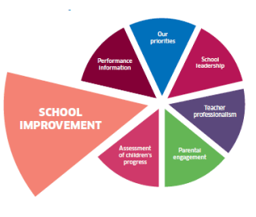
(See Self-Evaluation and Improvement Policy) In Greengairs Primary the key to raising attainment and achievement lies in the successful implementation of Curriculum for Excellence. This requires the three elements:
- Curriculum;
- Assessment; and
- Learning and Teaching to be linked and informed by robust self-evaluation.
The aim is to ensure progression in learning for all children and young people. Curriculum for Excellence requires that Greengairs Primary works across sectors to develop and implement approaches to the curriculum, assessment and learning and teaching.
Greengairs Primary has a clear curriculum framework with the following in place:
• Clear rationale for the curriculum;
• Clear strategic framework to support planning;
• A skills progressive pathway within each curriculum area;
• Planning ensures progression in learning; and
• A framework in place for Literacy, Numeracy and Mathematics, and Health and Wellbeing.
• A plan in place to develop and refresh curriculum areas to build back better;

PERFORMANCE INFORMATION
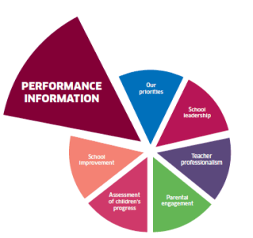
Greengairs Primary uses a wide range of data to inform approaches used to raise attainment including:
• Information from monitoring and tracking systems;
• Baseline results in Primary 1;
• Information on progress from nurseries
• On-going formative assessment;
• Periodic assessment (IDL, Taught writing);
• Standardised test results
- SNSA results at P1, P4 & P7

Standardised test results are recorded for each pupil as part of the tracking of attainment for individual children. This data is also analysed as part of self-evaluation in order to inform improvement at class and school level.

STRATEGIES FOR RAISING ATTAINMENT IN LITERACY AND NUMERACY
In line with national guidance we recognise the importance of providing all of our pupils with effective literacy and numeracy skills that will help them in their learning, life and work. At Greengairs Primary attainment levels in literacy and numeracy are a central feature of the school’s priorities for improvement. In order to effectively raise attainment in Greengairs Primary we ensure:
• High quality learning and teaching which includes effective use of higher order thinking skills and digital technologies
• Effective professional learning for teaching and support staff
• Consistent approaches across the school
• Skills based planning which ensures progression and application
• Clear differentiation with challenge and support as required
• Skills for learning, life and work are central to planning
• Learning should take place across the 4 contexts
• High expectations for all
• Learners engage in discussion about their learning and are clear about their achievements and next steps
• A wide range of strategies used to meet pupil need
• Clear assessment strategies using formative and summative assessments
• Robust and effective tracking and monitoring
• Moderation of achievement of a level using Benchmarks
• Clear processes to address barriers to learning
• Universal support strategies have a positive impact on learners
• Early intervention at all stages
• Parents and other partners have a positive impact on learners achievement

CLOSING THE POVERTY RELATED ATTAINMENT GAP/ PUPIL EQUITY FUNDING
In line with the National Improvement Framework, Greengairs Primary has a strong focus on closing the attainment gap. We have carried out rigorous self evaluation and considered a range of data and other information to inform our school improvement strategies to close the poverty related attainment gap.
“Closing the gap is a shorthand expression for all of our work to interrupt the cycle of deprivation and the impact on children’s progress and attainment.” (Graeme Logan, 2017)
Greengairs Primary uses a wide range of data to inform our self-evaluation. These include consideration of:
• FME data and links to attainment
• CfE Levels in literacy and numeracy by SIMD quintiles
• Attendance, exclusions, participation rates
We work together to define what the gap looks like in our school context and identify improvement priorities to address the gap. We endeavour to use our Pupil Equity Funding to achieve the best outcomes for learners. ‘Closing the Gap’ should ensure we have no pattern of lower attainment for children in lower SIMD bands. We aim to ensure all children achieve their full potential regardless of their SIMD band.

