Greengairs Nursery Class

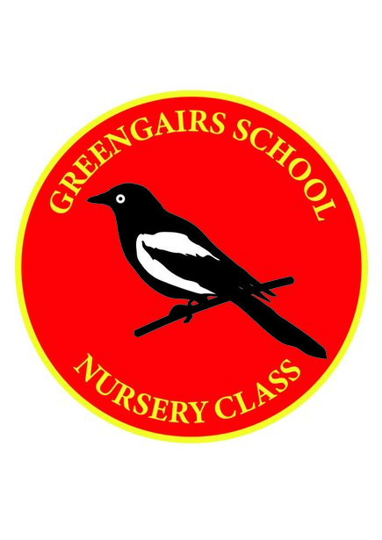

PPE Policy

PPE – Covid-19

Staff carrying out intimate care should wear an apron, gloves and face coverings are provided if staff desire to wear one.

Staff have access to disposable single use gloves for spillage of blood or other bodily fluids and also for disposing of dressings or equipment.

Hand hygiene is essential before and after all contact with a child receiving intimate or personal care, before putting on PPE, after removal of PPE and after cleaning equipment and the environment. Hands should be washed with soap and water.

Suspected Covid-19: Gloves, aprons and a fluid resistant surgical mask should be worn by staff if a child or young person becomes unwell with symptoms of Covid -19 and needs direct personal care.

