Greengairs Nursery Class

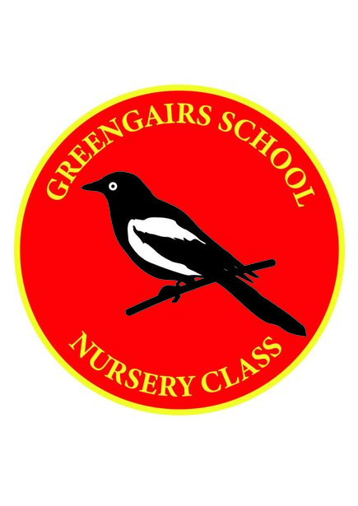

Health and Safety Policy

Health and Safety

Rationale
The health and safety of all members of our nursery community is of paramount importance. It is necessary for all staff to know procedures laid down by the Authority to promote safety and welfare within our establishment.

Aim
We aim to ensure that all staff are aware of North Lanarkshire’s Health and Safety Policy and where our Nursery statement meets the demands there in.

Objectives
In Greengairs Nursery we will;
- Ensure each member of staff has a copy of the NLC Statement and is able to access the relevant information.
- Locate the General and Master Safety files in the office and ensure that they are updated on a regular basis by the person responsible-
Mrs Emma Dalziel (Head Teacher)
- Ensure that a risk assessment tales place on an annual basis, findings should be reported to Senior Health and Safety Officer, Contracts and Provisions (Health and Safety).
- Ensure that all contractors adhere to the conditions set out in the standard circular 74
- Ensure that all accidents and injuries are recorded in the Nursery Accident log and /or School Accident book and the appropriate pro forma completed and sent to the Senior Health and Safety Officer, Contracts and Provisions (Health and Safety) by the person responsible – Mrs Emma Dalziel, Head Teacher.
- Ensure that all staff are aware of evacuation procedures in the event of a fire or any other reason; person responsible - Mrs Emma Dalziel, Head Teacher.
- Ensure that fire drills tale place regularly and are recorded in the fire procedures book (responsible person – Mrs Emma Dalziel Head Teacher). Regular fire drills allow children to become familiar with the routine.
- Ensure the fire alarm is tested on a regular basis and recorded in the Fire Procedures Book : person responsible – Mrs
- Ensure that all parents have met with the SMT.
- Actively encourage parents to inform illness, special needs, dietary requirements, etc. of their children, to enable us to support them appropriately; responsible person – all staffs responsibility

- Mrs Spyrka is the first aider (please see policy regarding medical scenarios) and Mrs Dalziel is the Health and Safety Representative. All staff concerns should be reported to her.
- Staff to complete risk assessments in both playrooms and outdoors on a daily basis. Any risks will be recorded on playroom risk assessment documents and reported.
- All staff to adhere to strict food handling and hygiene procedures throughout the nursery (see Food Handling Policy and Infection Control Policy).
- Staff to ensure that the nursery areas are cleaned on a daily basis and documented on to the cleaning rota documents that are in place.
- Staff to record the temperatures of the fridge and freezer each morning and afternoon and that these are recorded on the fridge temperature document.

Covid -19
- All staff must to adhere and comply with the up to date guidelines and rules from the Scottish Government in regards to the Health and Safety regulations in regards to Covid -19.
- PPE is available in each room for staff to use.
- Staff need to sign in and out of the school for track and trace
- All visitors to the school also have to sign in and out for track and trace.
- No parents are allowed within the school or nursery building to minimise the risk of infection.
- All staff have to comply with the 2m social distance rule.
- All parents are asked to follow the one way system and socially distance when dropping off and picking up at nursery.

Conclusion

Staff awareness of this document will be raised on an annual basis and will be reviewed in the light of the experience.

