Greengairs Nursery Class

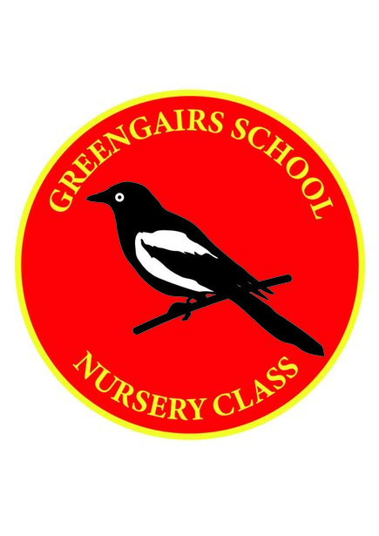

Ventilation Policy

Ventilation Policy – Covid-19

Both large and small playroom windows are left open throughout the session, doors are open also from the small playroom to the large room and from the large room to the welcome area.

