Greengairs Nursery Class

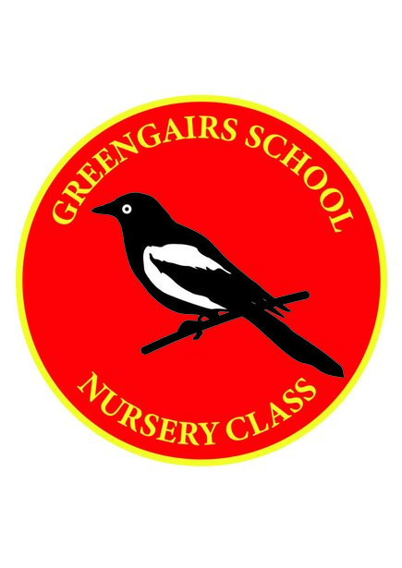

Prevention of Infection Policy

Prevention of Infection Policy – Covid-19

In Greengairs Nursery we adhere to North Lanarkshire Education Departments policies and the Scottish Government Covid- 19 guidelines.
We ensure that the guidelines for infectious diseases are followed and parents are asked to keep their child off if there is any doubt about illness.

If staff thought that a child was displaying symptoms of an infectious illness then the parents will be contacted and asked to take the child home.

Suspected Covid-19: Gloves, aprons and a fluid resistant surgical mask should be worn by staff if a child or young person becomes unwell with symptoms of Covid -19 and needs direct personal care.

In the event of a child being sick/soiled or bleeding, the nursery staff will wear protective clothing e.g. apron, disposable gloves and face covering if the staff member wishes to wear one. To prevent cross infection when dealing with the child.

Disposable paper towels are used by both adults and children when hand washing. Blue/White roll and toucan spray is used for cleaning surfaces and appropriate resources, if cloths are used they are either disposed of after use.

Antibacterial hand gel dispenser is available outdoors at the entrance to the nursery and also in the cloakroom/welcome area, bottles of hand gel are available within the playroom also.

Children have been encouraged not to bring any toys, comforters etc. from home.

Children have been encouraged to leave wellies, indoor shoes and a change of clothes which then goes in to a nursery bag which stays on their personal peg, to lessen the risk of contamination between nursery and home.

Hand washing should take place;
- On arrival to nursery
- Before and after eating
- After toileting
- When moving between areas – outdoors to indoors

Children are encouraged to cough and sneeze into a tissue which would then be disposed immediately or into their arms and then wash their hands

