Greengairs Nursery Class

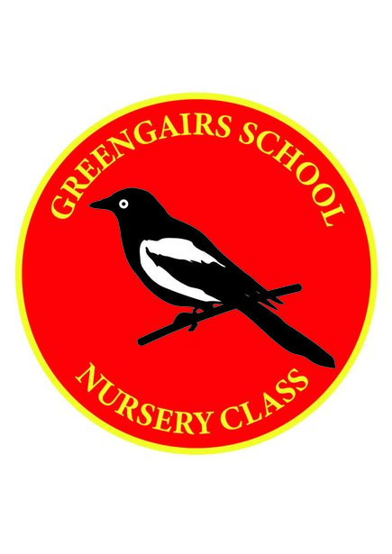

Handwashing Policy

Handwashing– Covid-19

Rationale
‘Hand washing plays a pivotal part in the control of cross contamination’

‘Guide to food hygiene’ North Lanarkshire

Aim
- To prevent the spread of infection
- To develop good personal hygiene

In Greengairs Nursery Class we adhere to the guidelines in ‘Guide to Food Hygiene’ supplied by North Lanarkshire Council and also Scottish Government in regards to the regulations in regards to Covid- 19.

Personal Hygiene staff:
- Due to the current circumstances in relation to Covid – 19 staff wash their hands and sanitizer regularly throughout the day, we have soap and hand sanitizing stations spread throughout the nursery and school. PPE is also available for staff to use.
- Before preparing and eating food
- When any visible contamination or soiling occurs after handling bodily fluids
- After handing children with cuts, abrasions or suspected infections
- After nose wiping – their own or a child’s
- After changing nappies/ soiled or wet clothes
- After touching the toilet or accompanying a child to the toilet.
- After touching materials/animals that may spread infection.

Personal hygiene children:

Hand washing should take place;
- On arrival to nursery
- Before and after eating
- After toileting
- When moving between areas – outdoors to indoors
- Children are encouraged to cough and sneeze into a tissue which would then be disposed immediately or into their arms and then wash their hands.
- Staff will support children daily when washing hands and provide support where necessary and ensure no sharing sinks or water and that their hands are dried thoroughly.

Resources

- Hands can be washed at the designated wash hand basins, where liquid soap and disposable paper towels are available for drying hands.
- Antibacterial hand gel dispenser is available outdoors at the entrance to the nursery and also in the cloakroom/welcome area, bottles of hand gel are available within the playroom also.
- A copy of ‘Guide to food hygiene : Appendix 3’ (How to wash your hands thoroughly) will be displayed beside designated wash hand basins, along with board maker symbols and a photographic visual guide on how to hand washing.
- The water temperature from taps in basins used by the children should be checked regularly throughout each day to prevent scalding. Any problems with the water temperature should be reported to the janitor immediately.

