Greengairs Nursery Class

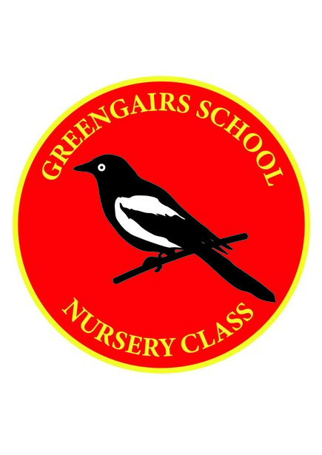

Enhanced Hygiene Policy

Enhanced Hygiene Policy – Covid-19

Disposable paper towels are used by both adults and children when hand washing. Blue/White roll is used for cleaning where possible, if cloths are used they are either disposed of after use.

Antibacterial hand gel dispenser is available outdoors at the entrance to the nursery and also in the cloakroom/welcome area, bottles of hand gel are available within the playroom also.

Parents/Carers have been encouraged not to enter the nursery and staff will greet children at the front doors, they will also exit the nursery in this way.

Children have been encouraged not to bring any toys, comforters etc. from home.

Children have been encouraged to leave wellies, indoor shoes and a change of clothes which then goes in to a nursery bag which stays on their personal peg, to lessen the risk of contamination between nursery and home.

Hand washing should take place;
- On arrival to nursery
- Before and after eating
- After toileting
- When moving between areas – outdoors to indoors

Children are encouraged to cough and sneeze into a tissue which would then be disposed immediately or into their arms and then wash their hands.

Staff will support children daily when washing hands and provide support where necessary and ensure no sharing sinks or water and that their hands are dried thoroughly.

