Greengairs Nursery Class

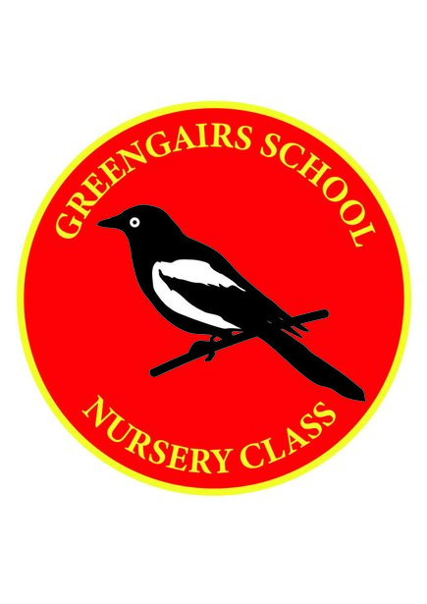

Days and ours of Opening Policy

Days and Hours of Opening

In Greengairs Nursery we follow term times and holidays of the school. A list of holidays can be found on the North Lanarkshire website.

The nursery operates full time sessions Monday to Friday from 8.45am to 2.45pm.

