Greengairs Nursery Class

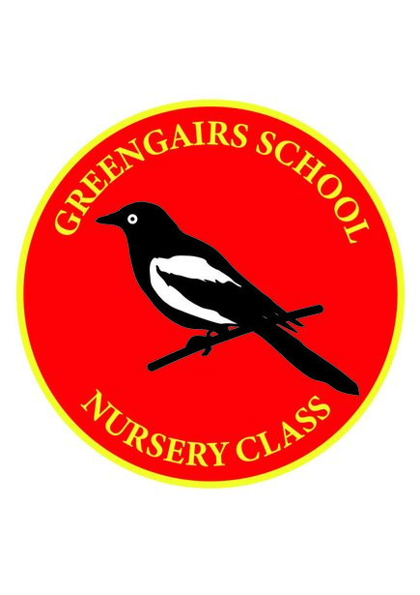

Cleaning Schedule Policy

Cleaning Schedule Policy – Covid-19

We operate in one cohort within Greengairs Nursery class with a maximum of 16 children. We use toucan and white/blue roll to clean the nursery environment.

Daily:

- All tables, chairs and hard surfaces sprayed and wiped down.
- A cleaning rota is in place to deep clean an area each night with all washable resources being cleaned in the dishwasher (as advised for deep cleaning). This means that each are within the playroom is deep cleaned every week.
- All other resources are sprayed and wiped down
- All soft furnishings are sprayed at the end of each day
- Malleable materials e.g. playdough, gloop are disposed of daily and freshly made the next day.
- Each child has their own tray stocked with arts and crafts resources, e.g. pens, pencils, paper, glue pots, glue stick, paint brush, chalk.
- Water trays are replenished daily and sprayed and wiped down.
- Each child has their own waterproof suit which is on a labelled hanger provided by the nursery, children are asked to bring in their own wellies.
- All snack dishes are washed in the dishwasher after each use.
- Touch points are cleaned regularly throughout the day by the cleaner.

Weekly:
- All areas are deep cleaned within the week
- Waterproof suits are washed weekly
Sand is given a thorough clean weekly and toucan sprayed and debris removed.

