Greengairs Primary School
Number Talks Policy

Number Talks – Resource Overview

Please find below a simplified overview of how to use the Number Talks resource for Mental Agility

Number Talks is a resource designed to support and facilitate daily ‘Mental Agility’ sessions within primary school numeracy lessons.
“Mental Agility is the ability to carry out multi-step mental questions accurately”.

Number Talks outlines the range of mental strategies for solving number-based problems for all 4 number operations (addition, subtraction, multiplication and division). Throughout Mental Agility sessions, the teacher will directly teach the range of strategies for their stage, engaging the children in a variety of active experiences that familiarise the children with the process of each mental strategy.
“The problems in a number talk are designed to elicit specific strategies that focus on number relationships and number theory. Students are given problems in either a whole class or small-group setting and are expected to mentally to solve them accurately, efficiently and flexibly.” (Parrish, Sarah. 2014 Number Talks)

The resource specifically highlights the significance of a purposeful conversation based around number problems that are to be solved mentally. The children are encouraged to select (from the variety of strategies taught by the teacher) the most effective strategy for mentally calculating the number problem posed and articulate clearly the process they went through to determine the answer.
“By sharing and defending their solutions and strategies, students have the opportunity to collectively reason about numbers while building connections to key conceptual ideas in mathematics.” (Parrish, Sarah. 2014 Number Talks)

The idea is that, regardless of the lesson’s focus, the children would begin every maths lesson with a number-based mental agility session. When Mental Agility using Number Talks is first being implemented, these sessions may take up to 40+ minutes, however as this becomes more embedded, “A typical classroom number talk can be conducted in five to fifteen minutes” depending on the problem, strategy being taught, stage etc.

Where to begin?
The resource is based on American Education grading. Below is a table clearly outlining the grade that represents Scottish Primary levels.
Converting American Grades to CfE Levels:
American Education | Scottish Education
Kindergarten | Primary 1  Primary 2
Grade 1 | Primary 3
Grade 2 | Primary 4
Grade 3 | Primary 5
Grade 4 | Primary 6
Grade 5 | Primary 7

Strategies
As mentioned above, each stage are taught varying strategies. Below is a table that outlines which strategies should be taught at each stage.
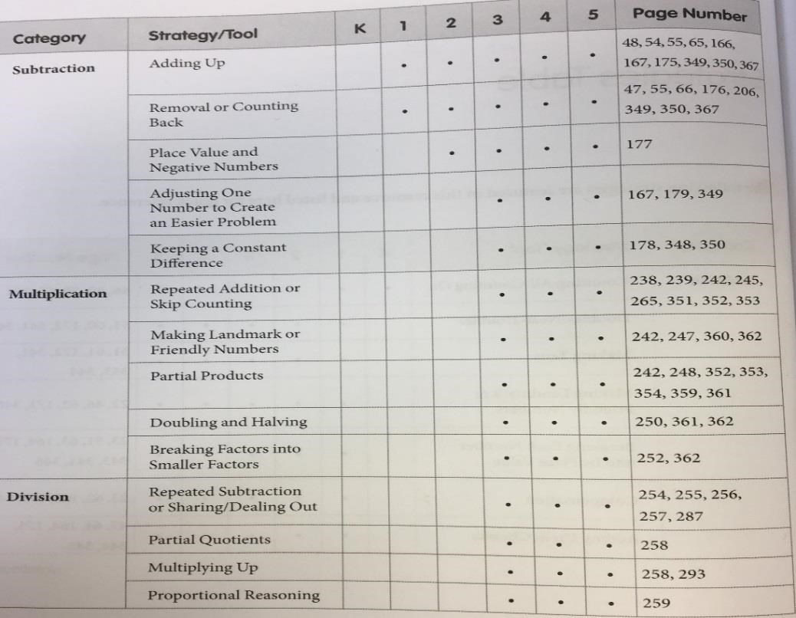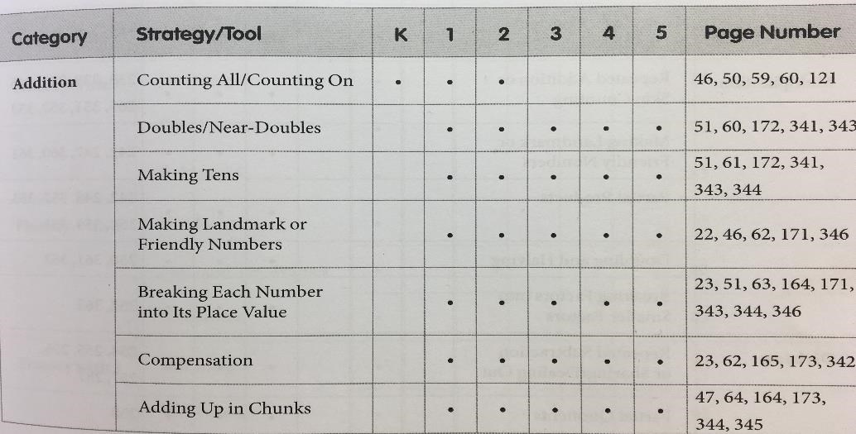

These tables can
be found on
p.xxix

and p.
xxx in the
Number Talks
book

Strategies taught
in each stage are
highlighted with a
dot

Mental Agility Methodology
Mental Agility can take a variety of forms. As we know children learn differently, some are visual learners; others learn kinaesthetically. The aim of Mental Agility sessions is to provide the children with an array of mental strategies that they can choose from. These strategies are further explained in the Number Talks book and can be arranged under the following headings:

Hands On
Counters, cubes, coins, some practical experience to draw upon, manipulate materials to allow exploration, being able “to see” the problem .

Visualisation Jottings 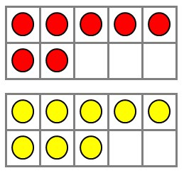
Dot images, Ten-Frames, Rekenreks etc - Developed through practical experience and practise.
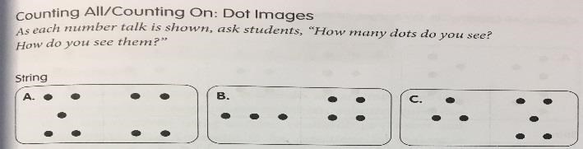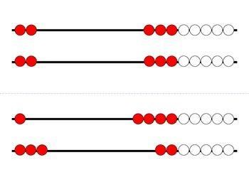 Ten-Frames

Dot Images

Rekenreks

Informal notes, use of models and diagrams, white boards, jottings jotter.
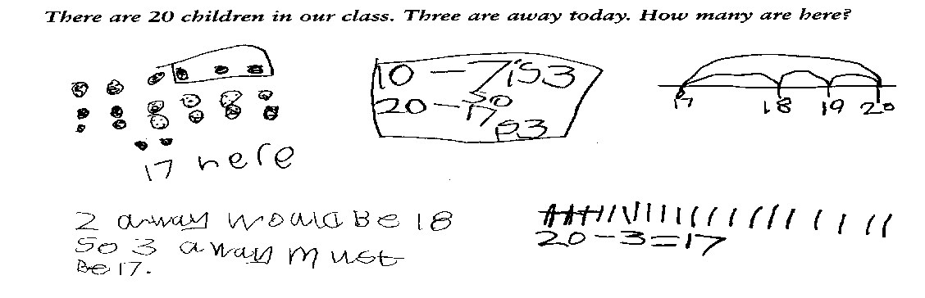

Empty Number Lines
Modelling calculations, developing understanding, develop an image of a number in their head.
Before children can begin to use an empty number line, they need to have had lots of experience of counting on and back using numbered lines, bead strings and partly numbered lines.
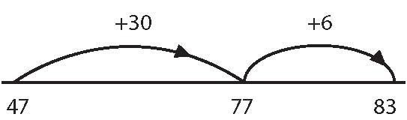

0
10 20

Mathematics lesson Structure Guide
Monday – Thursday Mathematic Planning
Approx. Time | Activity | Suggested Resources
5min | Learning Intentions Displayed and Discussed
10min | Mental Maths | Mental maths books  Mental maths planners  Have a go boards markers  Number fans  Clock faces  Songs, Rhymes, Raps  Flashcards
15mins | Number Talks Mental Agility | Number Talks Book  Strategy Posters Displayed  SmartBoard,  Whiteboard,  Hands-On resources,  Jottings Jotter,  Empty Numer Lines,  DreamBox Website has interactive mental agility strategies (*see link below)
15min | Revisit Learning Intention  Prior Learning  Direct teaching – whole class | Heinemann Teaching book
15min | Practical Activities – Differentiation | Active Maths
15min | Recording activities - Differentiation | Heinemann  T J
Fast Finishers | Extension Tasks Available | Extension books  Maths cards
15min | Plenary  Teacher/peer/self assessment  To include what we have learned  What we will be learning  Discuss Homework  Can be taken outside should vary throughout the week | Word Problem,  Use of Formative Assessment techniques,  Blooms-style Questioning,  Plenary Dice
*DreamBox website link - http://www.dreambox.com/teachertools

Friday Mathematic Planning
Approx. Time | Activity | Suggested Resources
5min | Learning Intentions Displayed and Discussed
15min | Mental Maths tests 2 groups  Tables test | Recorded at the Back of jotters
15mins | Number Talks Mental Agility | Number Talks Book
10min | Problem Solving Teaching skills – RACE CAR | RACE CAR Display PP
15min | Problem Solving/ Word problems – training for holistic assessments | Problem Solving disks  Holistic assessments
Fast Finishers | Extension Tasks Available | Extention books  Maths cards
15min | Plenary  Teacher/peer/self assessment  To include what we have learned  What we will be learning  Discuss Homework  Can be taken outside should vary throughout the week
N.B ICT must be include at some stage in the lesson.
Formative Feedback should be evident throughout and in assessments using 2 star and a wish

