Our current school role is 91 children. We received responses to our homework survey from 52 families, representing 63 children. | 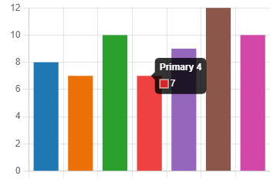
I feel homework is a vital part of my child's education. | Agree 27  Neutral 19  Disagree 6 | 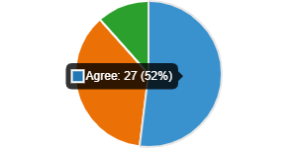
I would like my child/children to receive weekly homework. | Yes 40  No 12 | 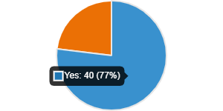
I would like my child/children to receive more homework than previously provided. | Yes 17  No 35 | 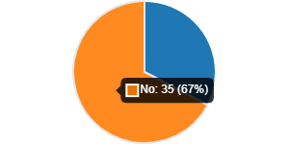
My child/children spend enough time in school learning and should be free to play and attend clubs after school without worrying about homework. | Agree 15  Neutral 24  Disagree 13 | 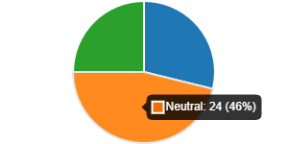
Homework places additional stress/pressure on family life. | Never 10  Sometime 19  Often 8 | 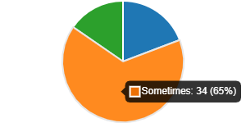
I would like to see all homework stop. | Agree 13  Disagree 39 | 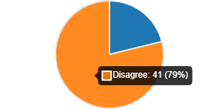
I would be happy for my child to continue receiving important core homework tasks such as reading, spelling and number facts. | Yes 47  No 5 | 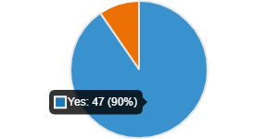
I believe that any tasks set should be practical and active and that written tasks should be avoided. | Agree 13  Disagree 39 | 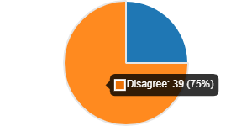
I would prefer short written tasks for my child/children. | Yes 17  No 5  Neutral 30 | 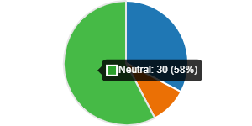
I feel it is important for children in the later stages of primary school to receive more formal homework tasks to help prepare them for secondary school. | Yes 41  No 11 | 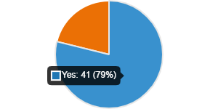
I would be happy for my child to access a weekly grid of suggested core homework tasks and additional tasks. Tasks could be to consolidate/extend learning. | Yes 39  No 13 | 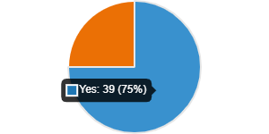

- 52% of families recognise homework as being a vital part of their child’s education and 77% of families would like their child to receive weekly homework.
- 67% of families do not want to receive more homework than previous years however 33% of families would.
- 65% of families agreed that homework could sometimes place additional pressure on family life.
- 21% of families would like homework to stop altogether.
- 90% of families would like children to receive core homework tasks each week.
- 75% of families disagreed to homework tasks should all be active and practical. 32% of families would like homework to consist of written tasks.
- 79% recognised that homework was important in the later stages of primary, preparing learners for high school.
- 75% agreed that a grid of core homework tasks weekly to consolidate and extend learning would be appropriate.

Next Steps – Homework for session 22/23
- Homework will be issued week beginning 3rd October. All children will be provided with a homework grid each week.
- All children will receive a homework jotter to complete core tasks in.
- Homework grids will be issued in paper form and taken home by pupils. The grid will also be uploaded to TEAMS.
- Homework will consist of both some written and some active tasks.
- The homework grid will consist of 4 Core Tasks and 2 Additional Tasks.
- Infants will have a Word Tin and a Phonics Keyring. These must come to school daily.
- Pupils will receive Reading Books/Novels. All reading books and novels must come to school daily.
- Further details around Homework set by the class teacher will be shared via TEAMS. Day issued and day to be returned will be shared by your child’s class teacher.

Please ensure that you/your child can access TEAMS. These can be found within the orange communication jotter.

Thank you for your continued support.
Greengairs is Great

