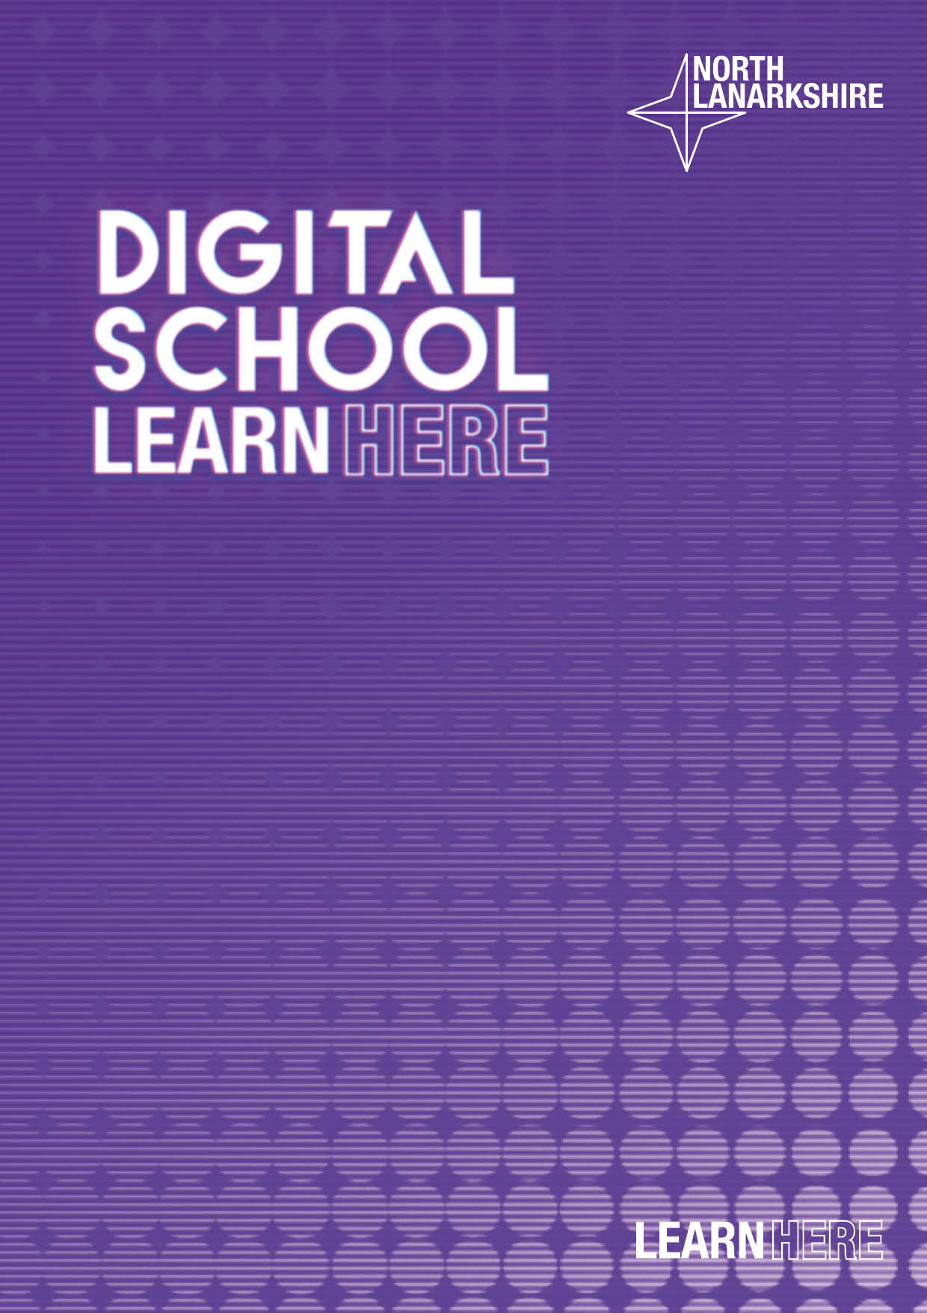
Digital Policy
Golfhill Primary School




DIgItal Literacy and computing science


Review of this Policy

This Digital Policy has been developed by:

- Gail Gallen (Head Teacher)
- Joanne Kirkcaldy (Principal Teacher)
- Leanne Docherty (Digital Champion)

Schedule for Review

Policy created in line with local authority guidelines | June 2024
The implementation of this Digital Literacy policy will be monitored by: | Head teacher  Principal Teacher  Digital Champion
The Policy will be reviewed annually, or more regularly in the light of any significant new developments in the use of the technologies, new threats to online safety or incidents | January 2024
Should serious online safety incidents take place or be disclosed, you should immediately advise: | Head Teacher

Contents

Introduction Page 3
Overview & Aims Page 4
Curriculum Development and Organisation Pages 5
Online Safety & Digital Citizenship Pages 6-8
Social Media – X Acceptable Use Page 8
Use of Digital Videos and Images Page 9
Misuse of digital technology and the internet; reporting and consequences Page 9
Social Media – Microsoft Teams Acceptable Use Page 9-10
Security and Maintenance of school owned devices Page 10 -11
Digital Leaders and their role in staff development Page 11
References Page 11

Introduction

In Golfhill Primary School, we strive to encourage our staff, learners and parents to take full advantage of the opportunities offered by digital technology in order to raise attainment, ambition and opportunities for all. As with Literacy, Numeracy and Health and Wellbeing, Digital Literacy is placed at the heart of learning across the curriculum in our school. We recognise and understand the technological needs of our pupils and how, through its use, we can enrich the teaching and creative learning opportunities that we offer them.
Creativity is a process which generates ideas that have value to the individual. It involves looking at familiar things with a fresh eye, examining problems with an open mind, making connections, learning from mistakes and using imagination to explore new possibilities. Education Scotland, 2013.

All teaching staff and members of the Leadership Team, where appropriate, will plan practical and creative learning opportunities for children to apply, reinforce and extend their digital skills across the curriculum to ensure they can successfully utilise a range of technological skills in a variety of contexts.
By engaging children in appropriate and purposeful use of a range of digital technologies and the internet, we aim to develop our learners’ skills for learning, skills for life and skills for work. We will embrace new technological developments to equip our pupils with employability skills that are often required in our ever increasing digitised world.
At Golfhill Primary School, we endeavour to develop responsible, rights respecting digital citizens who can communicate and participate safely and respectfully in the ever growing online global community.
In Golfhill Primary School we are striving to deliver a curriculum fit for the 21st century which will equip all of our pupils with the necessary skills and attributes to develop as lifelong learners enabling them to reach their full potential.
In addition, we strive to improve attainment and achievement and value the use of digital technologies to enhance learning and teaching. Our strategy outlines our vision for digital learning and teaching and sets out the standards we aim to maintain.

Our Curriculum Rationale which was created in consultation with our parents and pupils, clearly sets out our commitment to offering our pupils the best learning experiences across the curriculum. We use the four contexts for learning: Curriculum Areas, Interdisciplinary Learning, Ethos and Life of the School and Personal Achievement, to ensure our pupils become Successful Learners, Effective Contributors, Confident Individuals and Responsible Citizens.
In addition we incorporate the Scottish Government’s commitment to improving education in Scotland and delivering the best possible life chances for all of our children and young people.

Overview

This policy provides clear guidance on acceptable use of technology and the school network. It sets out our vision for the effective use and implementation of digital technologies to enhance, enrich, extend and support teaching and learning at all stages whilst also developing skilled, confident and responsible digital citizens.
This policy applies to all members of Golfhill Primary school’s community (including staff, pupils, volunteers, parents / carers, visitors and external agency staff) who have access to and are users of school ICT systems, both in and out of the school.

Aims
At Golfhill Primary School we aim to:
- Develop a whole school approach to the effective use of digital technology incorporating the seven principles of design – challenge and enjoyment, breadth, progression, depth, personalisation and choice, coherence and relevance.
- Ensure that digital technology is a central consideration in all areas of curriculum and assessment delivery.
- Provide regular professional learning opportunities to further develop skills and confidence of staff in the appropriate and effective use of digital technology to support learning and teaching.
- Enable children to become confident, independent and responsible users of digital technology, who are empowered to lead change.
- Use a wide range of digital technology to support learning, teaching and communication for pupils, staff and the wider school community.
- Support/challenge children with additional support needs through the use of appropriate apps, websites, hardware and software.
- Maximise the use of digital technology in developing and maintaining links with other schools, parents, the local community and other agencies.
- Use digital technology to increase pupil, parent and staff feedback opportunities.

Curriculum Development and Organisation

Access to Digital Technology

All classes have immediate access to digital technology to support, challenge and enhance learning across the curriculum whilst developing a range of transferable technological skills. Each class has a variety of iPads, laptops and a classroom smartboard. Using these devices the children thrive through the use of experiences such as increased independence of learning, using online tools and platforms to support learning across the curriculum, including IDLs Literacy, Sumdog, Kahoot, Book Creator, Glow, QR Codes and Microsoft Forms.
This approach has seen us acquire iPads and laptops across the stages of the school as follows:
Primary 1 | 19 Pupils with 12 iPads and 2 laptops
Primary 2 | 21 Pupils with 13 iPads and 5 laptops
Primary 3 | 22 Pupils with 12 iPads and 5 laptops
Primary 4 | 19 Pupils with 14 iPads and 7 laptops
Primary 5/4 | 21 Pupils with 12 iPads and 8 laptops
Primary 6 | 22 Pupils with 11 iPads and 7 laptops
Primary 7/6 | 23 Pupils with 11 iPads and 9 laptops


Enhancing Curriculum and Assessment Delivery

In Golfhill Primary, the use of digital technology should be a central consideration in the planning and delivery of teaching and learning. Learners should have countless opportunities to develop their digital skills across the curriculum. Glow should be regularly accessed for teaching, independent/collaborative learning and assessment purposes. It should also be used to save and share all documents, as required.

Equity and Inclusion

Digital strategies that encourage all to be included in the learning experience at our school should be sought and implemented. This has included the use of lunchtime clubs such as ‘Tech Tuesday’ club and regular meetings of the school digital leaders.

Home Learning

Relevant and engaging digital solutions to home learning that offer ‘anytime/anywhere learning’ should be promoted to our learners. Every child should have usernames and passwords for Glow, Sumdog and those who need support should have details for IDLs Literacy. All homework is issued on teams as well as Sumdog.
Over the past three years our school has continued to develop and improve the learning in Digital Literacy for all our pupils. The impact of COVID and the changes to the way we deliver our curriculum has allowed us to deliver a curriculum that can be smoothly transitioned from school to home and vice versa. We have taken our Digital Learning in a new direction and have used creativity and skills for life to foster the most beneficial and valuable experiences for our young people.

Online Safety & Digital Citizenship

Roles and Responsibilities

The following section outlines the online safety roles and responsibilities of individuals and groups within our School:

Head Teacher

- The Head Teacher has a duty of care for ensuring the safety (including online safety) of members of the school community, though the day to day responsibility for online safety and education around this will be delegated to each class teacher as well as the Principal Teacher.
- The Head Teacher is responsible for ensuring that all staff receive suitable training to enable them to carry out their online safety roles and to train other colleagues, as relevant.

Digital Champion:

- takes day to day responsibility for online safety issues and has a leading role in establishing and reviewing the school online safety policies / documents
- ensures that all staff are aware of the procedures that need to be followed in the event of an online safety incident taking place
- provides training and advice for staff
- liaises with the Local Authority
- liaises with school technical staff
- meets regularly with the Head Teacher to discuss current next steps in SIP
- reports regularly to Senior Management Team with feedback and next steps
- the production / review / monitoring of the school Online Safety Policy / documents

Teaching Staff

Are responsible for ensuring that:
- they report any suspected misuse or problem to the Head Teacher, PT or digital champion
- all digital communications with pupils, parents / carers should be on a professional level and only carried out using official school systems
- Microsoft Teams, Glow and Sumdog are used for Homework and Self isolation
- pupils have a good understanding of research skills and the need to avoid plagiarism and uphold copyright regulations
- they monitor the use of digital technologies, mobile devices, cameras etc in lessons and other school activities (where allowed) and implement current policies with regard to these devices
- in lessons where internet use is pre-planned pupils should be guided to sites checked as suitable for their use and that processes are in place for dealing with any unsuitable material that is found in internet searches

Pupils:

Whilst the use of digital technology is regularly encouraged at Golfhill, this is balanced by educating pupils to take a responsible approach. The education of pupils in online safety is therefore an essential part of the school’s online safety provision. Children and young people need the help and support of the school to recognise and avoid online safety risks and build their resilience.
Online safety should be a focus in all areas of the curriculum and staff should reinforce online safety messages across the curriculum. The online safety curriculum should be broad, relevant and provide progression, with opportunities for creative activities and will be provided in the following ways:

- A planned online safety curriculum, should be provided as part of Digital Literacy lessons and should be regularly revisited
- Key online safety messages should be reinforced as part of a planned programme of assemblies
- Pupils should be taught in all lessons to be critically aware of the materials / content they access on-line and be guided to validate the accuracy of information.
- Pupils should be taught to acknowledge the source of information used and to respect copyright when using material accessed on the internet
- In lessons where internet use is pre-planned, it is best practice that pupils should be guided to sites checked as suitable for their use and that processes are in place for dealing with any unsuitable material that is found in internet searches.
- Where pupils are allowed to freely search the internet, staff should be vigilant in monitoring the content of the websites the young people visit.

Pupils of Golfhill Primary School:
- are responsible for using the school digital technology systems in accordance with the Pupil Acceptable Use Agreement
- should have a good understanding of research skills and the need to avoid plagiarism and uphold copyright regulations
- need to understand the importance of reporting abuse, misuse or access to inappropriate materials and know how to do so
- will be expected to know and understand policies on the use of mobile devices and digital cameras. They should also know and understand policies on the taking / use of images and on cyber-bullying.
- should understand the importance of adopting good online safety practice when using digital technologies out of school and realise that the school’s Digital Education & Citizenship Policy covers their actions out of school, if related to their membership of the school.

Parents / Carers

Parents / Carers play a crucial role in ensuring that their children understand the need to use the internet / digital devices in an appropriate way. The school will therefore seek to provide information and awareness to parents and carers through:

- Curriculum activities
- newsletters, Twitter, school website
- Parents / Carers ICT sessions

Parents and carers will be encouraged to support Golfhill in promoting good online safety practice and to follow guidelines on the appropriate use of:
- digital and video images taken at school events
- the school website and X page
- their children’s personal devices in the school

Social Media – X


Golfhill Twitter account (@Golfhill_PS) is an account managed by staff and is used for:
- communicating information to our families and wider school community
- regular reporting on children’s learning
- sharing and celebrating success and achievements both in and out of school
- modelling responsible and respectful use of social media with children
This is the school’s main X account and will therefore be updated with important information such as school closures, holidays, lunch menus etc. It is recommended that all staff and parents follow the school account to be kept up to date.

X Code of Conduct for all staff members:
- staff X accounts must be used solely for professional purposes and not contain any personal posts or reposts that are not of an educational context and relevant to learning in their class or the wider school.
- staff should not follow back parental accounts
- staff should monitor their followers and block any who appear to have: no link to the school, no relevance to the work of the school, inappropriate usernames not in keeping with NLC policy or the ethos of the school e.g. sexualized, football team affiliated, alcohol or drug related names or posts or comments that could cause offence.
- Only children’s first names should be used when referencing children and not at all if the child can be identified in a video or photo attached to the post.
- If children are photographed sharing their work, staff must ensure that their name is not displayed on the work.
- monitor followers and block any who fit the above categories
- welcome positive comments only
- follow educationally linked accounts. Parental accounts, unless educationally linked, will not be followed back.
As X users must be at least thirteen years old, pupils will not be allowed to use X accounts independently. However, in school they will have the opportunity to contribute to posts as part of planned educational activities.

Code of Conduct for parents and the wider school community when interacting with the school or staff X accounts:
- Staff members should not be sent direct messages. The school should be contacted using formal means of communication only; email or telephone contact to discuss issues or queries.
- If commenting on a photo or video of a child, do not include the child’s name in the post.
- If posting a photo or video of your own child, it is recommended that you do not include their name in the post.
- Seek permission from parents before uploading photos or videos of children other than your own.

X Misuse

Any concerns or issues about the misuse of X should be reported to the Head Teacher immediately.

Use of digital and video images
The development of digital imaging technologies has created significant benefits to learning, allowing staff and pupils instant use of images that they have recorded themselves or downloaded from the internet. However, staff, parents/carers and pupils need to be aware of the risks associated with publishing digital images on the internet.

- When using digital images, staff should inform and educate pupils about the risks associated with the taking, use, sharing, publication and distribution of images. In particular they should recognise the risks attached to publishing their own images on the internet e.g. on social networking sites.
- Written permission from parents or carers will be obtained at the beginning of each school session before photographs of pupils are published on the school website, social media or the local press.
- Parents / carers are welcome to take videos and digital images of their children at school events for their own personal use. To respect everyone’s privacy and in some cases protection, these images should not be made publicly available on social networking sites, nor should parents / carers comment on any activities involving other pupils in the digital images / videos.
- Staff and volunteers are allowed to take digital images to support educational aims, but must follow school policies concerning the sharing, distribution and publication of those images. Those images or videos should only be taken on school equipment, the personal equipment of staff should not be used for such purposes.
- Pupils must not take, use, share, publish or distribute images of others without their permission
- Pupils’ full names will not be used anywhere on a website or blog, particularly in association with photographs.


Using Microsoft Teams
Teachers will:
- ensure that they are logged in to Teams when delivering lesson to have
full access to the management console
- discuss roles and responsibilities with pupils at the outset of delivery
- be punctual at the beginning and end of each lesson
- notify all pupils/parents and schools of any cancelled classes
- face the laptop/camera when teaching and talking
- use background effects if you feel the room is distracting
- discuss a virtual lesson with their line manager afterwards. Sharing any concerns and issues.
- remove a young person from the lesson if their behaviour is inappropriate and as above, share with their line manager
- only communicate with the young people through Glow and Teams. Do not use personal email addresses or social media
- ensure that they keep themselves up to date with all relevant policies and procedures, including Child Protection

Pupils will:

- only use their GLOW email address for class communication
- be punctual for all lessons
- dress appropriately for any online lesson, as you would in school
- have an understanding that behaviour and remote learning will be discussed with schools and should your behaviour be inappropriate you will be removed from the learning
- ensure that the learner’s mobile phone is switched off for the period of live learning
- access the files for each lesson in advance and have the materials to hand if applicable
- make sure they have all power adaptors, laptops, headphones, screen connections ready before the lesson begins
- use headphones wherever possible in order to have the best possible sound quality and to enhance the privacy of the dialogue between the pupils and teachers submit all assignments on time in accordance to the agreed protocols
- show respect for everyone in the online classroom
- ensure the location they log in from is appropriate, I.e. give consideration to background, camera angle, privacy etc.
- seek to contribute to the class in a positive manner and not be disruptive at any time
- you do not have permission to screen shot of film any virtual leaning. Doing so will result in further actions being taken by schools.
- do not share recordings/images of the class out with the class environment

Class iPads and Laptops

- information relating to allocated laptop/iPad numbers and chargers is stored and checked at regular intervals by the Principal Teacher
- faults or damages should be reported as soon as possible to the Principal Teacher
- should be charged regularly


Classroom desktop computers

- should be logged off throughout the day when not in use by a pupil or class teacher
- should be shut down at the end of the school day
- faults or damages should be reported as soon as possible to the Principal Teacher

Smartboard

- Only a dry microfibre cloth should be used to maintain the panel
- Faults or damage should be reported as soon as possible to the Principal Teacher

Digital Leaders
The development of a Digital Leaders’ team in session 22/23 has had a significant impact on digital learning in our school. This will continue next session.

The Digital Leaders team:

- are role models for responsible and respectful digital citizenship across the school
- actively seek new technology and resources to trial, review and purchase
- lead learning in classes across the school to model use of innovative technology, programs and resources
- offer regular staff skills sessions to build staff confidence and raise awareness of effective digital approaches to teaching and learning that could be implemented in their classrooms
- support staff delivering lessons with new digital technology and resources
- support staff with technical issues
- support staff with maintenance of school owned devices

References

Sources referred to during the creation of this policy include:

- Enhancing Learning and Teaching Through the Use of Digital Technology. Education Scotland, 2016
- Acceptable Use of ICT, version 2.0. North Lanarkshire Council
- What Digital Learning Might Look Like, Examples of digital literacy and computing science learning at Early, First and Second levels. Education Scotland 2020
- Features of Highly Effective Digital Learning, Teaching and Assessment in Schools. Education Scotland 2022

