Golfhill Primary School



Numeracy and Mathematics Policy

Contents

Mission Statement

Rationale and Aims

Numeracy and Mathematics Curriculum Organisers

Planning, Learning and Teaching

Assessment

Recording

Mission Statement

The numeracy and mathematics programme at Golfhill Primary School follows A Curriculum for Excellence (CfE) which states that:

’All teachers have responsibility for promoting the development of numeracy. With an increased emphasis upon numeracy for all young people, teachers will need to plan to revisit and consolidate numeracy skills throughout schooling.’
(Education Scotland, 2005:1).

What does it mean to be numerate?
Being numerate helps us to function responsibly in everyday life and contribute effectively to society. It increases opportunities within the world of work and establishes foundations which can be built upon through lifelong learning. Numeracy is not just a part of mathematics; it is also a life skill which permeates and supports all areas of learning, allowing young people access to the wider curriculum. We are numerate if we have developed confidence in using number, solving problems, analysing information and making informed decisions based on calculations.
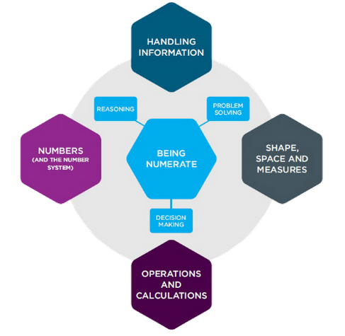

Our mission
At Golfhill Primary School our mission is to develop children’s confidence and self-esteem in numeracy and mathematics, alongside their skills, to prepare them for life, future learning and work. We are fully committed to working with parents, carers and relevant partners to ensure that we provide the highest quality of learning and teaching in numeracy and mathematics with the needs of the whole child being recognised, nurtured and developed.

Rationale and Aims

Mathematics equips us with many of the skills we require for life, learning and work. It develops logical reasoning, analysis, problem solving skills and creativity. The numeracy and mathematics programme in Golfhill Primary aims to provide a differentiated, progressive balance of these elements and allow learners the opportunity to achieve to their fullest potential.

‘To face the challenges of the 21st century, each young person needs to have confidence in using mathematical skills, and Scotland needs both specialist mathematicians and a highly numerate population’
(Education Scotland, 2005:1)

At Golfhill Primary School we aim to develop in children:

- a positive attitude to mathematics as an interesting and valuable subject;
- an understanding of mathematics through a process of enquiry, reasoning and problem solving;
- a range of learning strategies: working actively, cooperatively, collaboratively and independently;
- confidence in mathematics where children can express ideas fluently and talk about the subject using mathematical language;
- an understanding of the importance of mathematics in everyday life.

We recognise that a highly numerate staff is central to achieving these aims:

“All schools need to have strategies to ensure that all children and young children develop high levels of numeracy skills through their learning across the curriculum. These strategies will be built upon a shared understanding amongst staff of how children and young people progress in numeracy and of good learning and teaching in numeracy. Collaborative working with colleagues and across sectors will support staff in identifying opportunities to develop and reinforce numeracy skills within their own teaching activities.”
(Education Scotland, Numeracy across learning)

Ethos and Diversity

Children at Golfhill Primary come from a range of religious and cultural backgrounds and with a diversity of life experiences. The school aims to celebrate the natural diversity of its population and use it to support the numeracy and mathematics programme.
At the heart of the school’s work is the belief that all children should be valued equally. We set out the standards we expect and encourage our children to have high expectations of themselves. In numeracy and mathematics, as in all areas of the curriculum, the ethos should develop children’s self-esteem and confidence, alongside their skills.

Scotland has a maths problem. Too many of us are happy to label ourselves as “no good with numbers.” This attitude is deep-rooted and is holding our country back educationally and economically.
(Scottish Government, 2016)

Improving children’s confidence and fluency in Numeracy and Mathematics is therefore key. Opportunities to experiment with developing skills and ideas should be possible between supportive peers in a classroom where risk-taking is encouraged. Teachers who offer this learning environment can maintain a realistic dialogue with children about their current learning and their next steps. Our task / challenge is to offer a framework of support which makes such attainment and achievement in numeracy possible across the curriculum, by making maths relevant to real life and work and building self confidence in all of our learners.

Numeracy and Mathematics Curriculum Organisers

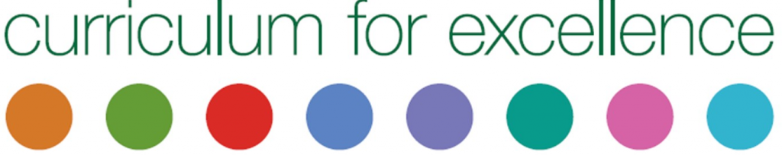

A Curriculum for Excellence identifies three broad areas of mathematics organised as follows:

Number, Money and Measure
- Estimation and rounding
- Money and money processes
- Number and number processes
- Multiples, factors and primes
- Powers and roots
- Fractions, decimal fractions and percentages
- Money
- Time
- Measurement
- Mathematics – its impact on the world, past, present and future
- Patterns and relationships
- Expressions and equations
Shape, position and movement
- Properties of 2D shapes and 3D objects
- Angle, symmetry and transformation
Information Handling
- Data and analysis
- Ideas of chance and uncertainty

The skills and knowledge to be taught within and across these areas come from A Curriculum for Excellence. The balance of the areas taught will vary across stages and the sequence of learning and teaching is guided by the school’s bespoke Mathematics Programmes of Study. Developed by staff and reviewed annually, these stage-specific pathways ensure coverage of the experiences and outcomes across the levels, as well as continuity, pace and progression.

Planning
An Annual Overview of the mathematical concepts to be covered in each term is provided at the start of the school year. Daily plans contain the specific details of the lesson content and include: the resources to be used; the teaching methodologies; the differentiation by group; the activities that children will be engaged in and the assessment tools that will be used.

Learning and Teaching
Children are given opportunities to experience success and develop confidence in numeracy and mathematics through interactive and collaborative learning. Children are encouraged to take risks, ask questions and explore solutions without fear of being wrong. Teachers use children’s misconceptions and wrong answers as opportunities to improve and deepen understanding, giving children opportunities to work:
- individually on independent tasks such as textbook exercises and assessments;
- in pairs or groups to solve problems, complete practical work and play games;
- as a class for direct teaching, to discuss problem solving strategies and for mental maths.

Daily maths sessions are structured as recommended by North Lanarkshire’s Numeracy Team:
Mental Maths (10 minutes)

Mental Agility (15 minutes)

Main Body of Lesson (approx. 40 minutes)
Direct teaching
Differentiation according to group
Group work / partner work / individual work
Concrete materials / games / practical investigations / written work

Plenary and Self-Assessment (10 mins)
Lesson Structure
Our school day is structured to ensure that all children receive one and a half hours of numeracy and mathematics every day. Teachers use groupings as and when required to ensure that children are appropriately challenged and supported. Each session starts with a re-cap of prior learning, an introduction to the mathematical concepts being taught and an explanation of what each group will be required to do that session. Clear learning intentions and success criteria are shared with learners. In the very best examples, children work with the teacher to identify the success criteria. After the main body of the lesson, the plenary session relates back to the learning intentions and success criteria and gives children the opportunity to assess their own learning and identify their next steps.

Resources
Teachers use a range of resources to support effective learning and teaching methodologies which stimulate the interest of children and promote creativity:
- Mental Maths: SumDog.
- Mental Agility: Number Talks.
- Numeracy and Mathematics: TeeJay Maths, Twinkl, Heinemann, Leckie Primary Maths
- Problem-solving: Maths Comprehension Cards.

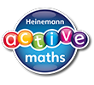
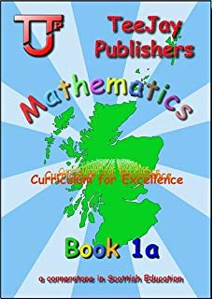
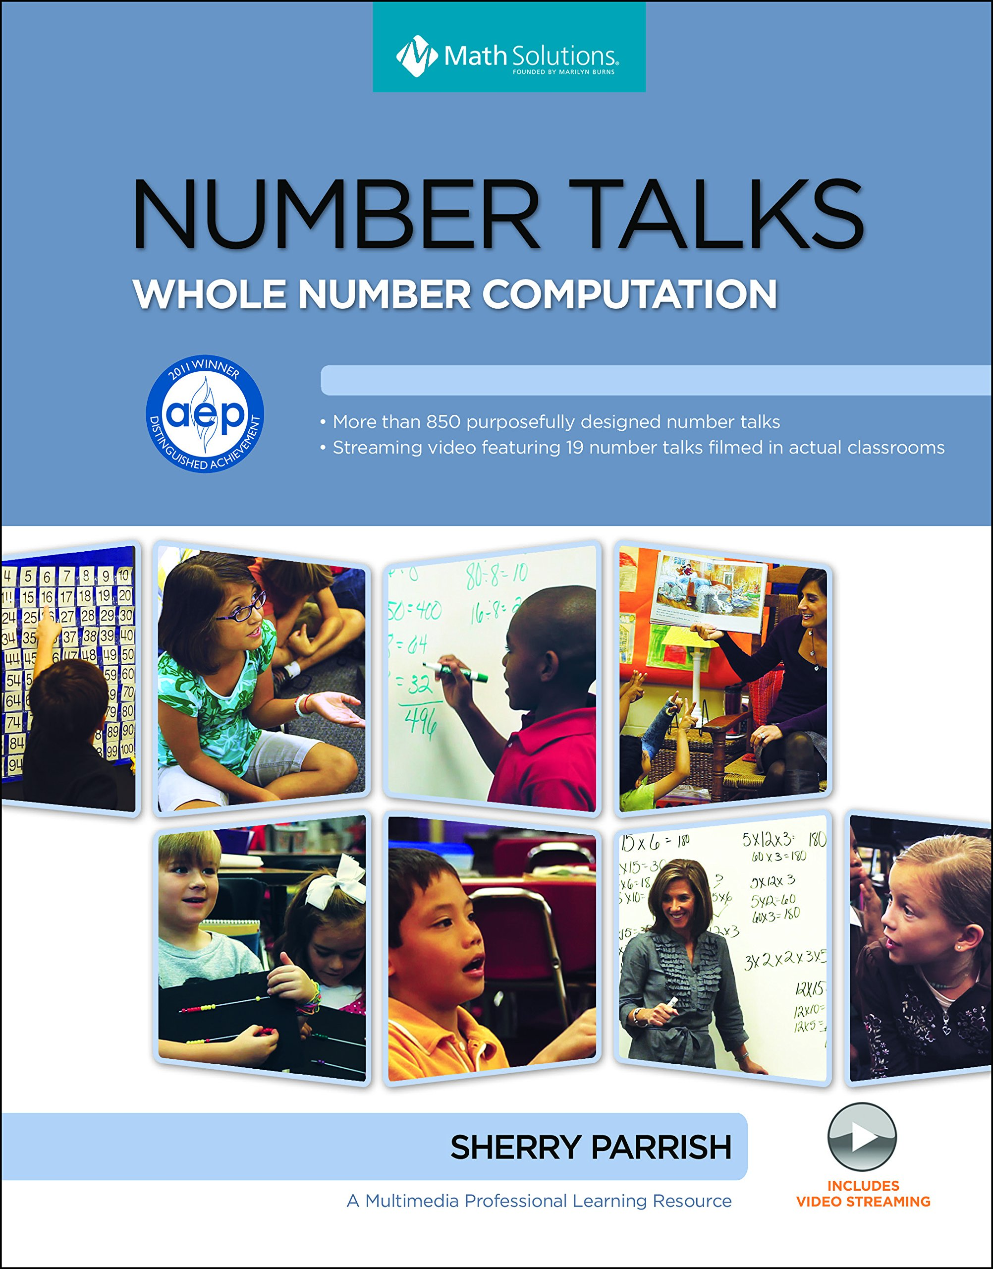
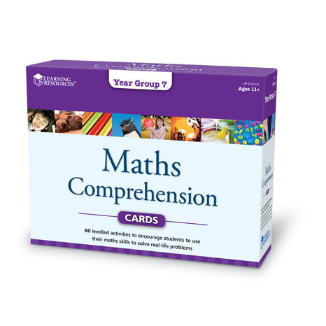




A wide range of supporting resources are also used at the teacher’s discretion and opportunities are given to the children to experience mathematics in both active and contextualised ways. Direct teaching always precedes any work from textbooks and other follow-up activities include: active learning; independent tasks; games; problems; work cards/worksheets and ICT. A variety of concrete and practical resources are also used to ensure children understand and can apply the mathematical skills and strategies taught.

Homework
Homework in maths should be given regularly and should be as engaging as possible. There are opportunities for children to complete homework online using the Sum Dog mental maths programme. Homework should be relevant to the work that the children do in class and should reinforce and consolidate their learning. It should be regularly marked and gone over with the children.

Additional Support
We ensure early intervention for children requiring additional numeracy and mathematics support. Teachers highlight children in need of support at termly Pupil Progress Meetings and the Senior Management Team (SMT) determine the specific measures that need to be put in place to support a child on an individualised basis. Data analysis ensures that children’s attainment in mathematics is monitored on an ongoing basis and that children who require additional support receive the intervention that is most appropriate to their specific needs. The following interventions are currently used to support children:

Number Box
This is both a one-to-one and group approach carried out in class by the teacher, or by a classroom assistant, and consists of three to five 10 minute sessions per week. It revisits early number and mathematics skills, closing any gaps that are preventing the child from progressing.

Catch-Up Numeracy
This is a one-to-one approach, usually carried out by an additional support teacher, and consists of two 15 minute lessons per week. It identifies the specific gaps in a child’s learning and provides focused lessons to address and close these gaps.

Assessment
Regular, ongoing assessment allows teachers to check that children have understood what they have been taught and to plan their next steps for learners. Assessment activities are identified at the planning stage and take account of the Numeracy and Mathematics Benchmarks. Assessment is undertaken in a variety of ways and different forms of evidence are gathered to give a robust overview of children’s progress and support teacher judgements around attainment:

- Formative assessment is ongoing throughout the teaching and learning process. It includes teacher observations, dialogue with children around progress and next steps and teacher’s written comments in jotters. Children should be given frequent opportunities to discuss their progress and next steps with their teacher.
- Summative assessments provide teachers with further evidence of a child’s understanding at various points in the school year.

- Formal summative assessments are carried out at various pre-scheduled points in the year:
  - In September and June, P1 children undertake the PIPS assessment which provides a baseline and endline measure of attainment at the Early Level.
  - In September and June, MaLT assessments are used to track children’s progress over time and ensure early intervention for children in need of additional support. These are pencil and paper assessments, which are carried out under test conditions, from P1 – P7.
  - The Scottish National Standardised Assessments (SNSA’s) are online, individual assessments which can be used diagnostically and to support teacher judgements. These are done in May at the P1, P4 and P7 stages.

Recording
The above assessment evidence is collected and analysed by class teachers who monitor and track children’s progress against the Numeracy and Mathematics Benchmarks. It is recorded in the following formats:

Maths Jotters
- Daily written work that has been marked by the teacher with appropriate verbal or written feedback.
- Daily worksheets that have been marked by the teacher and indicate the child’s progress on a particular concept.
- Mental Maths and Tables tests.

Data Folders
- MaLT booklets.
- An overview of the results of MaLT assessments.
- Results from PIPS and INCAS+.
- SNSA results (where applicable).
- Maths Tracking Spreadsheet.

References

Education Scotland (2009) Numeracy across learning: Principles and Practice. Livingston: Education Scotland.
Scottish Government (2005) A Curriculum for Excellence. Edinburgh: APS Group.
Scottish Government (2016) Making Maths Count. Edinburgh: APS Group.

