Glenmanor Primary
Learning Profile
This is me!
My
Achievements
My
Future targets

My Progress

The secondary school I will go to in August is …
I am currently in Primary 7 at Glenmanor Primary
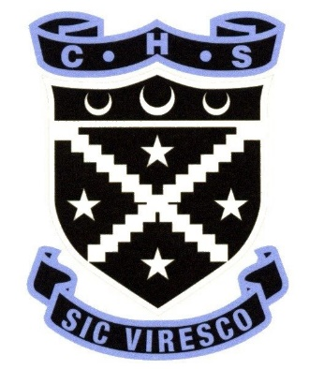

Name -

I am
I am
I am

My Top Ten Learning Styles

I learn best when:
the class is quiet. | I work on my own.
the task is broken down into little chunks. | I work with a partner.
I am using the computer. | I work with a group.
the task is written down for me. | I use practical materials.
the task is illustrated for me. | I work with an adult to support me.
I listen to instructions. | I write notes/make a plan.
I do the task. | I draw pictures.
I discuss the task. | I research information.
I reflect on my work. | I observe the task.
My Learning, Achievements & Strengths: My Statement

My Learning Wall
Literacy & English

Mathematics & Numeracy

Health & Wellbeing
Skills Across the Curriculum

ICT | Problem Solving
Teamwork | Listening
Organisation | Negotiation
Independence | Determination
Communication | Presentation
Confidence | Literacy
Resilience | Numeracy
Skills for Learning, Skills for Work, Skills for Living.
I have developed the following top 10 skills this year.

My Ambitions For the Future

Your child has now completed their final Primary 7 profile, which highlights their latest progress and achievements. This profile will be shared with their Secondary School. We would like you to discuss the contents of this profile with your child and comment on it in the space provided below. Thank you!
Parent/Carer Comment -
Personal Achievements School Clubs Attended

