


Glengowan Primary School and Nursery Class
Child Protection and Safeguarding Policy
August 2026
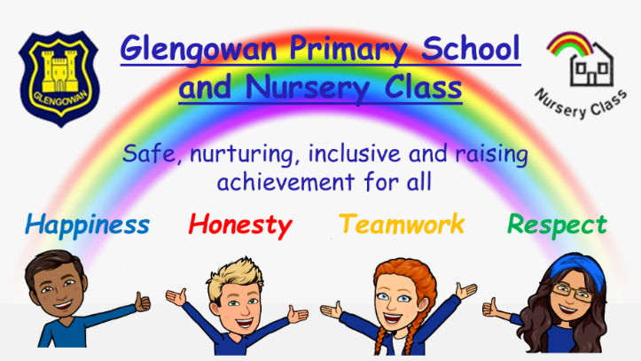



The Designated Child Protection Coordinator for Glengowan PS and NC is:
Ms Rhona Morrison
Prevent Co-ordinator is: Ms Rhona Morrison
Telephone: 01236 632154
E-mail: enquiries-at-glengowan@northlan.org.uk

In the event that the Headteacher is not available, please report any child protection concerns to the Principal Teachers, using the above contact information:
Mrs Kirsty Teasdale Mr Jonathan Grier

Next Review Date August 2027

This Policy is underpinned by the UN Convention on the Rights of the Child (UNCRC):
Key articles:

Article 3: The best interests of the child must be a top priority in all things that affect children.
Article 6: Every child has the right to life. Governments must do all they can to make sure that children survive and develop to their full potential.
Article 12: Every child has the right to have a say in all matters affecting them, and to have their views taken seriously.
Article 19: Governments must do all they can to ensure that children are protected from all forms of violence, abuse, neglect and bad treatment by their parents or anyone else who looks after them.
Article 28: Every child has the right to an education.

Any concerns regarding Child Protection should be brought immediately to the attention of the Child Protection Co-ordinator. At Glengowan Primary, this role is fulfilled by Rhona Morrison, the Head Teacher. In the event of the Head Teacher’s absence, concerns should be directed to Kirsty Teasdale or Jonathan Grier, Principal Teachers. We recognise that nursery parents’ initial contact may be with Pauline Miller, Nursery Lead Early Learning Practitioner, and concerns can be brought to her attention.

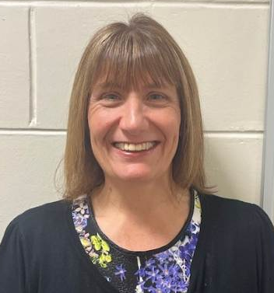
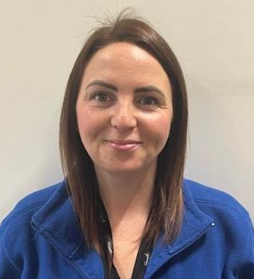


Rhona Morrison Kirsty Teasdale Jonathan Grier Pauline Miller
Head Teacher Principal Teacher Acting Principal Teacher Lead ELP

Rationale
All children have a right to be protected from abuse and neglect, therefore child protection is the responsibility of everyone. The shared responsibilities of Education & Families and other agency employees are to protect children from abuse and exploitation, to respond appropriately when abuse is identified and to ensure whenever possible that all children are able to exercise their right to be raised in a warm, stimulating and safe environment with the support of staff, their families and carers. It is the clear responsibility of all those involved in our school and nursery to demonstrate good practice throughout their work.
(For further information access the E&F Sharepoint Pink Tile and the CP Team - MS Teams)
NLC Child Protection Practice Guide

Aim
The aim of this policy is to provide advice and guidelines for staff in relation to issues of child protection and the health and wellbeing of the children in our school and nursery. The main purposes of the policy are:
- to raise staff awareness of the categories of abuse and the indicators which could signify that abuse is taking place
- to identify the roles and responsibilities in the care and protection of our pupils
- to provide guidance and support to staff in carrying out their role and responsibilities in the protection of our pupils

Procedures
- all staff receive an annual Child Protection update on the August inservice days and they are prompted to join the CP team on MS Teams and to access the current policy and guidance on the pink tile on the EF Sharepoint. All staff should access Child Protection information on the GLOW web page as the documents are live and will be regularly updated.
- in addition, staff who join our establishment during the course of the year are required to complete the ‘Understanding Child Protection Self Learning Pack’ and have this signed off by the Designated Child Protection Coordinator.
- the procedures outlined in this policy must be followed meticulously, at all times and by all staff, and should be implemented in conjunction with NLC Child Protection Procedures and Guidance – these can be accessed through the Education & Families Sharepoint on the Glow dashboard.

What is child abuse and neglect?
The Scottish Government’s National Guidance for Child Protection in Scotland (refreshed in 2014) states that abuse and neglect are forms of maltreatment of a child. Somebody may abuse or neglect a child by inflicting, or by failing to act to prevent, significant harm to the child. This online document provides the following definitions of some of the ways in which children may experience abuse.
- Physical abuse – may involve hitting, shaking, throwing, poisoning, burning or scalding, drowning or suffocating.

- Emotional abuse – may involve conveying to a child that they are worthless, unloved or inadequate, they may be constantly criticised, ignored, humiliated. Some level of emotional abuse is present in all types of ill treatment of a child but can occur independently of other forms of abuse.

- Sexual abuse – involves forcing or enticing a child to take part in sexual activities which may involve physical contact, but which also applies to non-contact sexual activities, such as involving children in looking at, or in the production of, indecent images. It includes using sexual language to a child or encouraging them to behave in sexually inappropriate ways.

- Neglect – may involve a parent or carer failing to provide for a child’s basic needs, failing to protect a child from physical harm or danger, not ensuring access to appropriate medical care or treatment. Neglect also incorporates ‘non-organic failure to thrive’ where a child has significantly failed to meet their normal development and growth milestones and there are no known genetic or medical reasons for this.

Indicators of Risk
The following circumstances are considered to be indicators that a child may be at increased risk of harm within their families:
- Domestic abuse
- Parental alcohol and drug misuse
- Non-engaging families
- Children and young people experiencing or affected by mental health problems
- Children and young people who display harmful or problematic sexual behaviour
- Female Genital Mutilation (FGM)
- Honour based violence and forced marriage
- Fabricated or induced illness (previously known as Munchausen by proxy)
- Sudden unexpected death in infants and children
- Radicalisation (See Appendix 2 for further details on Prevent)

Further detailed information on all of the above circumstances can be found within the National Guidance for Child Protection in Scotland. This can be accessed online at:
Supporting documents - National Guidance for Child Protection in Scotland 2021 - updated 2023 - gov.scot
Roles and Responsibilities
In Glengowan Primary School and Nursery Class the Head Teacher, who is the Designated Child Protection Coordinator, has overall responsibility for all child protection issues. These responsibilities include the following:
- ensuring that the North Lanarkshire Child Protection Procedures and Guidance are brought to the attention of all staff on an annual basis
- ensuring that all staff know the name of the child protection co-ordinator in the establishment and who to speak to in her absence
- developing establishment policy and practice to meet national and local authority guidance
- ensuring child protection training for all staff
- developing a school ethos and providing learning opportunities which promote the safety and wellbeing of all children
- completing and returning all Child Protection paperwork as outlined in local guidance

All Staff
It is everyone’s responsibility to keep children safe therefore all school and nursery staff have an active role to play within this establishment. In terms of child protection, staff should be aware of the following grounds for concern, which can arise from a wide range of circumstances but will generally be covered by the following events:
Grounds for Concern:
- a child states that abuse has taken place or the child feels unsafe
- a third party or anonymous allegation is received
- a child’s appearance, behaviour, play, drawing or statement cause suspicion of abuse
- a child reports an incident of abuse which occurred some time ago
- staff witness abuse

Responding to Grounds for Concern:
- any grounds for concern should be reported immediately to the Designated Child Protection Coordinator
- if a child protection concern arises, then this must be reported immediately. Staff should not wait to gather evidence nor agree to keep the information secret or discuss the matter with others
- staff must provide a handwritten record of the incident, in the child’s words as far as possible, with all information recorded being relevant and accurate
- staff must date and sign the record of the incident
- staff must follow the guidance given by the Designated Child Protection Co-ordinator in relation to recording concerns, supporting the child, co-operating with subsequent actions to investigate the grounds for concern, and protecting the child or children
- it is essential that there is no delay in initiating child protection procedures even where the Designated Child Protection Coordinator is absent or unavailable. In such circumstances staff should speak to one of the Principal Teachers (Mrs Kirsty Teasdale or Mr Jonathan Grier). Further support is available from the Acting Child Protection Development Officer, Lynn Kinstrie, at the Civic Centre, Motherwell. Her contact details are listed below:

Lynn Kinstrie – Acting Child Protection Development Officer
Email:
Kinstriel@northlan.gov.uk
Contact number: 07890532941

Supporting the Child
During any disclosure of abuse by a child staff should respond in a sensitive and supportive manner. The following strategies should be adopted:
- listen with care
- treat the allegation in a serious manner
- reassure the child that they are right to tell
- affirm the child’s feelings as expressed by the child
- do not give a guarantee of confidentiality or secrecy
- do not ask leading questions
- ask open ended questions which seek to clarify information already given
- do not interrogate the child
- do not show disbelief
- do not be judgmental
- do not introduce personal or third party experiences of abuse
- do not display strong emotions

What happens next?
A medical emergency should be reported immediately to medical services and, if required, first aid should be administered before reporting the incident to the senior social worker.
Child abuse is a criminal offence. Urgent circumstances may require help from the police, for example to immediately avoid further abuse, to ensure the immediate pursuit of an alleged abuser or to avoid destruction of evidence.
Child Protection concerns should be reported directly to a Senior Social Worker at Airdrie Locality, Social Work Department on (01236) 757000. If there is an immediate child protection concern then the Police or Social Work must be contacted without delay. The staff member reporting the concern should follow the advice given. The grounds for concern and action taken should be recorded, signed and dated (on the same day) using Appendix 1 Notification of Concern (NOC). Two copies should be sent immediately as advised. The copy retained in the establishment should be stored on the Wellbeing App. Grounds for concern are to be recorded as a significant event on SEEMiS pastoral notes.
Following a Notification of Concern (NOC) the Police and Social Work will liaise regarding an investigate and may initiate an ‘Initial Referral Discussion’ (IRD) through a Microsoft Teams call. The purpose of the IRD is to ensure that key agencies/services are involved in the initial sharing and analysing of information to inform a collective decision about whether a notification of child protection concern should proceed to a child protection investigation. This ensures a collective responsibility and consistent involvement by police, social work, health and education staff in sharing information and assessing risks and a single record of joint decision making.

Whistleblowing
All organisations that work with children are required to have policies and procedures in place that allow individuals to escalate a child protection concern outside of their management structure. Senior managers and child protection coordinators are required to deal with child protection concerns appropriately, this includes not minimising or dismissing allegations of harm. Senior managers could also be suspected of harming a child or young person. If staff need to escalate a concern, please contact:
- Barry Smedley, Chief Officer (Education North) - smedleybar@northlan.gov.uk
- James McParland, Chief Officer (Education South) - mcparlandjam@northlan.gov.uk
Police Scotland on 999 in an emergency or 101 for non-emergencies (0141 308 1070) without delay if a child or young person is at risk of harm.
The Whistleblowing Poster is prominently displayed on our staff noticeboard and in several areas of the school and nursery (Appendix 3).

Co-operating with Agencies involved in Child Protection Process
Following reporting and recording of concerns, staff should co-operate fully with subsequent investigations and support plans as directed by the head of establishment and in consultation with the appropriate agency representatives. This may include attendance at initial child protection case conferences, core group meetings, child protection planning meetings, child protection case conferences and reviews.

Dealing with child protection issues can have stressful consequences for employees. Education & Families have a duty of care to all employees. Support can be accessed through the Staff Welfare Officer. The details are included in the Child Protection training powerpoint presentation and are displayed on the staffroom noticeboard.

All children have the right to be cared for and protected from abuse and harm in a safe environment in which their rights are respected. By being aware of and following the procedures in this policy, and by referring to local and national guidance, we can remain vigilant in protecting our pupils and promoting their Health and Wellbeing.

Useful Resources which can all be found within the Child Protection Team on Glow and the EF Pink Sharepoint, include:
- NLC Child Protection Procedures and Guidance (2023)
- Understanding Child Protection Self Learning Pack 2020
- National Guidance for Child Protection in Scotland 2021
- Initial Referral Discussion (IRD) Guidance

Appendix 1: OFFICIAL SENSITIVE: POLICE AND PARTNERS

Notification of Child Protection Concern
Agency details  (the agency completing Notification of Child Protection Concern) | Name:
 | Address: |  | Agency and Designation:
 |  |  | Tel No:
 |  |  | Email:
 |  |  | Fax:
In relation to this Notification of Child Protection Concern please detail:
Date of initial verbal discussion:
Details of person with whom discussion took place: (police/social work employee)
Details of the advice given at this time:
Has the parent(s)/carer(s) been advised that concerns have been shared? |  | 1 Yes | 1No
Child to whom concerns relate
Name:  (inc Forename and Surname) | Home Address: | Current Address: | DOB:
Name:  (inc Forename and Surname) | Home Address: | Current Address: | Unique Identifier:
Name:  (inc Forename and Surname) | Home Address: | Current Address: | CHI:
Name:  (inc Forename and Surname) | Home Address: | Current Address: | SEEMIS:
Name:  (inc Forename and Surname) | Home Address: | Current Address: | SWIS:
Name of establishment attended: |  | Contact Person: | Person’s Contact Details:
Is child/young person care experienced?
Is the Child’s name on the Child Protection Register?
Please advise of any additional or communication needs e.g. English as an additional language, hearing impairment or learning disability
Family Details
Parent 1 | Name: | Address: | Unique Identifier:
Parent 1 | Name: | Address: | DOB:
Parent 1 | Name: | Address: | Telephone No:
Parent 2 | Name: | Address: | Unique Identifier:
Parent 2 | Name: | Address: | DOB:
Parent 2 | Name: | Address: | Telephone No:
Other Carer 1 | Name: | Address: | Unique Identifier:
Other Carer 1 | Name: | Address: | DOB:
Other Carer 1 | Name: | Address: | Telephone No:
Other Carer 2 | Name: | Address: | Unique Identifier:
Other Carer 2 | Name: | Address: | DOB:
Other Carer 2 | Name: | Address: | Telephone No:
Siblings & Other Household Members
 | 1 | 2 | 3
Name:
Address:
DOB:
Unique Identifier:
Name of Establishment
 | 4 | 5 | 6
Name:
Address:
DOB:
Unique Identifier:
Name of Establishment
Family Antecedents
Please include:
- Relationships between the listed adult(s) and child(ren)
- Current living arrangements
- Current child access to adult(s)
Summary Of Current Child Protection Concerns including identified risk and need
Nature of Concerns
Child/Young Persons’s Views
Parent/Carer’s Views
Please tick which category is relevant to your Notification of Child Protection Concern:
Please tick as many as are relevant
Physical Harm |  | Familial Harm |  | Extra Familial Harm
Sexual Harm |  | Domestic Abuse |  | Child Sexual Exploitation (CSE)
Emotional Harm |  | Mental Health Issues |  | Child Criminal Exploitation (CCE)
Neglect |  | Forced Marriage |  | Peer-on-Peer Harm
Self-Harm / Suicidal |  | Honour Based Abuse (ABA) |  | Missing Episodes
 |  | Female Genital Mutilation (FGM) |  | School Absence
 |  | Servitude |  | Alcohol Abuse
 |  | Human Trafficking |  | Drug Abuse
Is the child affected by any adult support & protection issues?
What are the family, you or your agency currently doing to support the child?
Are you aware of actions from any other agency being taken to support child/family currently or in the past?
Are you aware of any previous Notifications of Child Protection Concern? If so, please provide details of any outcome that you are aware of
Health (excluding inpatient areas): Resilience Matrix
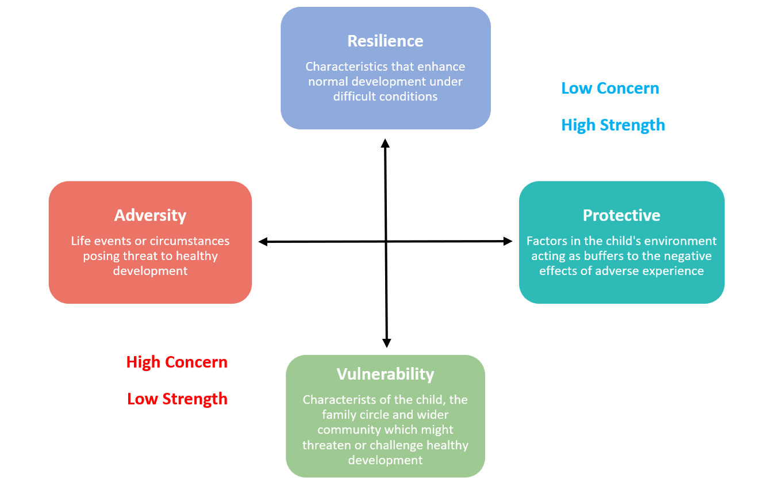
Resilience
Protective
Vulernabilty
Adversity
Is the Named Person aware of the Notification of Child Protection Concern? |  | 1 Yes | 1 No
Is the Lead Professional aware of Notification of Child Protection Concern (where applicable)? |  | 1 Yes | 1 No
Named Person Details | Name
Named Person Details | Address
Named Person Details | Agency & Designation
Named Person Details | Tel No
Named Person Details | Email
Named Person Details | Name
Named Person Details | Address
Named Person Details | Agency & Designation
Named Person Details | Tel No
Named Person Details | Email
Information Required for Onward Submission to Police Concern Hub
(To be completed by person submitting NOCPC to Police)
Details of Person Sharing with Police | Name
Details of Person Sharing with Police | Address
Details of Person Sharing with Police | Agency and Designation
Details of Person Sharing with Police | Tel No
Details of Person Sharing with Police | Email
Immediate Police Action Required
Child / young person injured? |  | 1 Yes | 1 No
Child / young person victim to penetrative sexual offence within last 7 days? |  | 1 Yes | 1 No
Other
Action Taken
Child spoken with?
If yes, include when, where & by whom
Child made disclosure?
Opinion on capacity for JII?
Child/young person willing to engage with police?
Home visit carried out?
If so, include when, by whom, persons present, observations re living conditions
Interim Safeguarding
Where is the child(ren)/young person(s)?
Who is caring for child / young person?
If there is a suspect, does suspect have access to any other children?
What safeguarding is in place?
Interagency Referral Discussion
IRD requested |  | 1 Yes | 1 No
IRD availability
Date Form Completed

Appendix 2: PREVENT Duty in Scottish Schools

Prevent Duty in Scottish Schools
In Scotland, the Prevent duty is part of the UK Government’s broader counter-terrorism strategy, CONTEST, and aims to stop people from becoming terrorists or supporting terrorism. Below that lies the 4 Ps
Prevent: to stop people becoming terrorists or supporting terrorism
Pursue: to stop terrorist attacks
Protect: to strengthen our protection against terrorist attack
Prepare: to mitigate the impact of a terrorist attack

Role and Responsibilities of Schools in North Lanarkshire Council under Prevent
Scottish schools have a statutory duty under Section 26 of the Counter-Terrorism and Security Act 2015 to have “due regard” to the need to prevent people from being drawn into terrorism. This duty is integrated into existing safeguarding responsibilities and is not intended to create new functions. The Child Protection Coordinator is responsible for PREVENT in their establishment. For Glengowan Primary and Nursery, the Child Protection Coordinator responsible for PREVENT is Rhona Morrison.
Schools must ensure staff understand the risks of radicalisation and are equipped to respond appropriately. All education staff are required to complete the mandatory PREVENT training every two years via the Learn NL portal.
Should a PREVENT Concern arise, referrals can be made to PreventReferrals@scotland.police.uk
The PREVENT referral form is available on the North Lanarkshire Child Protection Share Point or National Prevent referral form
When referring please also include the Child Protection Development Officer Lynn Kinstrie KinstrieL@northlan.gov.uk and Chief Officer (Legal & Democratic) Rachel Blair blairr@northlan.gov.uk
Further details can be found here Counter Terrorism and Keeping Safe | North Lanarkshire Council
Protecting people susceptible to radicalisation
The Prevent duty: safeguarding learners vulnerable to radicalisation - Guidance for those working in education settings with safeguarding responsibilities.
Managing risk of radicalisation in your education setting – Guidance to help education settings consider indicators of risk and decide what response is appropriate and proportionate.
Full PREVENT Guidance is available at Prevent duty guidance: for Scotland (accessible) - GOV.UK

Appendix 3: Whistleblowing Poster
