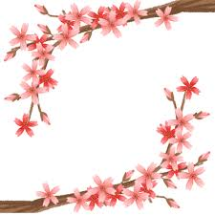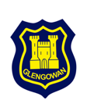

**Glengowan Primary School**

**April 2021 Newsletter**

**Outdoor Learning**

In line with current guidance to minimise the risk of transmission of coronavirus, we have increased our outdoor learning and teaching opportunities. The children are enjoying learning more about their environment and the world around them and engaging in Daily Mile and PE outdoors.

**Happiness Honesty Teamwork Respect**

We have also made use of the playground surface as an outdoor canvas for the children to demonstrate their learning in literacy and numeracy through chalking numbers and common words, and some classes have also shared their social studies learning. These learners are drawing Roman soldiers, including all of the details of their uniforms and the P5/4 pupils are creating Aztec designs in a large scale.

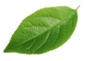

Recognising Achievement and Celebrating Success

We are always happy to recognise and share children’s successes and achievements from within school, and also from out with school. We have recently reviewed our Assembly Awards and how we celebrate success, and we are updating some of our awards so look forward to us sharing these on twitter **@GlengowanPS**. We are very proud to share with you that a boy from P6 has earned a Blue Peter badge, which is an amazing achievement. Well done!

Health and Wellbeing

We have recently started our second block of cycling lessons for this session, with our P5-7 classes. The children are loving the physical activity, surrounded by the great scenery at the reservoir. This has also led to an increasing number of children travelling to and from school on their bikes or scooters. We encourage this active travel for the positive impact on children’s physical and mental health. We recommend that children who cycle or scoot to school, wear a helmet and bring a chain to secure their bike or scooter to the cycle racks. Please note, we are unable to accept liability for bikes and scooters on school premises.

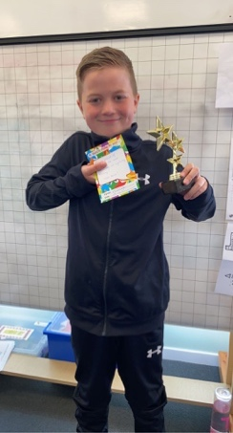

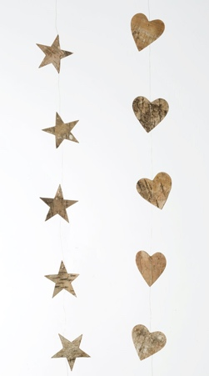

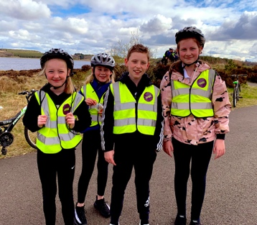

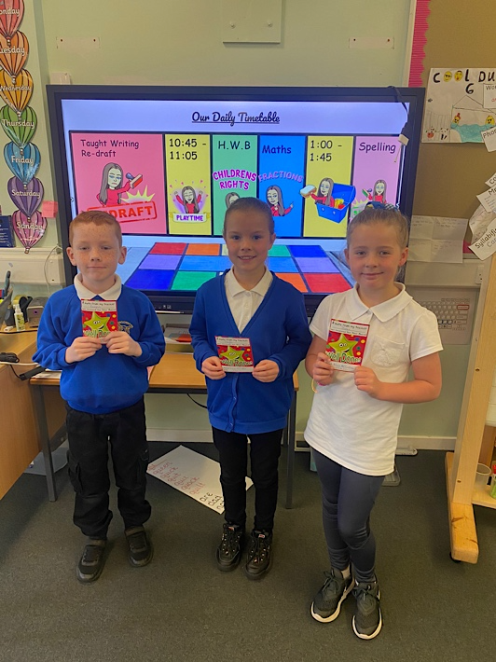

Rights Respecting School

As you are aware, we are a Bronze Award school, and we are awaiting our Silver assessment. The children learn about the Articles from the United Nations Convention on the Rights of the Child and they are able to discuss what they mean in their own words. We will keep you updated with our progress as we embed children’s rights in our practice.



Earth Day

April 22nd was officially Earth Day. Lots of our learners across the school took part in a variety of activities. Some classes created posters, watched interesting videos and spent time outside.



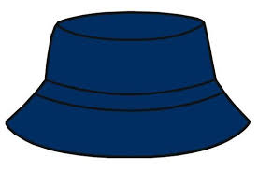

Sun Safety

We are hoping that the warm, sunny weather will return soon, after its brief appearance recently. Please keep your child safe in the sun:

* apply sun cream before your child comes to school
* encourage your child to wear a suitable hat with good coverage
* long sleeves provide good sun protection
* provide your child with plenty water in a sports cap bottle/s

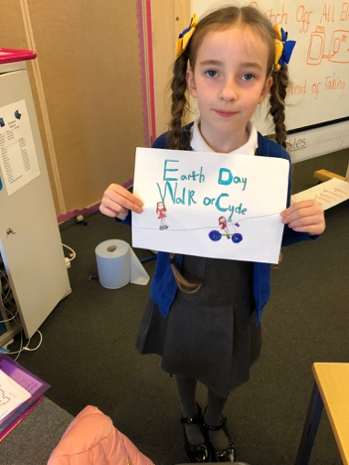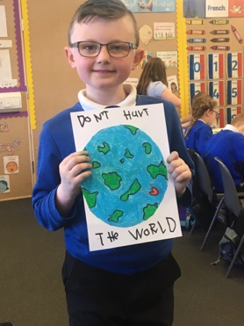

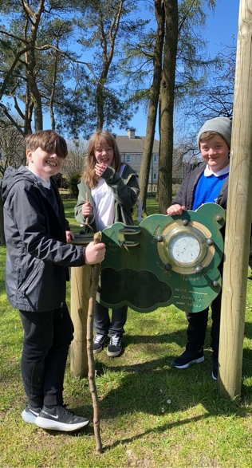







Contact Us

Telephone us on **(01236) 632154**

Email [enquiries@glengowan.n-lanark.sch.uk](mailto:enquiries@glengowan.n-lanark.sch.uk)

Twitter: @GlengowanPS

DIARY DATES

Thurs 6th May INSERVICE – CLOSED TO PUPILS

Mon 10th May PARENT COUNCIL MEETING 6 P.M.

Fri 28th May HOLIDAY

Mon 31st May HOLIDAY

Relationship, Sexual Health and Parenthood

Information will be sent out about our RSHP programme, which our learners will be taking part in during the month of May.

Coronavirus Contact Tracing - UPDATE

There has been a change to the process when communicating information to families of children and young people identified as close contacts of positive Covid-19 cases in schools. If a positive case occurs in the school that your child attends, the school will be in contact to ask for children to be collected. Following risk assessment, Contact Tracers from NHS Test and Protect will then be in touch with you directly with advice for close contacts, and not the school as was previously the case. Wider community letters will continue to be issued following positive cases but direct contact for close contacts will be made by NHS Test and Protect.

