Glencairn Primary Nursery Class
January 2025 Newsletter


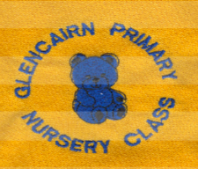
Welcome!  Happy New Year everyone, we hope you had a lovely Winter break. Welcome to all the children and families who will be joining us over the next few weeks.  This month we will be learning about the season Winter and the changes in the weather and environment. The story we will be learning about over the next few weeks is Handa’s Surprise by Eileen Browne. The rhymes/songs we will be focusing on are Oats and Beans and Barley Grow, Open them, Shut them, Alice the camel and Ali Bali.  The artist of the month is Pablo Picasso.  The Nurture Principle we will be focusing on is Transitions, ensuring all children have a smooth return or start to their nursery life, the SHANARRI indicator is Achieving. The children’s right article of the month is Article 31 – I have the right to relax, play and take part in a wide range of cultural activities.  Making connections  If possible could you send a photo of your family to help us make connections with your child? We plan to create a nurture wall within the home corner displaying photographs of our families.  Illnesses/allergies  As we move into the winter season there are many bugs and illnesses around, if your child is unwell and/or has a temperature, please ensure they have recovered before sending them back to nursery, this ensures the wellness of all children and staff.  Please inform staff of any allergies or dietary requirements.  If your child has been sick or has diarrhoea, please do not send them back to nursery until 48 hours after their last episode.  Safety and security  To ensure the safety and security of all children we ask you close the nursery gate behind you. The nursery door will be always locked, please buzz to gain access, a member of staff will be on door duty during busy times. | Contact Details  Glencairn Primary School and Nursery Class  Glencairn Street, Motherwell, ML1 1TT  Tel: 01698 274982  Mobile 07583122840  Email-  enquiries-at-glencairn@northlan.org.uk  X (Twitter)  Follow us at: @GlencairnNursery  Or @GlencairnNC  Newsletter  The newsletter will be sent out monthly to keep you updated.

School Registration
If your child is 5 between 1/3/25 and 28/2/26 they should be registering for Primary School next week. Each school has different times and dates, you can find them on social media. We will tweet them too. Please take along your child’s birth certificate and council tax letter.

SWAY’s
These are online learning profiles unique to your child, all members of staff add photographs and observations of their learning at nursery. If for any reason you are unable to access this then please speak to Mrs McGowan who can arrange for you to view or troubleshoot any problems.

Nursery Funds
We rely on nursery funds to bring essential money into the nursery. We use this money to buy snack items, Christmas gifts, Easter eggs and to buy new resources and plan outings to enhance the children’s learning. We are requesting parents contribute £2 each week into the nursery funds. Thank you.

Nursery Initiatives
We continue to provide a variety of initiative throughout the week. If your child is part of an initiative, we will inform you of their progress and add photographs and observations to their SWAY.

Book bug with Miss Farrell and Miss Cleary
Time to talk with Mrs McGowan
Early Language and Listening Group with Mrs Cambridge and Mrs Ward/Mrs McGowan
Heuristic group with Mrs McGowan and Miss McCafferty
Sunnybank with Miss McCafferty
Children’s Rights with Mrs Donaldson and Mrs McGowan

Spare clothing
Please ensure your child has spare clothes in their nursery bag in case of accidents. Please make sure your child’s name is on all their belongings. We are running short of spare pants and trousers especially for girls, we would appreciate any donations of these items if possible.

Bringing toys to nursery.
We ask that your child does not bring toys from home to nursery as they can become distressed if their toys go missing or get broken.

Pick up/drop off routine.
When dropping off or picking up your child we ask you to sign them in on the laminated sheets at the nursery entrance. When picking up your child in the morning session or dropping off in the afternoon session we ask you to go into the playroom and go to their keyworker, this ensures the safety of all children and information can then be passed on if required.
Group areas –
Orange Fireflies (Mrs Cambridge) – snack area
Purple Dragonflies (Mrs Donaldson) – block area
Turquoise Turtles (Miss Farrell) – snack area
Red Ladybirds (Miss McCafferty)– story corner
Blue Butterflies (Miss Cleary) – House corner
Green Caterpillars (Miss O’Rourke) – art area
Education Scotland Inspection
Glencairn Primary and Nursery are being inspected the week beginning 20th of January, there may be a few new adults in the nursery. At times, the inspectors may ask parents/carers questions.

Loose Part Donations
We are looking for donations of loose parts, these are everyday objects which can improve children’s creativity, boost social and problem-solving skills and support wellbeing, literacy and numeracy skills.
Here is a list of some items we would appreciate.
Baby clothes – newborn size, Clothes pegs, Buttons, Bottle lids, Shells, Corks, scarves, cultural clothing, baskets, CD’s, records, potato masher.

Rabbie Burns
We will be celebrating the Scottish poet Rabbie Burns during the week of the 20th of January where the children will be tasting a variety of Scottish food and drinks.

Important Reminders

- Please also make sure your child’s outside shoes do not have laces if your child cannot tie laces by themselves, as the children are encouraged to change their shoes themselves.
- Please ensure that when you enter and exit the nursery grounds, you do not use the nursery car park. This is for staff only unless you have a blue badge.

Glencairn Primary and Nursery aims and values.
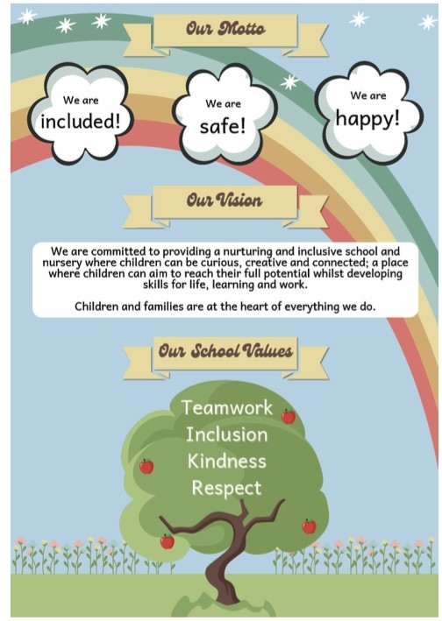

THE SCHOOL YEAR: 2024-2025
We are a 48-week establishment and are only closed on these dates. However, a few children may share funding with childminders and during term time. Please note that during holiday periods our session times may vary.

February 2025
Mid-term break Monday 17th and Tuesday 18th of February
In Service Day: Wednesday 19th of February 2025

April 2025
Good Friday 18th and Easter Monday 21st of April 2025

May 2025
May day holiday: Monday 5th of May 2025
In-Service day: Tuesday 6th of May 2025
May weekend holiday: Friday 23rd and Monday 26th of May 2025

Schools close
Wednesday 25th of June 2025

Fair Monday
Nursery is closed 15th of July 2025

August 2025
In-Service day: 12th and 13th of August

January 2025 Question of the Month
As part of our Improvement Plan, we are making links within the wider community focusing on the diversity and values of our families. Over the next few weeks, we will be working with the Maryam Centre who will be teaching us about the festivals of Eid and Ramadan.

Do you have any suggestions of other community networks we could collaborate with?

Do you have any skills you would like to share with the staff and children?

